LLM -> large language model

LLMM -> large language multi model

**GenAI**

Foundation Models -> general base models, have multi parameters.

User perspective (for personal user)

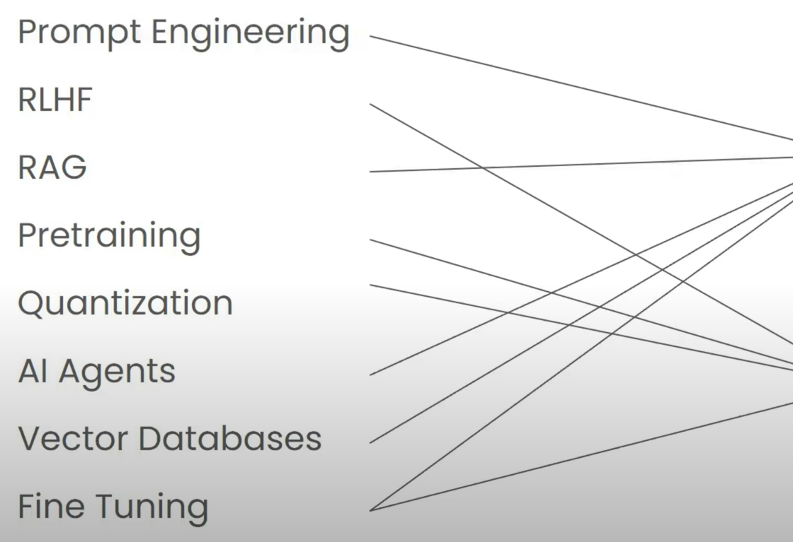Builder perspective (company side production for service)

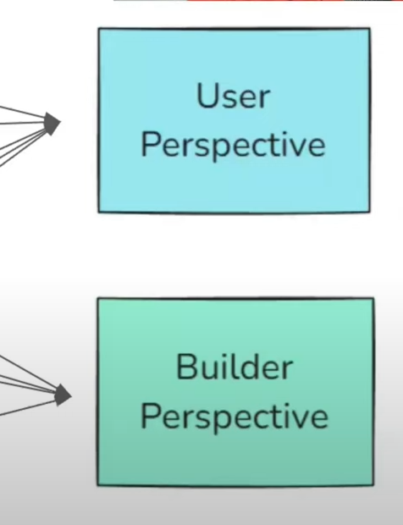

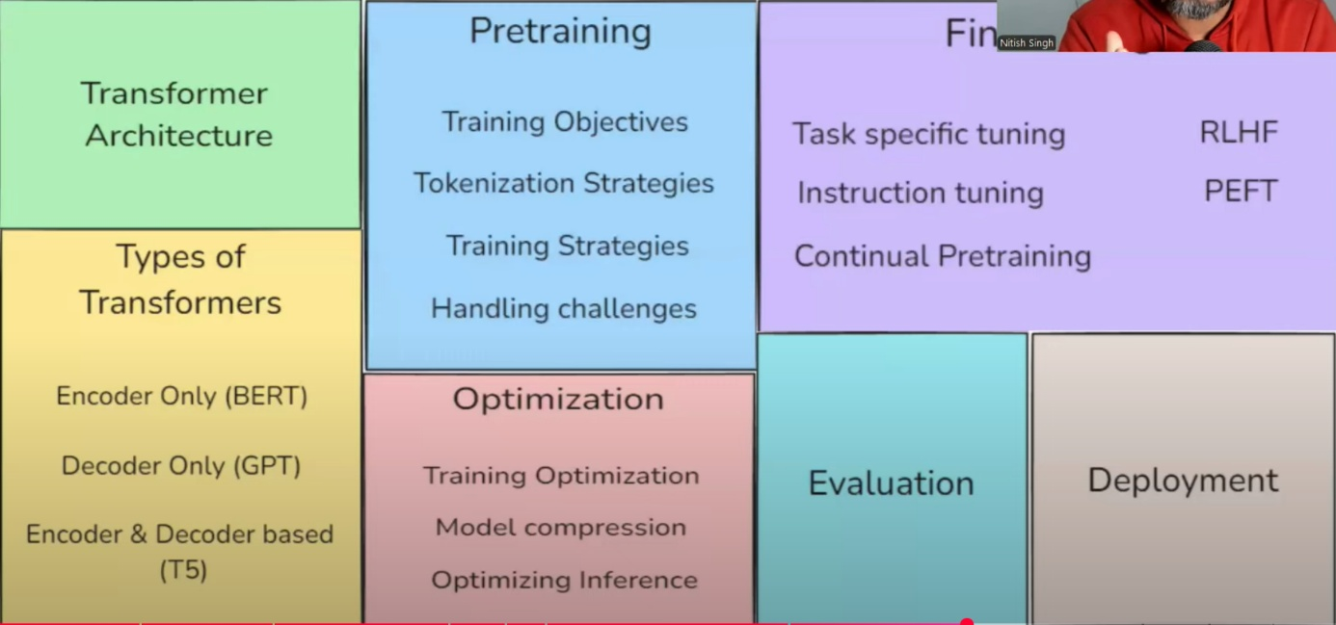

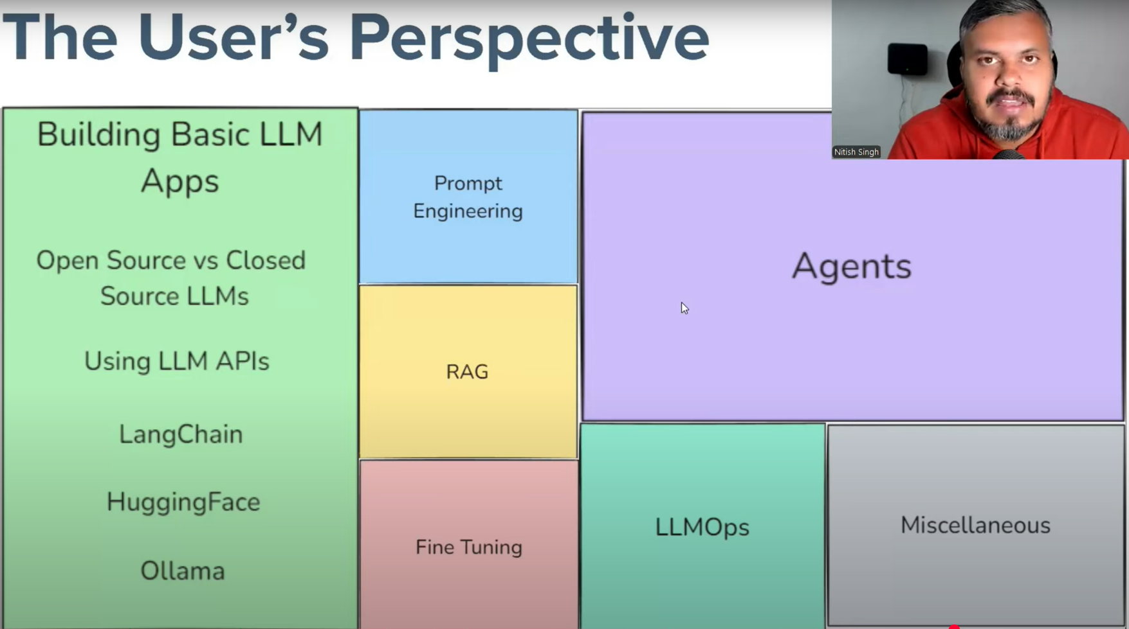

Embedding -> convert information into vectors (set of form)

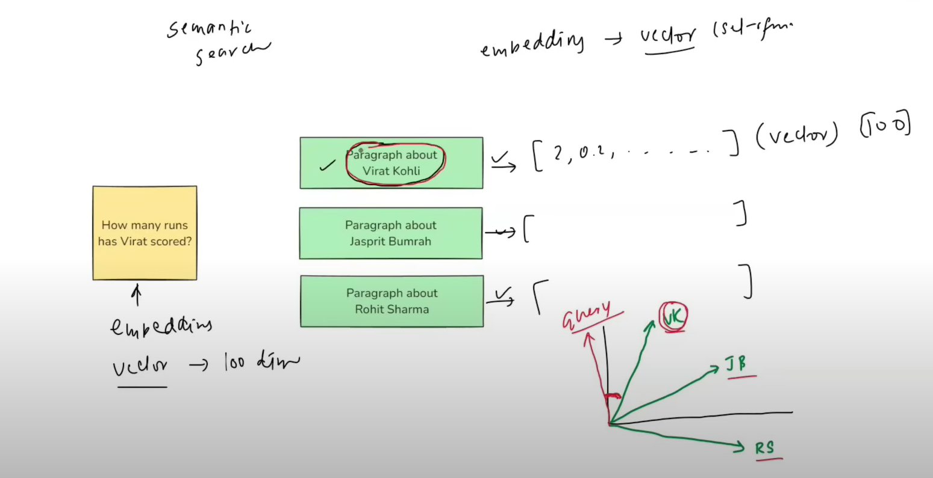

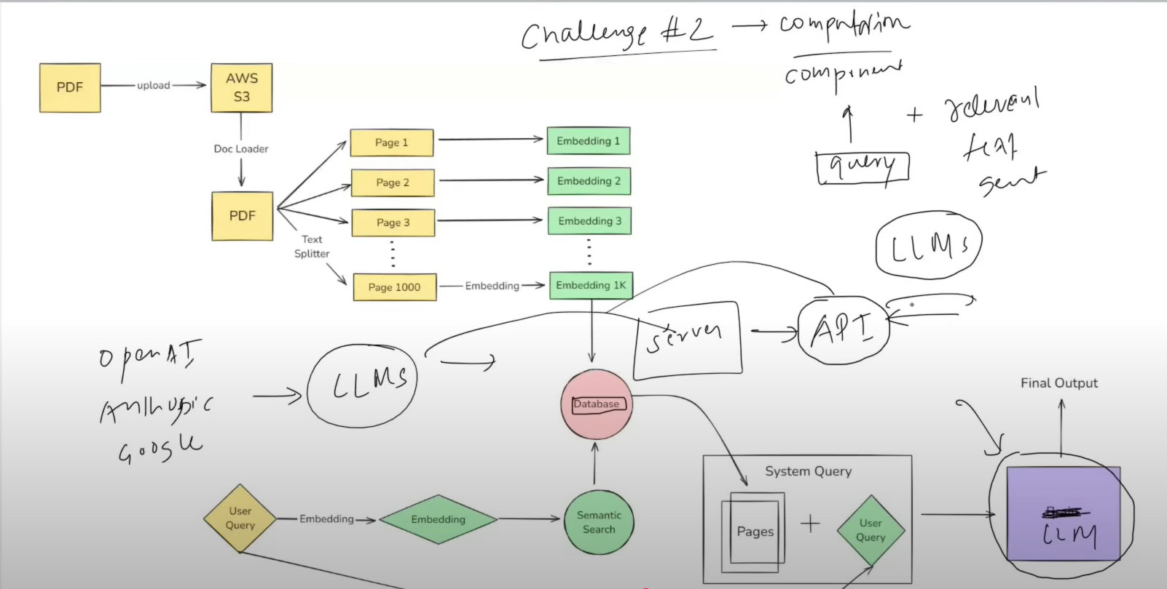

What did Langchain offered us

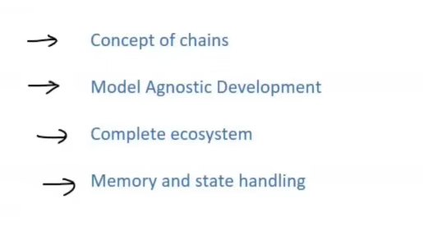

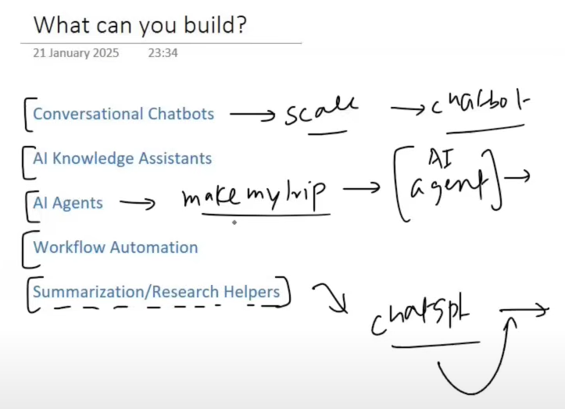

Alternatives of Langchain

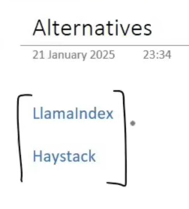

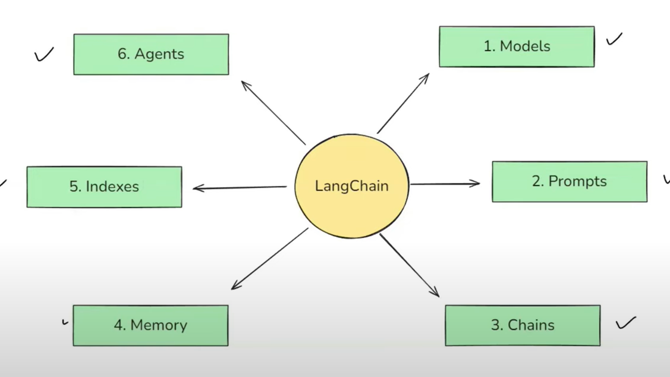

**Models:**

Langchain find a solution 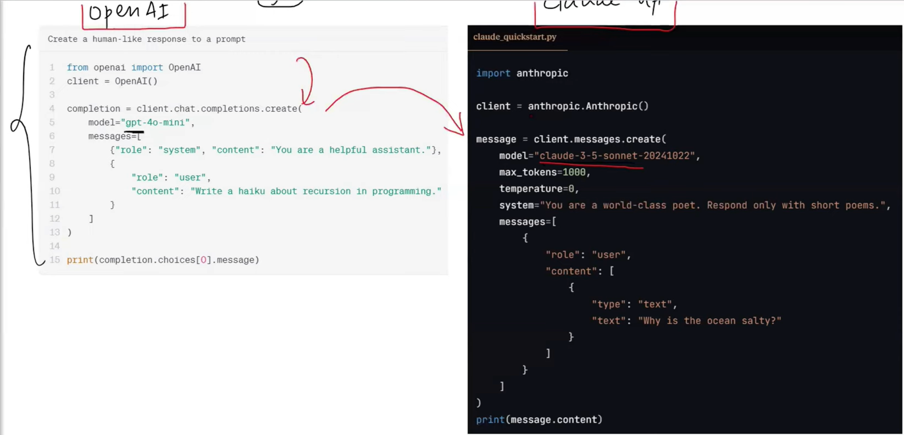

Model component in langcahin is an interface to communication with any other AI model

Langchain way to interect with many AI model

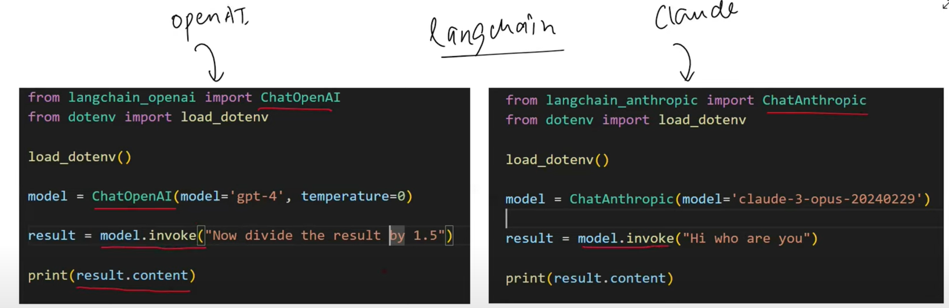

**Types of models are accessible:**

* Language model (LLMs)
  + Text 2 Text
* Embedding model
  + Text 2 vector -> semantic search

<https://python.langchain.com/docs/integrations/providers/>

**Prompts**:

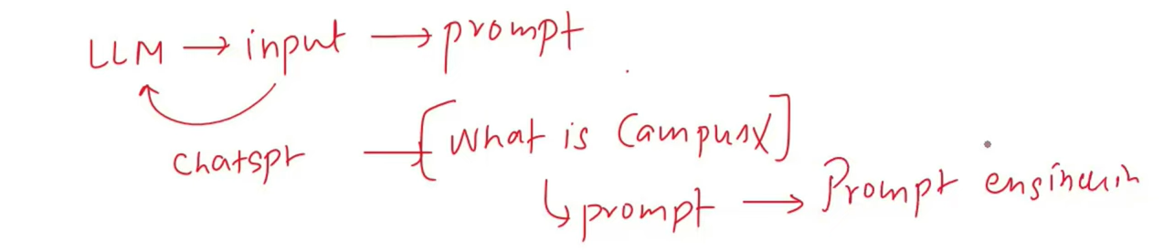

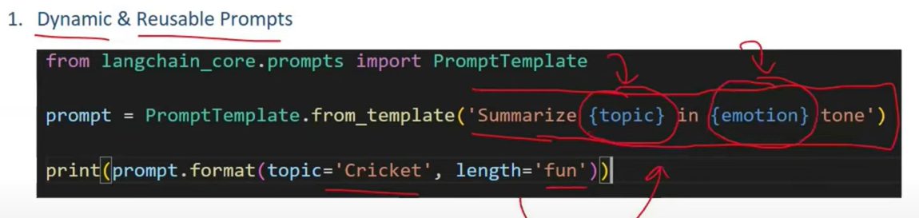

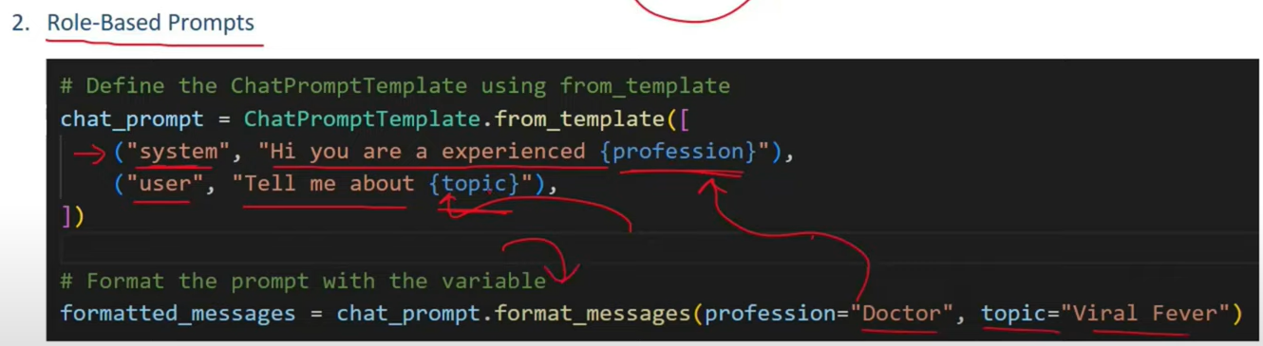

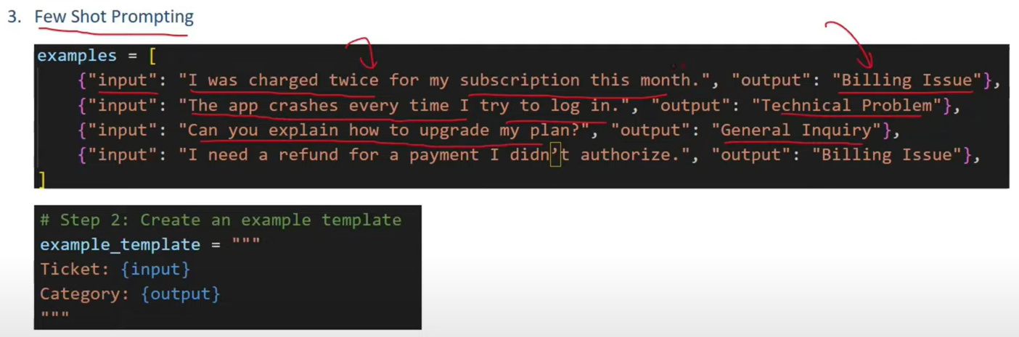

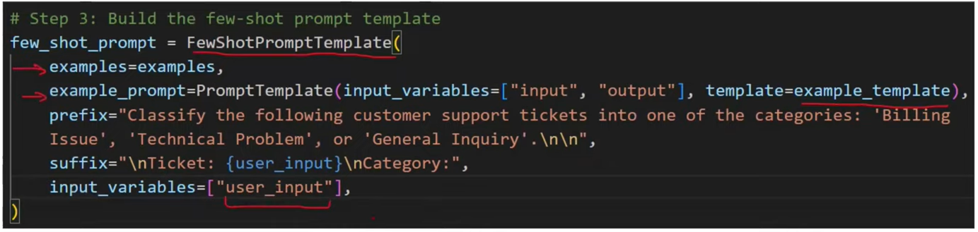

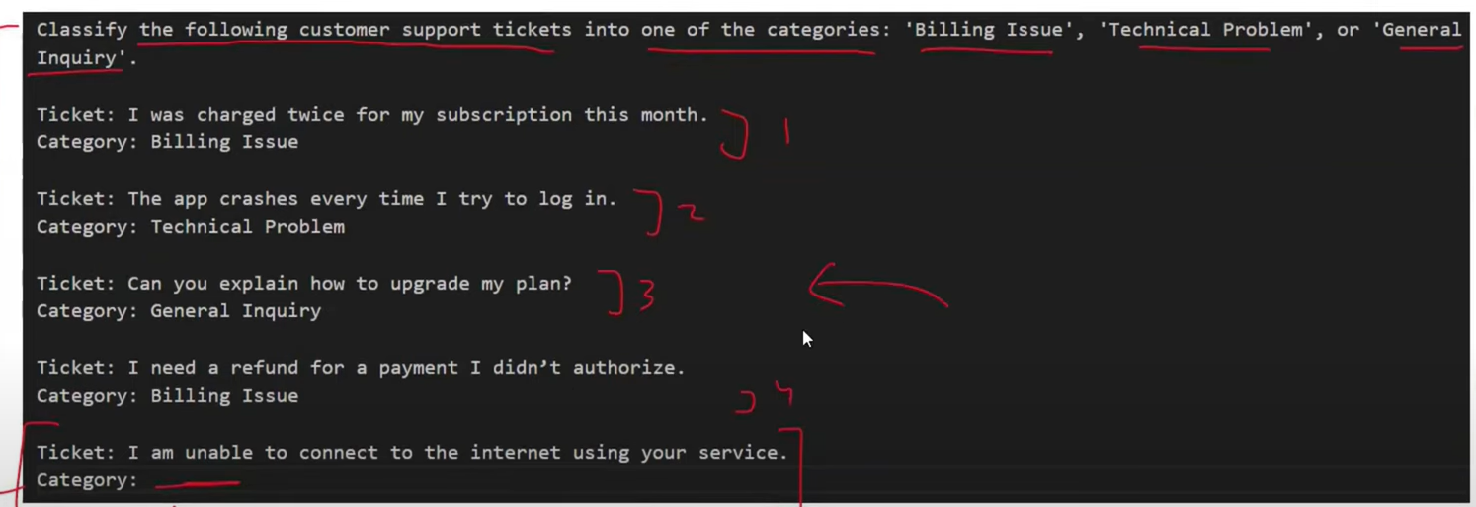

**Chain:**

Pipeline concept

Automatically output of current stage becomes input of next stage, no manual assigning.

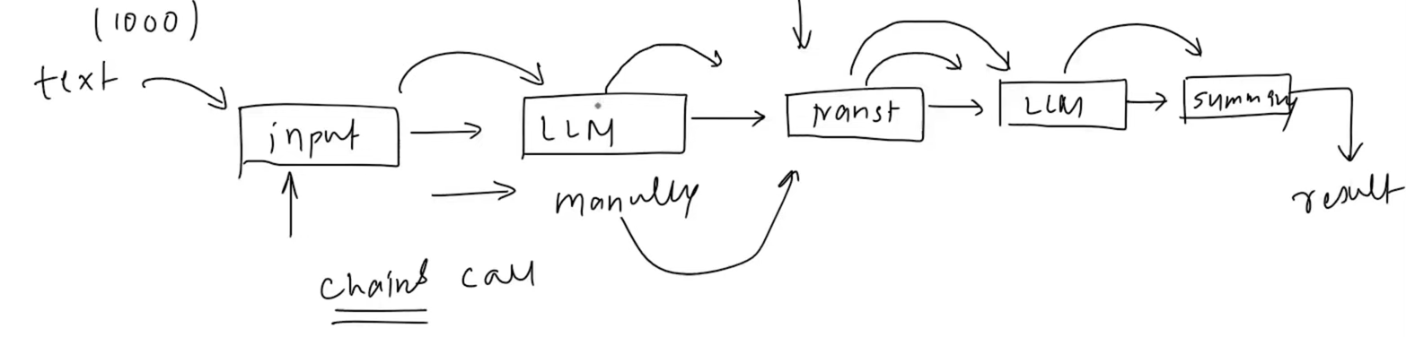

Complex Pipeline:

* Parallel chain
* 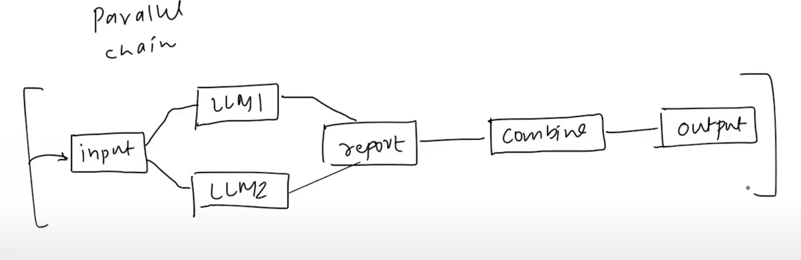
* Conditional chain
* 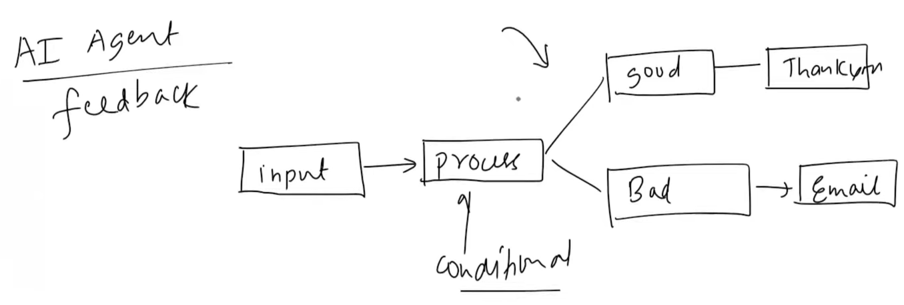

**Indexes:**

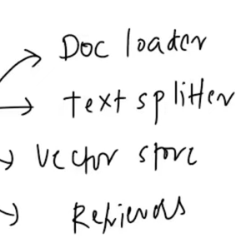Indexes connect your application to external knowledge-such as PDFs, websites, or databases.

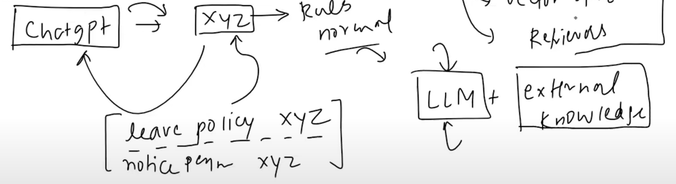

**Memory:**

(Practical topic)

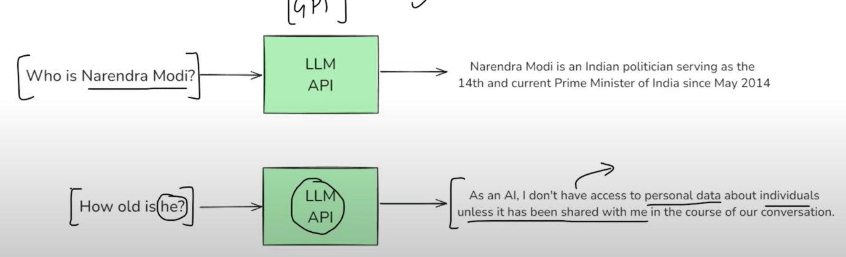

* Conversation Buffer Memory: Stores a transcript of recent messages. Great for short chats but can grow large quickly (costly when large transcript)
* Conversation Buffer Window Memory: Only keeps the last N interactions to avoid excessive token usage.
* Summarizer-Based Memory: Periodically summarizes older chat segments to keep a condensed memory footprint.
* Custom Memory: For advanced use cases, you can store specialized state (e.g., the user's preferences or key facts about them) in a custom memory class.

**Agents:**

AI agent is an advanced version of Chatbot because the agent has reasoning capability and access of tools.

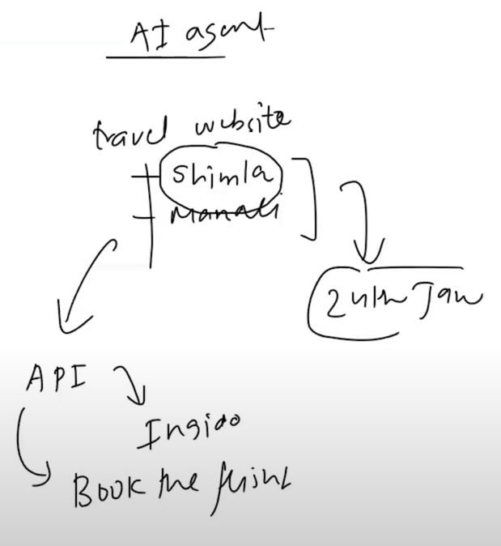

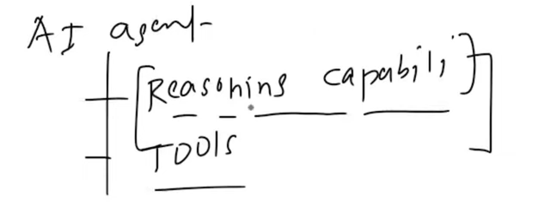

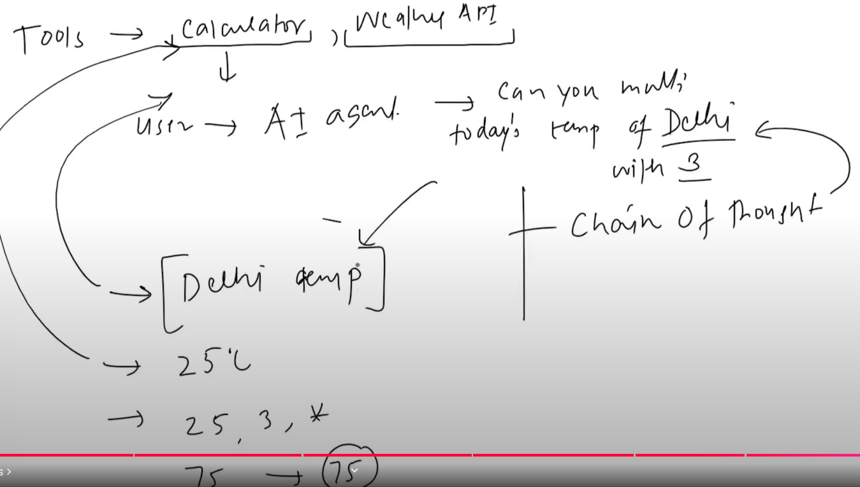

**Video #3:**

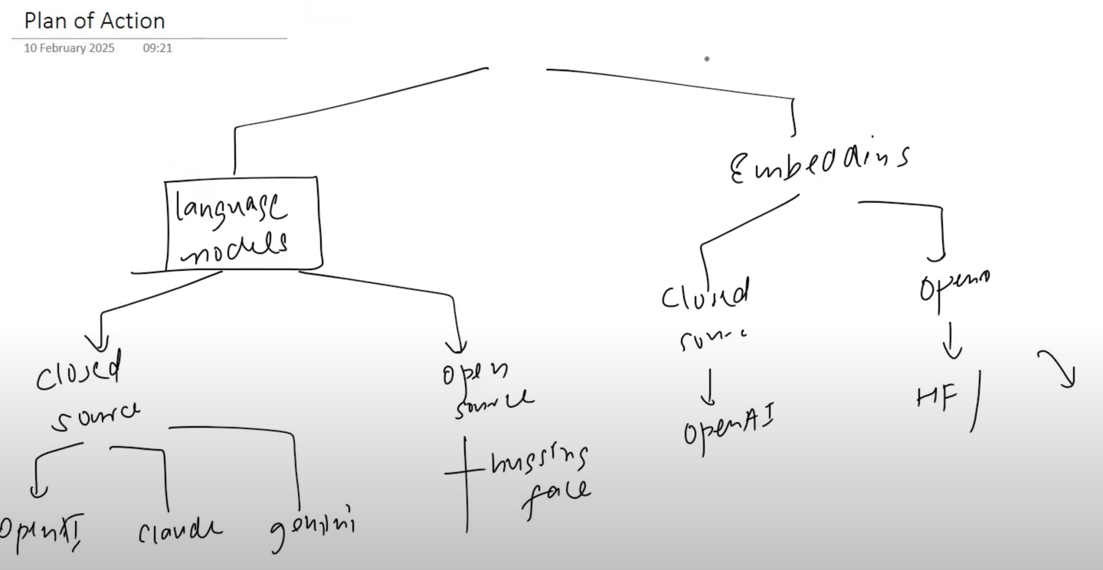

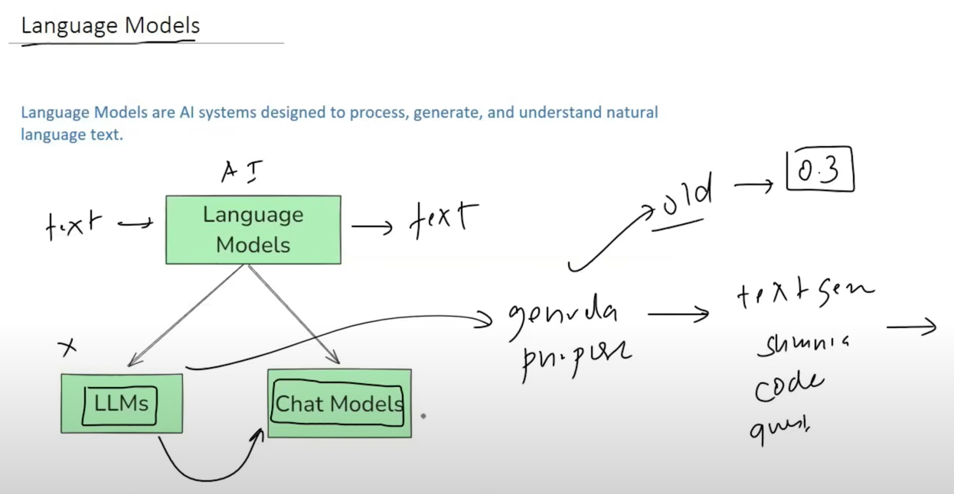

* LLMs - General-purpose models that is used for raw text generation. They take a string (or plain text) as input and returns a string (plain text). These are traditionally older models and are not used much now.
* Chat Models - Language models that are specialized for conversational tasks. They take a sequence of messages as inputs and return chat messages as outputs (as opposed to using plain text). These are traditionally newer models and used more in comparison to the LLMs.

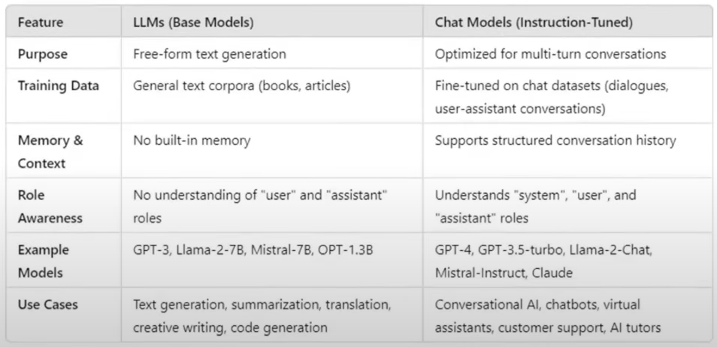

**Open-Source Models:**

Open-source language models are freely available Al models that can be downloaded,

modified, fine-tuned, and deployed without restrictions from a central provider. Unlike closed-

source models such as OpenAl's GPT-4, Anthropic's Claude, or Google's Gemini, open-source

models allow full control and customization.

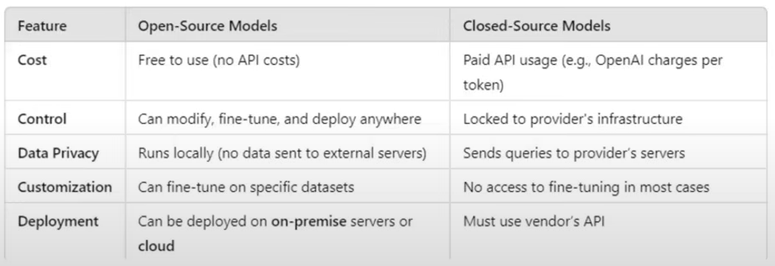

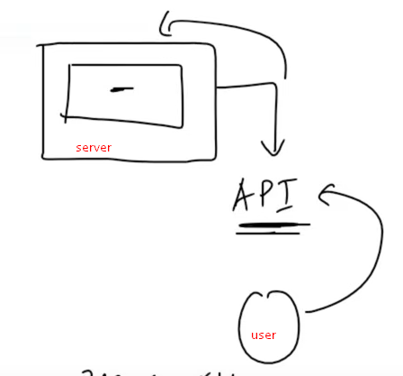

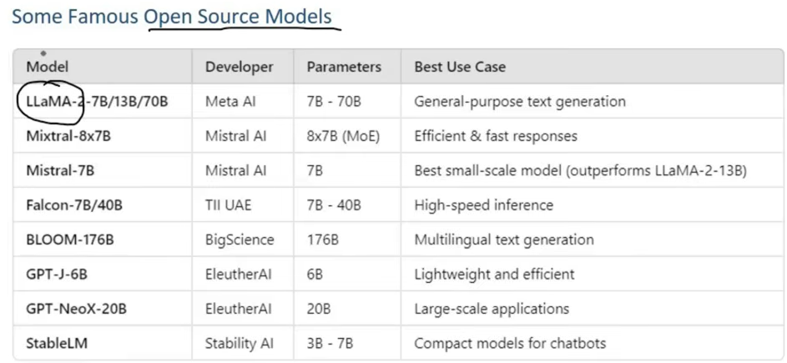

Where to find them?

HuggingFace:- <https://huggingface.co/models>

Ways to use **Open-Source Models:**

* Using HF inference API
* Run Locally

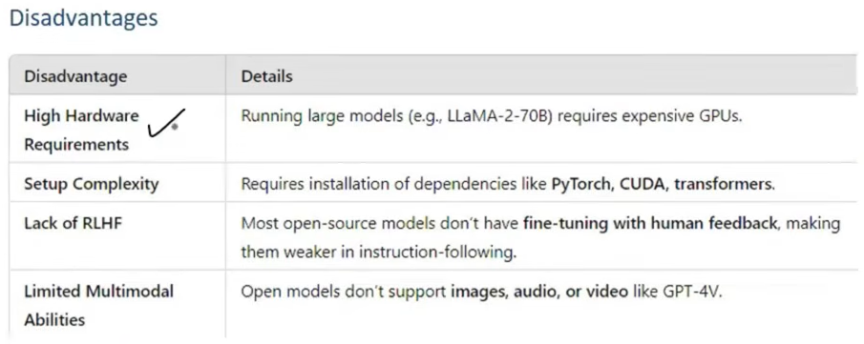

**Embedding Models**

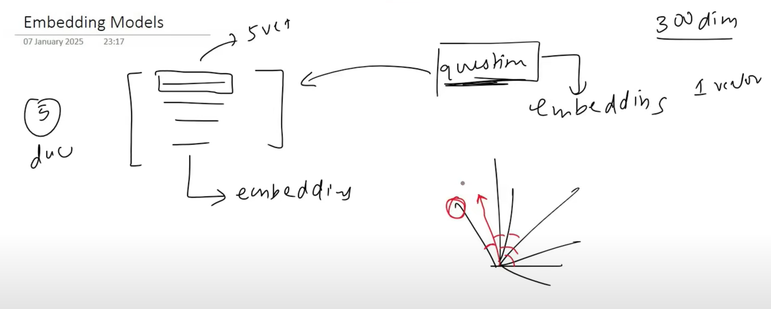

**Video #4**

What are Prompts

Prompts are the input instructions or queries given to a model to guide is output

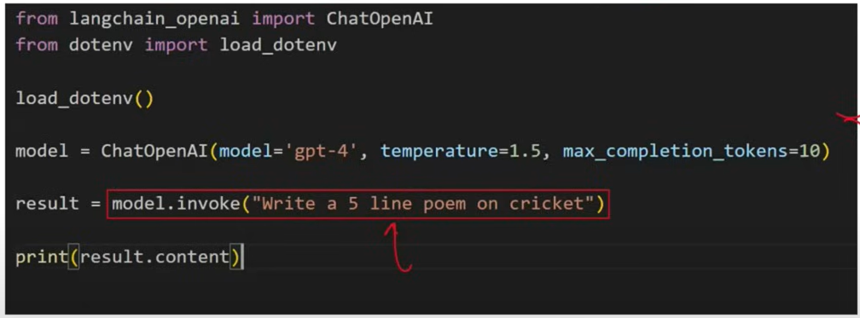

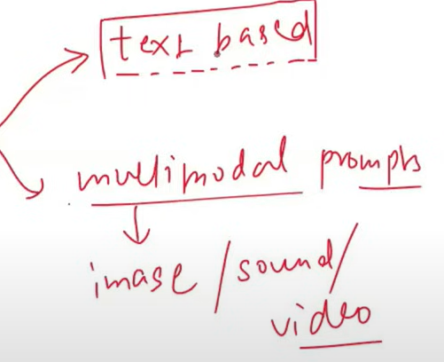

Propmts modes

Flow of prompt to output

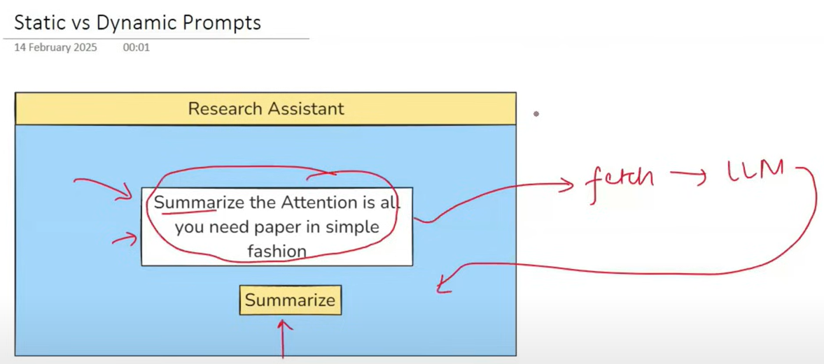

In static prompt:

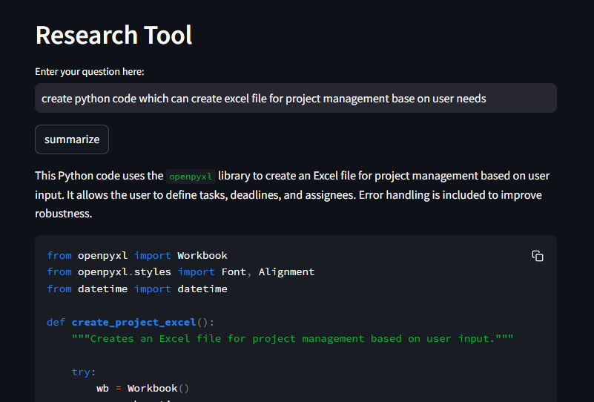

In static prompt, the user will enter the prompt but the chance of error is high.

to overcome this, we can create a dynamic prompt where the user can enter the question and the model will generate the answer.

For example,

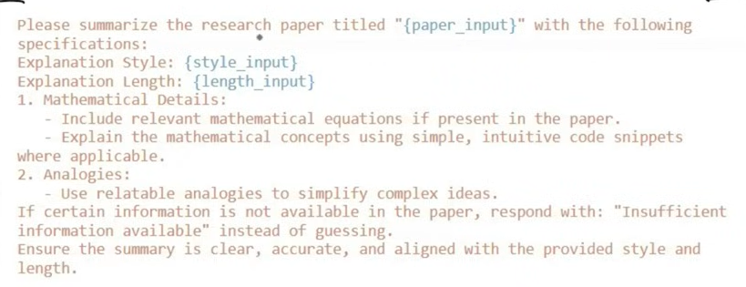

Here we will provide 3 dropdowns to user, so no spelling mistake.

One dropdown paper input, second for style input and third for length input

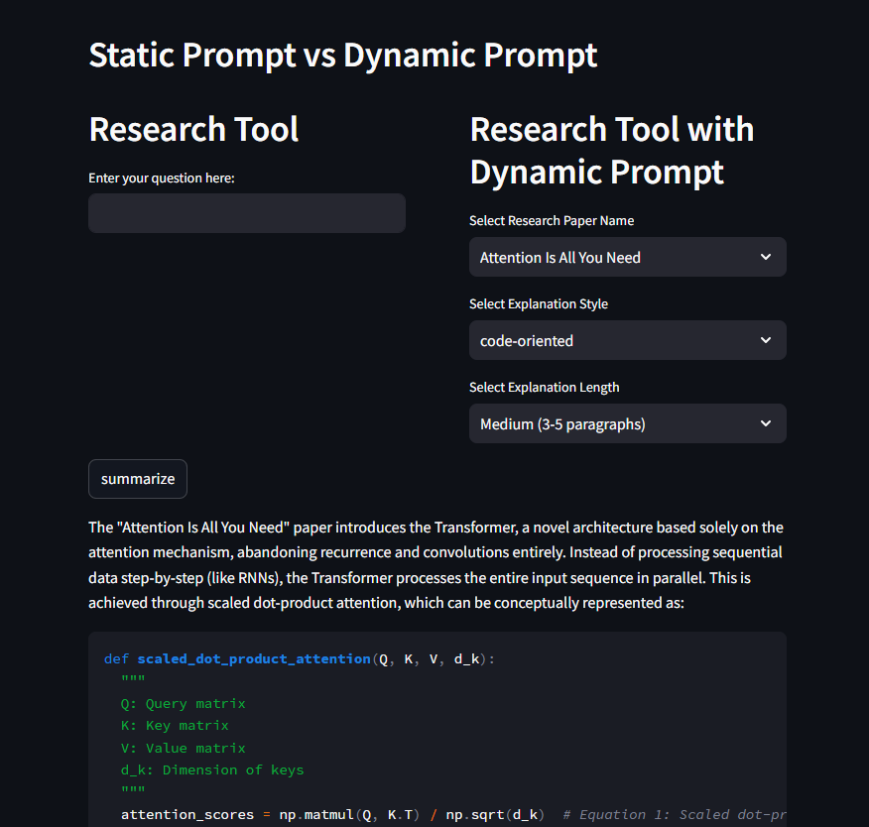

**Prompt template:**

A PromptTemplate in LangChain is a structured way to create prompts dynamically by

inserting variables into a predefined template. Instead of hardcoding prompts,

PromptTemplate allows you to define placeholders that can be filled in at runtime with

different inputs.

This makes it reusable, flexible, and easy to manage, especially when working with dynamic

user inputs or automated workflows.

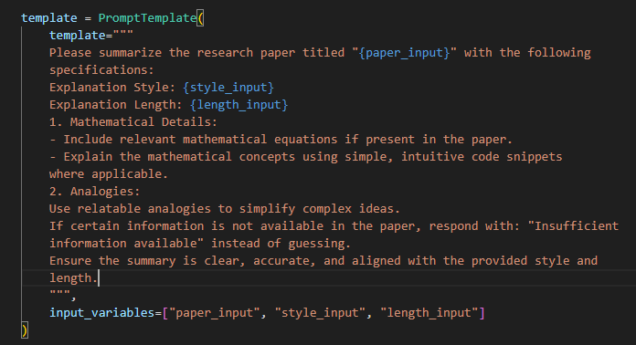

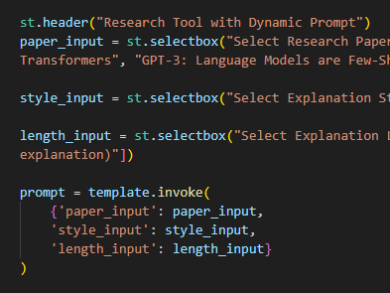

Template vs f string:

* Template provide build in validation, setting validation_template = True in template parameter
* F string does the same job but not provide any validation features (user must do by own).
* Template allows user to save it into .json if the template is too large.

Why use PromptTemplate over f strings?

1. Default validation
2. Reusable
3. LangChain Ecosystem

To save template use ->

template.save(template.json)

to load template use ->

from langchain_core.prompts import load_prompt

template = load_prompt(‘template.json’)

To simplify double invoke logic into single invoke

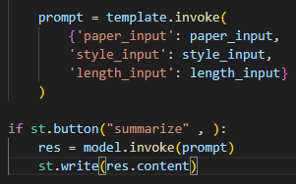

To

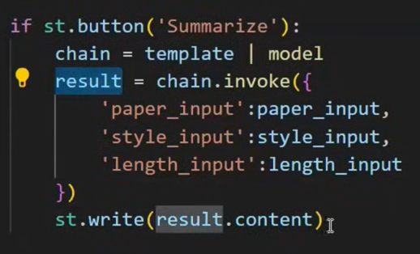

By using chain concept.

# simple chatbot project (console)

You…..

Bot….

You…..

Bot….

You…..

Bot….

What to do to make your chat bot better:

* Use chat history (use simple list and append function)
* Use chat history with message owner name (use langchain or create by custom)

Types of messages in Langchain:

* System
* Human/user
* AI/bot

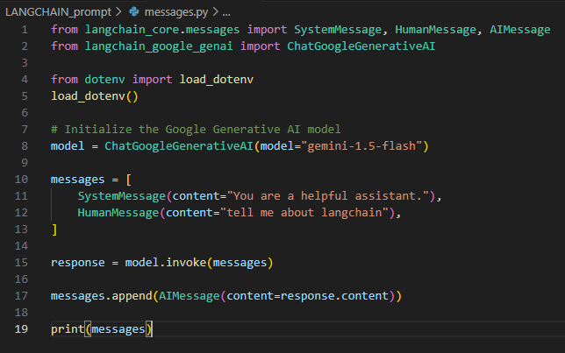

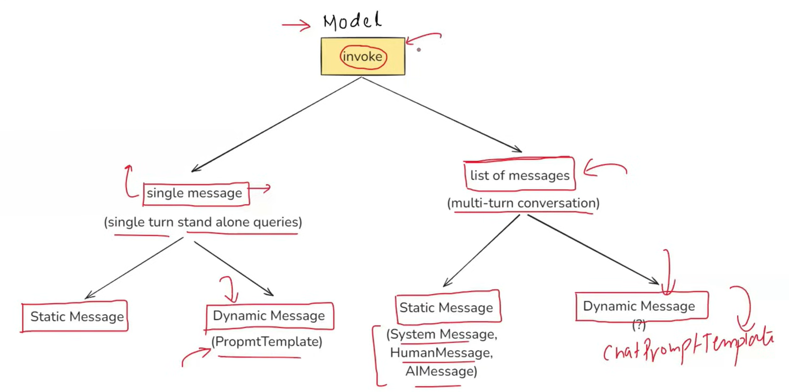

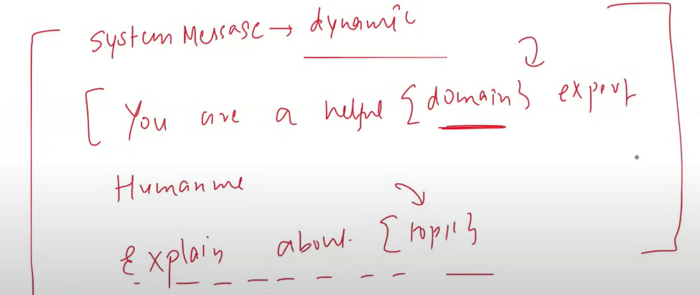

**What is message placeholder:**

A MessagesPlaceholder in LangChain is a special placeholder used inside a

ChatPromptTemplate to dynamically insert chat history or a list of messages at runtime.

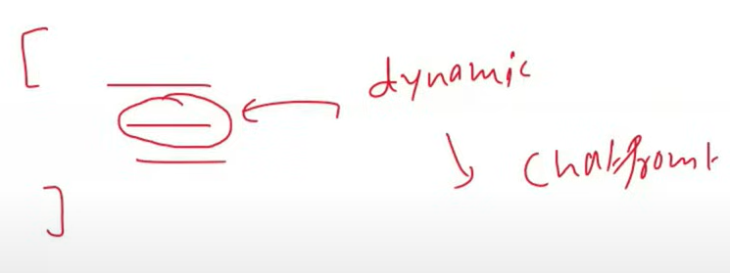

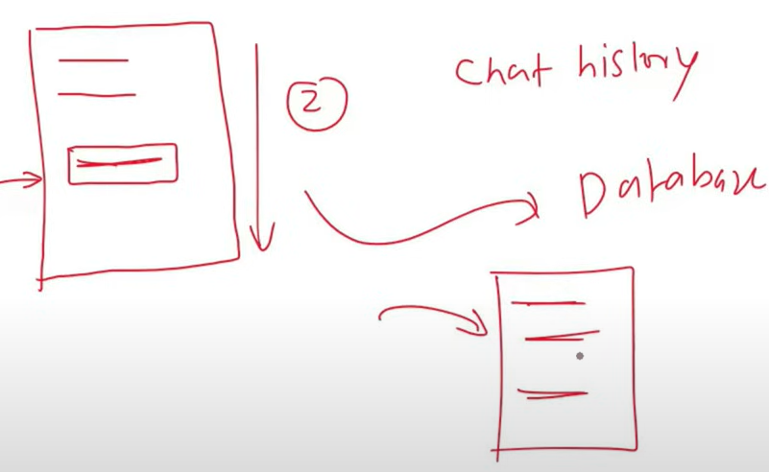

**Video #5**

**Structured output:**

In LangChain, structured output refers to the practice of having language models return

responses in a well-defined data format (for example, JSON), rather than free-form text. This

makes the model output easier to parse and work with programmatically.

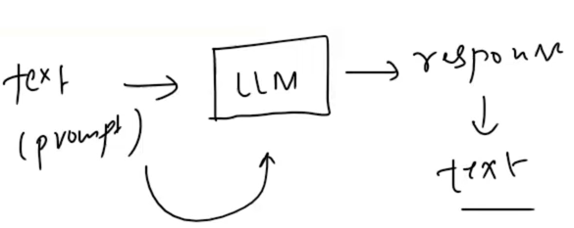

Unstructured data (Like text)

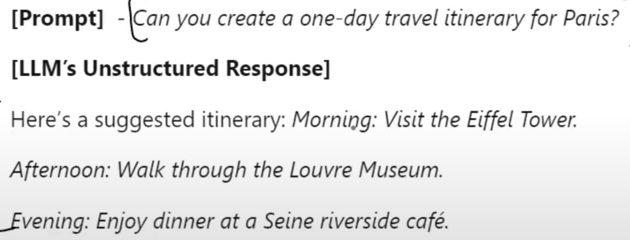

We cannot send queries to database API with unstructured data

Structured data (like json)

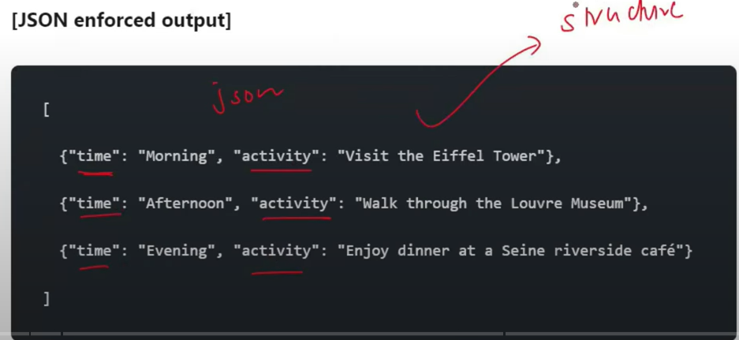

Why do we need structured output:

* Data extraction
* API building
* Agents

Eg data extraction:

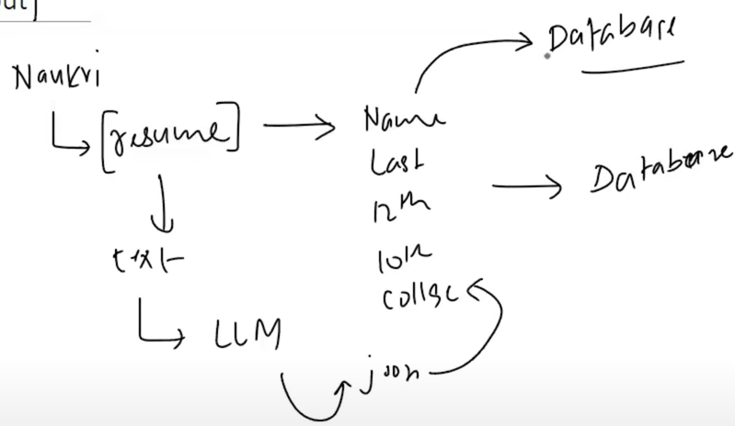

Eg API building:

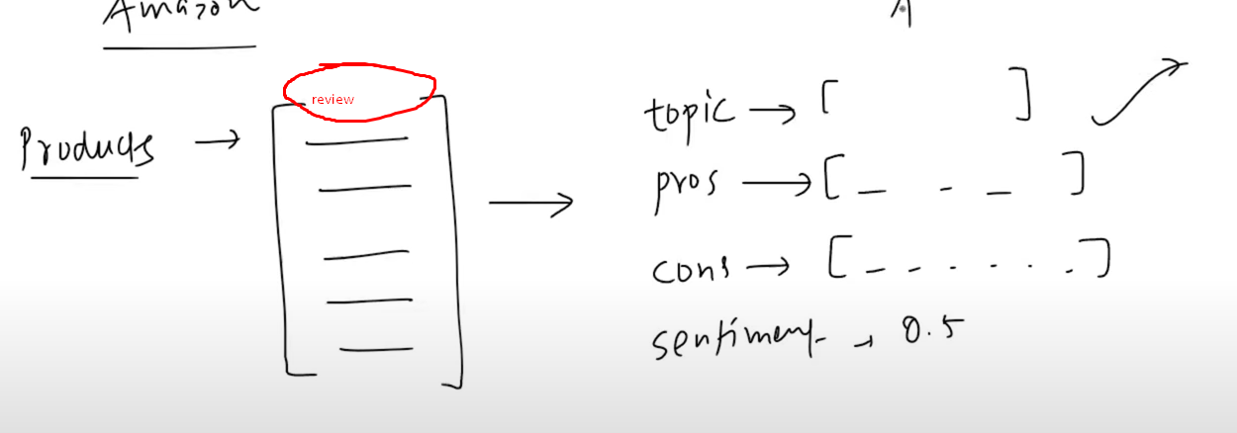

Eg agents:

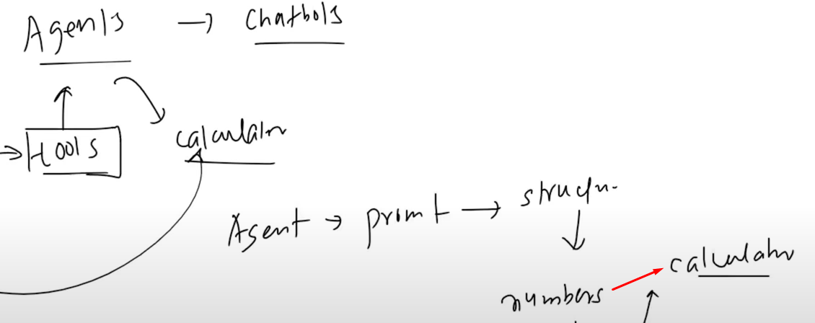

**Ways to get structured output:**

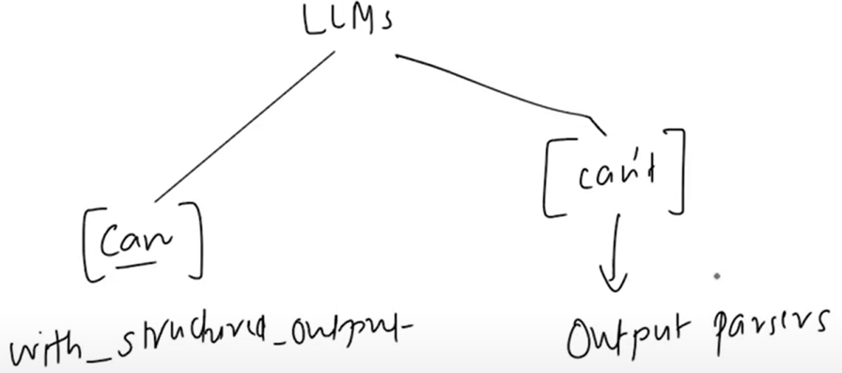

**Let us talk about with structured output:**

Flow -> before model invoke user must define a data format to get structured output.

3 ways to do this:

* Typed dict
* Pydantic
* Json schema

What is TypedDict:

* TypedDict is a way to define a dictionary in Python where you specify what keys and values should exist. It helps ensure that your dictionary follows a specific structure.

Why use TypedDict?

* It tells Python what keys are required and what types of values they should have.
* It does not validate data at runtime (it just helps with type hints for better response).

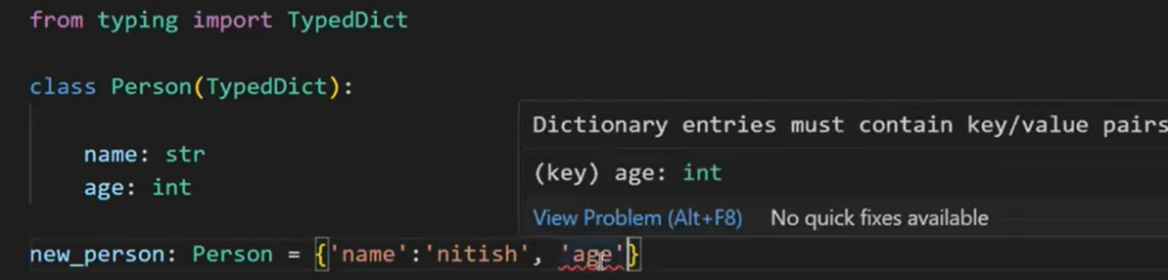

Define the format of dict that we want:

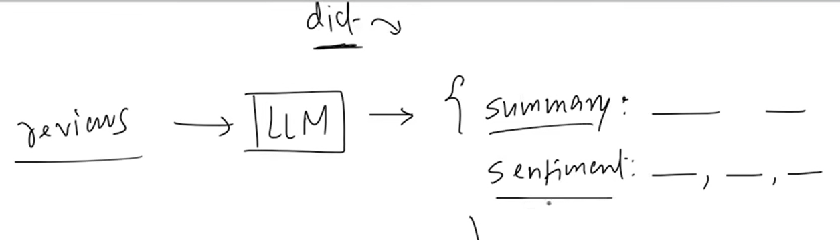

How all this works:

* Behind the sense a prompt is generated telling the model to return its response in the way the structured is provided.

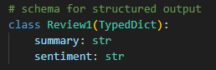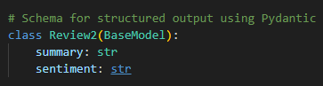

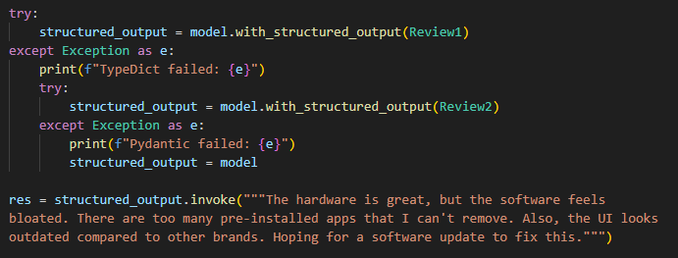

I directly used pydantic because TypeDict causing me ValuError.  
To import pydantic use -> from pydantic import BaseModel

Sometime what happen is model may not well trained, in this case we provide extra instructions by annotation.

**Pydantic:**

* Pydantic is a data validation and data parsing library for Python. It ensures that the data you work with is correct, structured, and type-safe.
* More powerful from typedict

Types of parameter in pydantic:

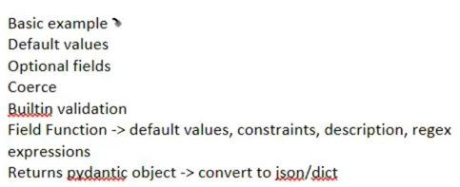

from typing import TypedDict, Annotated

from pydantic import BaseModel

# Schema for structured output using Pydantic

class Review3(BaseModel):

    summary: Annotated[str, "A brief summary of the review"]

    sentiment: Annotated[str, "Return sentiment of the review either neutral, positive or negative"]

for optional logic:

from typing import Literal, Optional, TypedDict, Annotated

TypeDict is old, instead use pydantic.

the Optional, Annotated and Literal are imported from typing

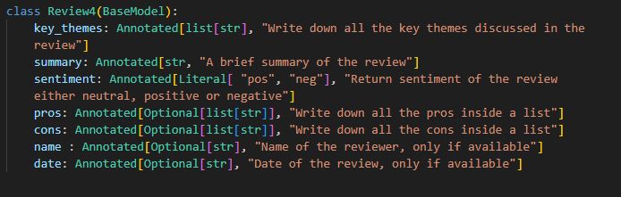

Let’s say this text there is no date of review is mention

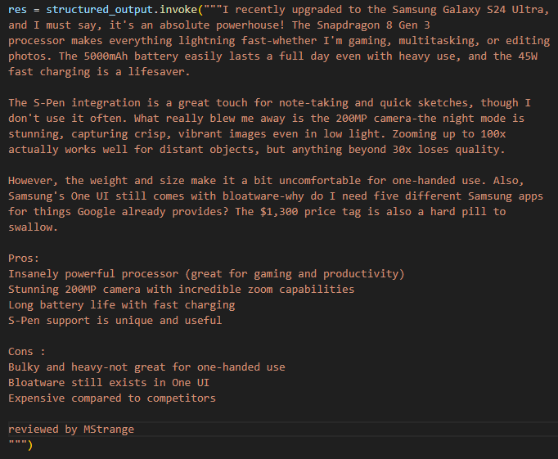

If you want to convert the pydantic object in dict or json.

For proper output I use

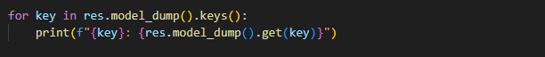

So we are getting that no date provided or null sometime

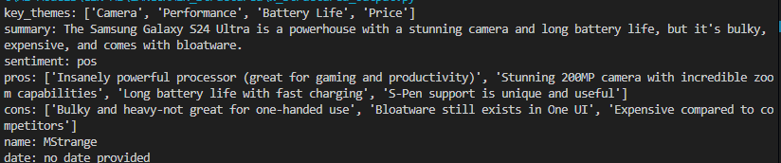

But after all this effort there is still chance that your LLM makes mistake and result in different format or can still return value when there is no value given to it.

As we are using pydantic, along with structure it offers data validation. If the key is told to be in integer then this structure will not allow string, it will raise error.

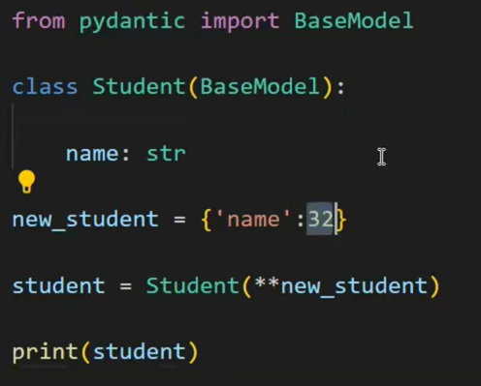

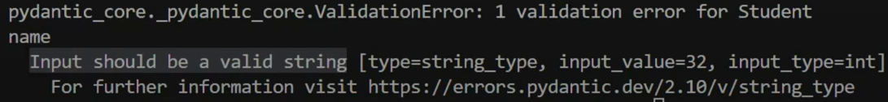

Using default value in structure:

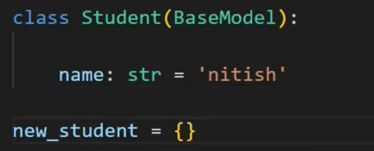

What is coerce parameter in pydantic:

* Pydantic is smart enough to detect value regardless of data type the value is in and convert it into declared data type.

Bonus tip:

* Pydantic can also verify email string (build-in)
* From Pydantic import EmailStr
* 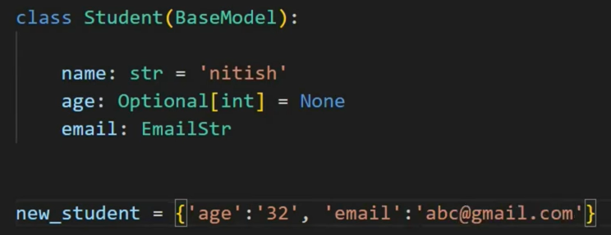

Field function parameter:

* From Pydantic import Field
* 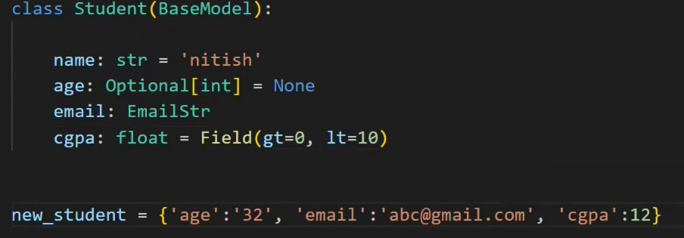
* It will raise an error, because cgpa must be from 0 to 10.
* Field (gt=0, lt=10, default=5, description = “description to add”)
* You can use regex too.

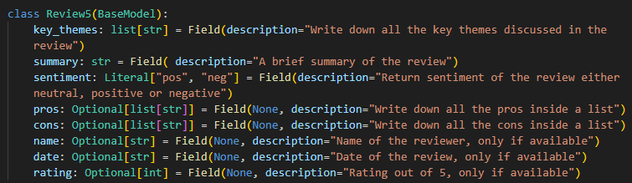

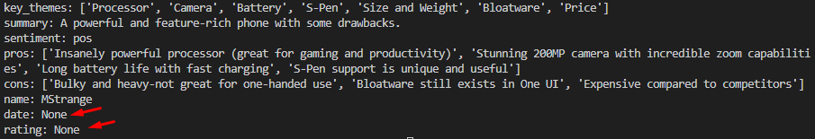

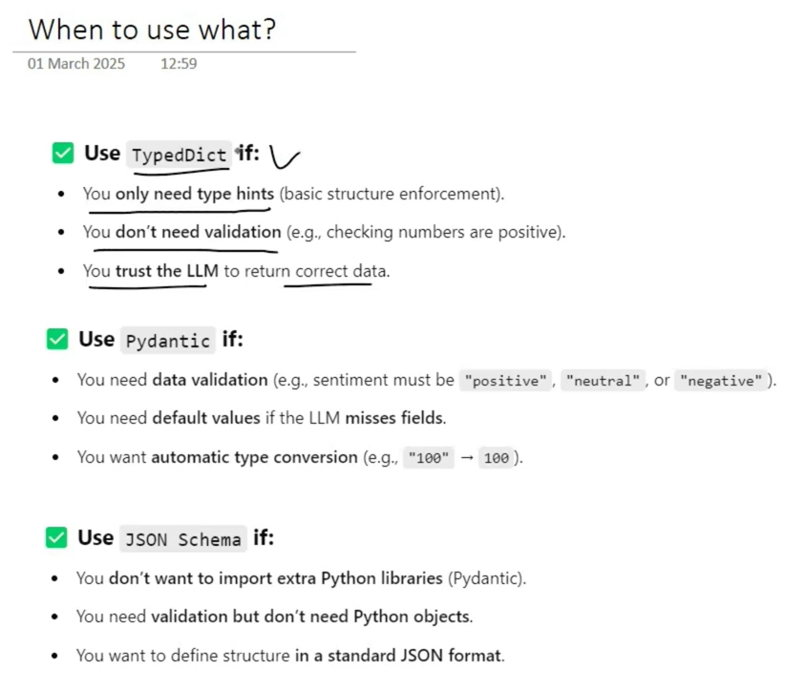



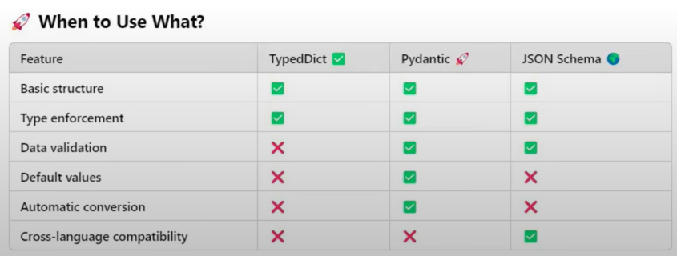

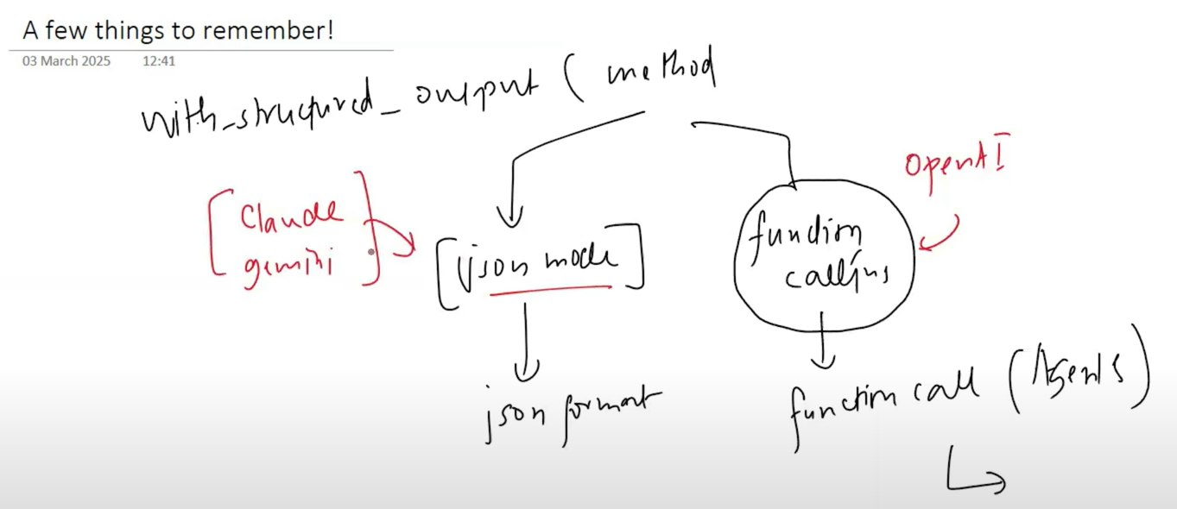

**Video #6**

**Output Parsers in LangChain**

**What is output Parsers:**

* Output Parsers in LangChain help convert raw LLM responses into structured formats like JSON, CSV, Pydantic models, and more. They ensure consistency, validation, and ease of use in applications.

LLms that can’t provide structured output, then parser comes in role.

Output parser works with both models which can and cannot provide structured output

Parser types:

* String output parser
* Json output parser
* Structured output parser
* Pydantic output parser
* There are more…

**StrOutputParser:**

The StrOutputParser is the simplest output parser in LangChain. It is used to parse the output of a Language Model (LLM) and return it as a plain string.

* from langchain_core.output_parsers import StrOutputParser

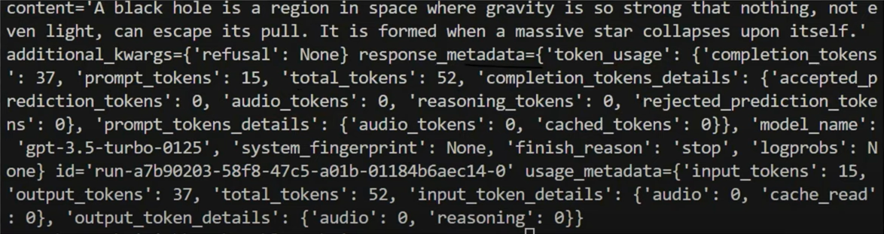

In previews code to print model response we were using response.content, as in response we also get the meta data of that query.

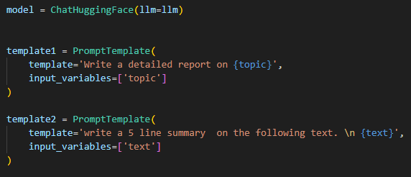

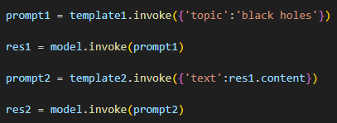

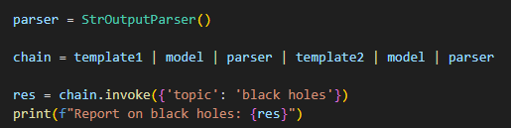

**JsonOutputParser:**

* from langchain_core.output_parsers import JsonOutputParser

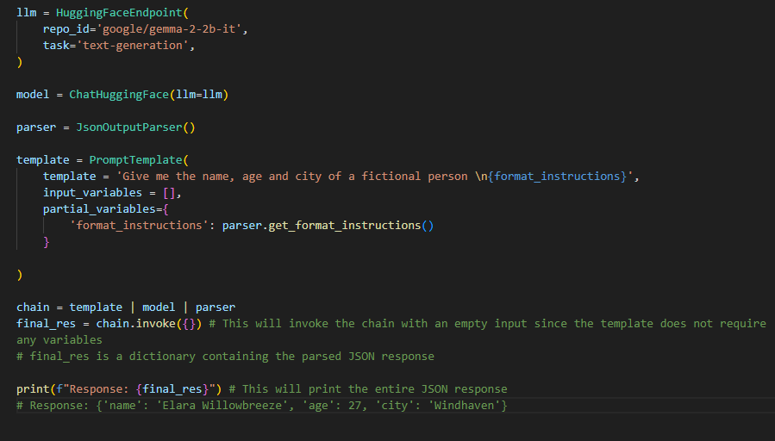

**StructuredOutputParser:**

* It is an output parser in LangChain that helps extract structured JSON data from LLM responses based on predefined field schemas.
* It works by defining a list of fields (ResponseSchema) that the model should return, ensuring the output follows a structured format.

from langchain.output_parsers import StructuredOutputParser, ResponseSchema

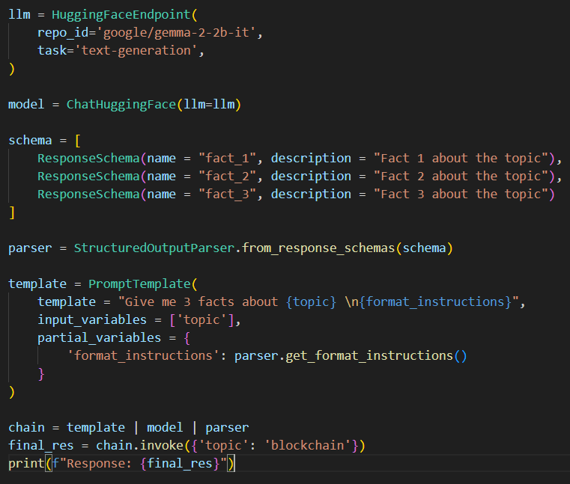

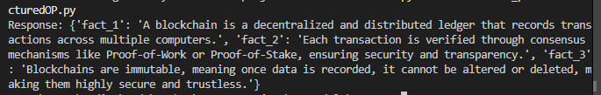

De-mirts:

* No data validation like pydantic

**PydanticOutputParser:**

What is PydanticOutputParser in LangChain?

* PydanticOutputParser is a structured output parser in LangChain that uses Pydantic models to enforce schema validation when processing LLM responses.

Why Use PydanticOutputParser ?

* Strict Schema Enforcement - Ensures that LLM responses follow a well-defined structure.
* Type Safety - Automatically converts LLM outputs into Python objects.
* Easy Validation - Uses Pydantic's built-in validation to catch incorrect or missing data.
* Seamless Integration - Works well with other LangChain components.

Conclusion for this 3 output parser:

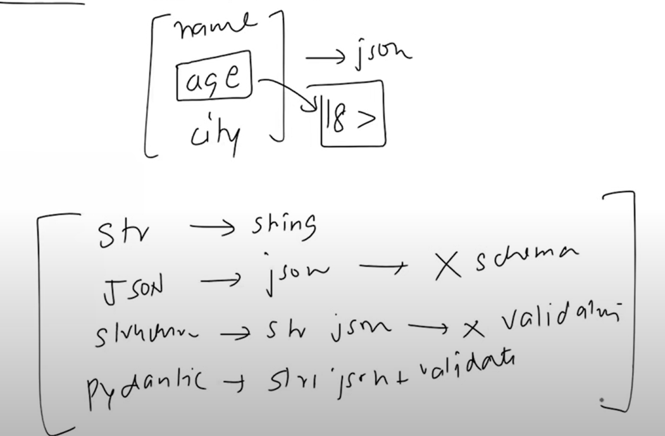

**Video #7**

**Chains in Langchain**

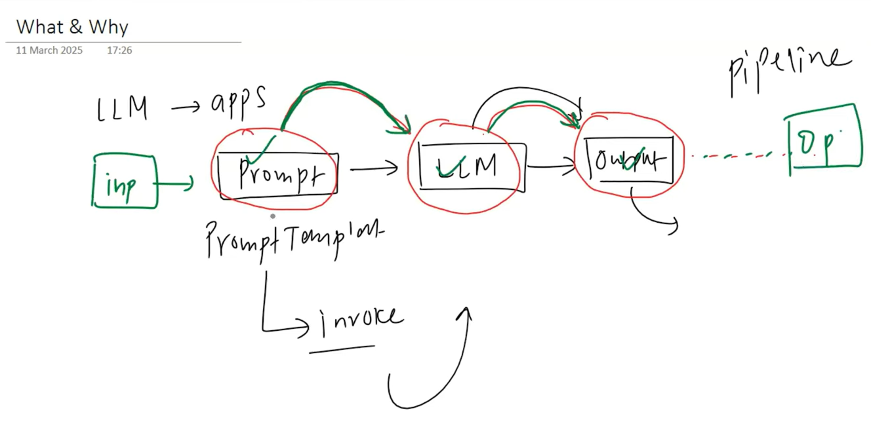

**Simple chain:**

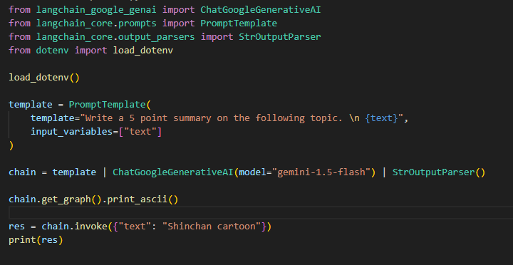

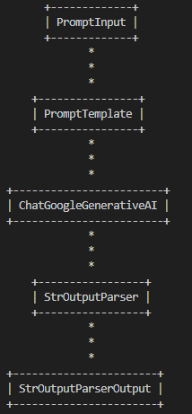To display chain use ->

chain.get_graph().print_ascii()

**Sequential chain:**

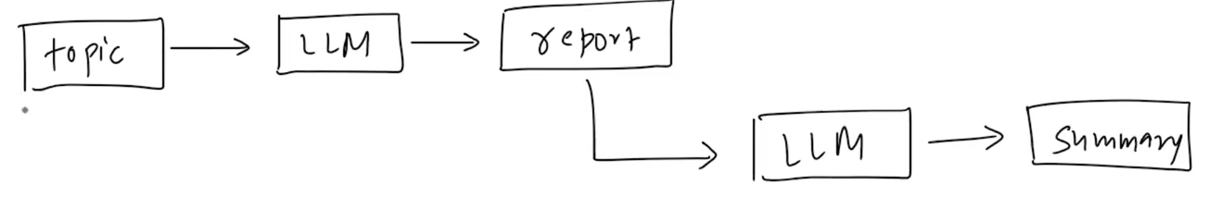

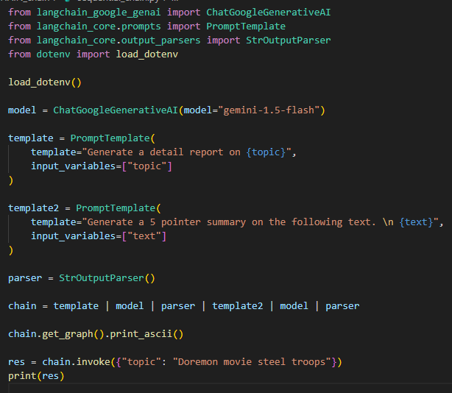

**Parallel chain:**

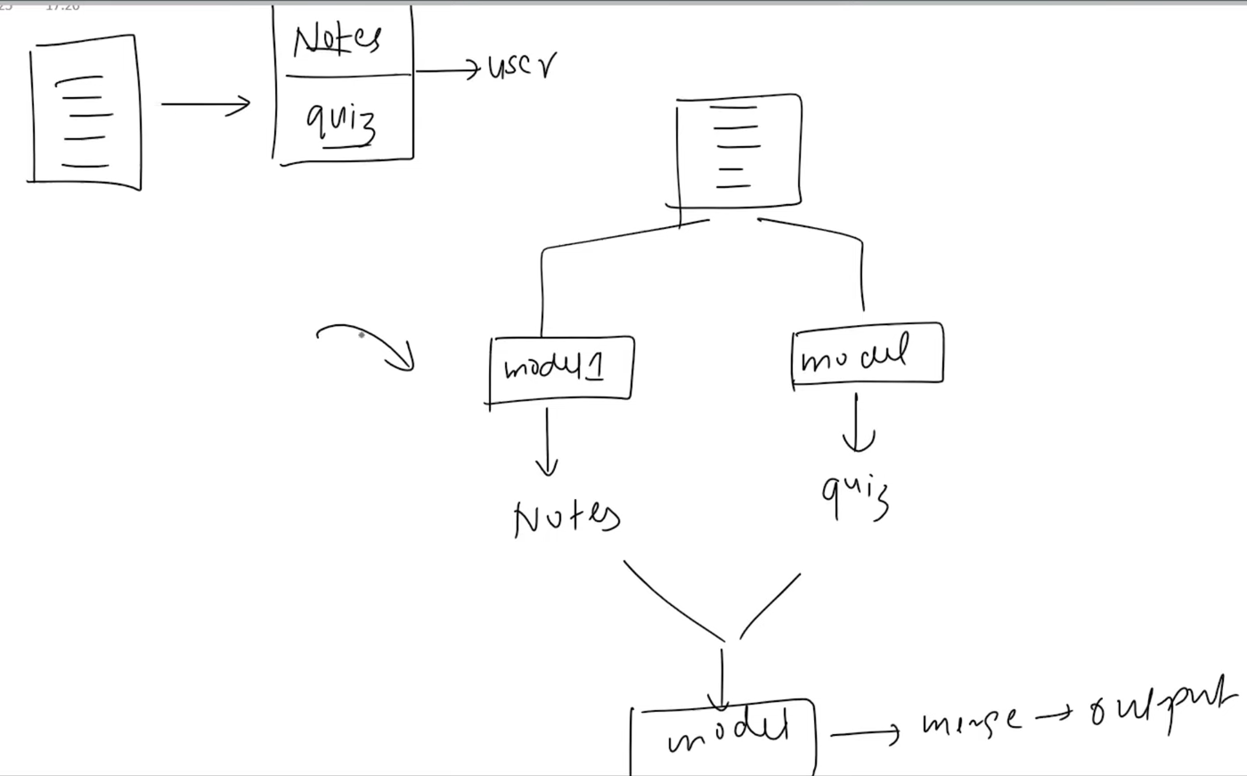

from langchain.schema.runnable import RunnableParallel # RunnableParallel is a class that allows you to run multiple chains in parallel.

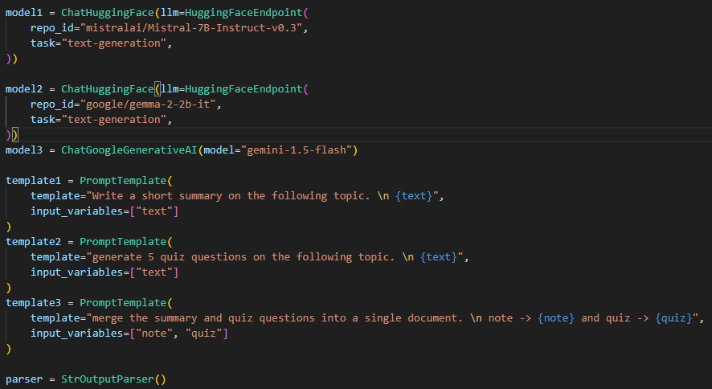

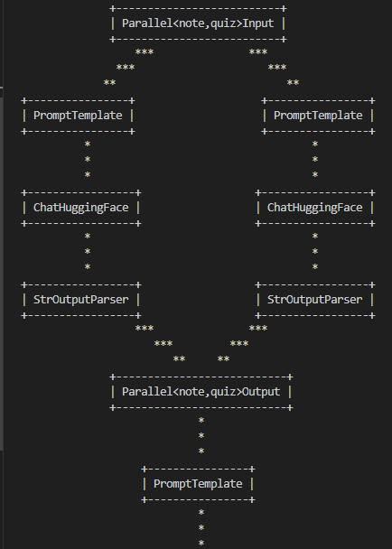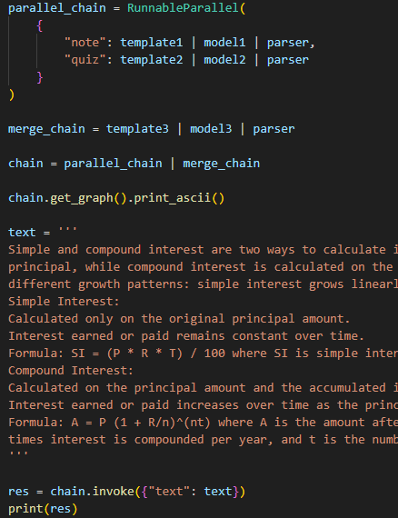

**Condition chain:**

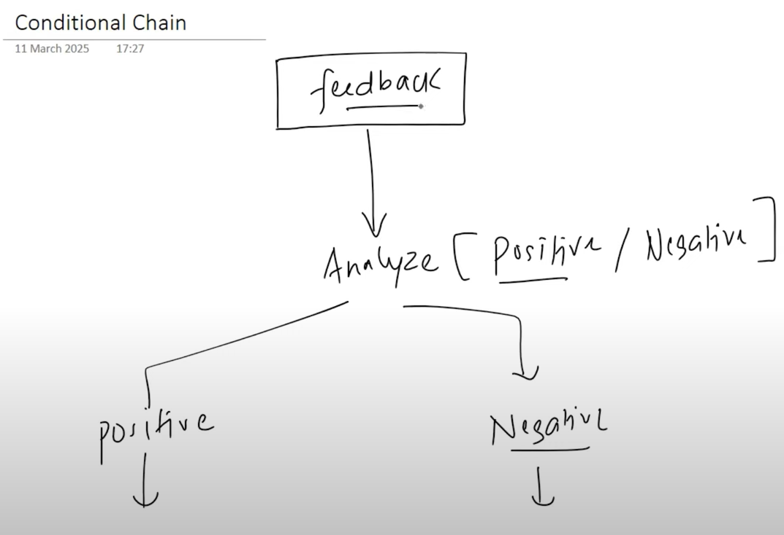

feedback

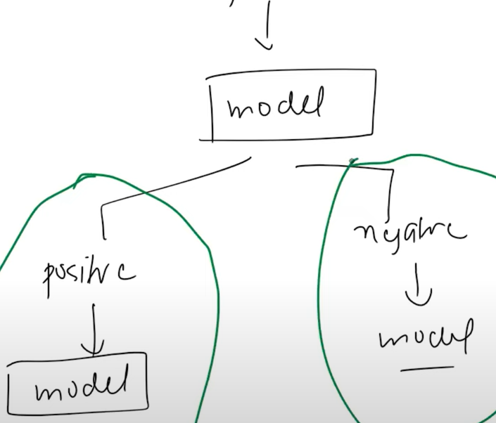

**Video #8**

Let’s understand how chain works internally through **Runnables.**

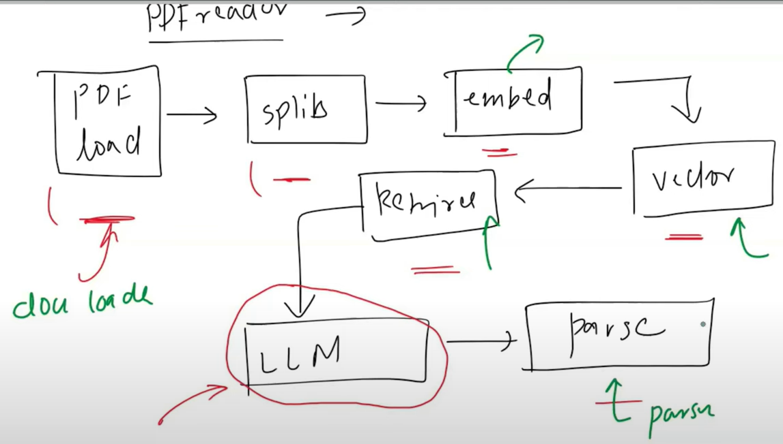

First lets check out a simple LLm app and we will perform a PDFreader app

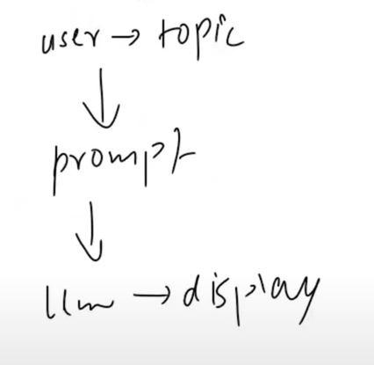

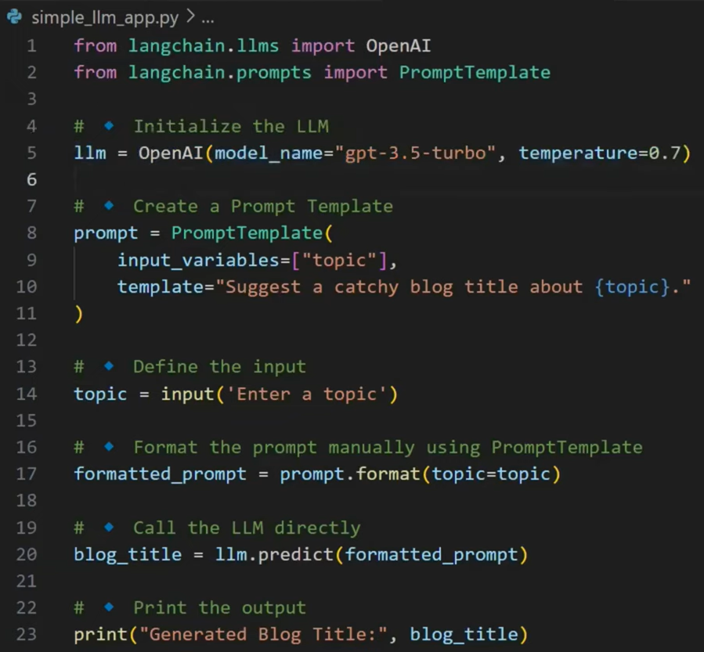

PDFreader app:

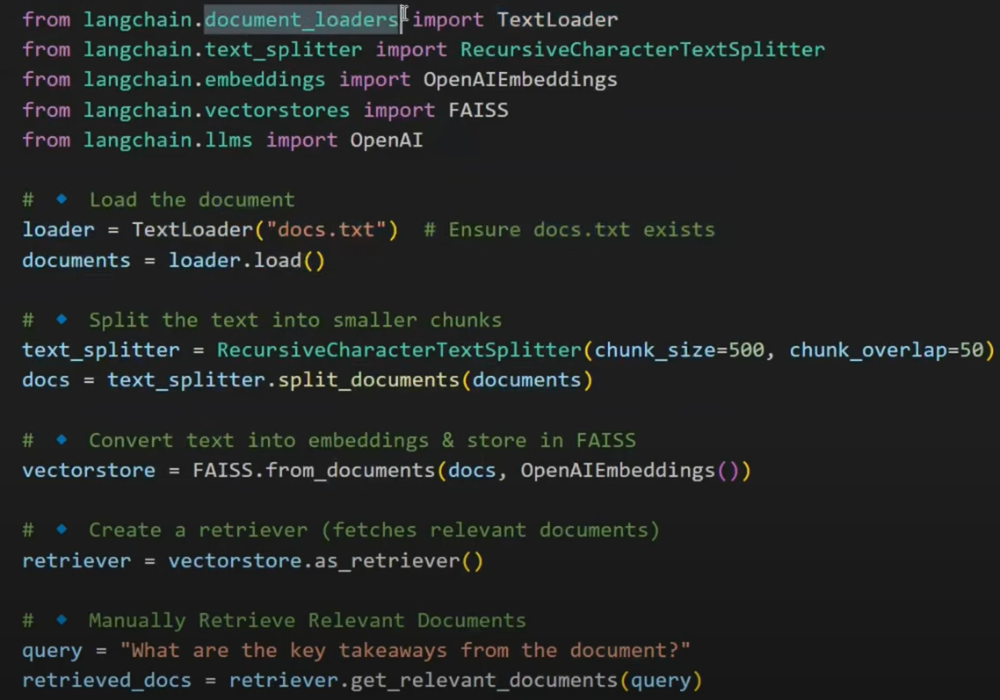

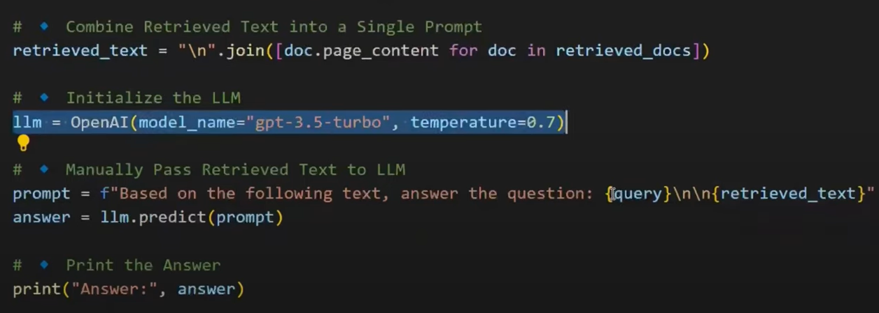

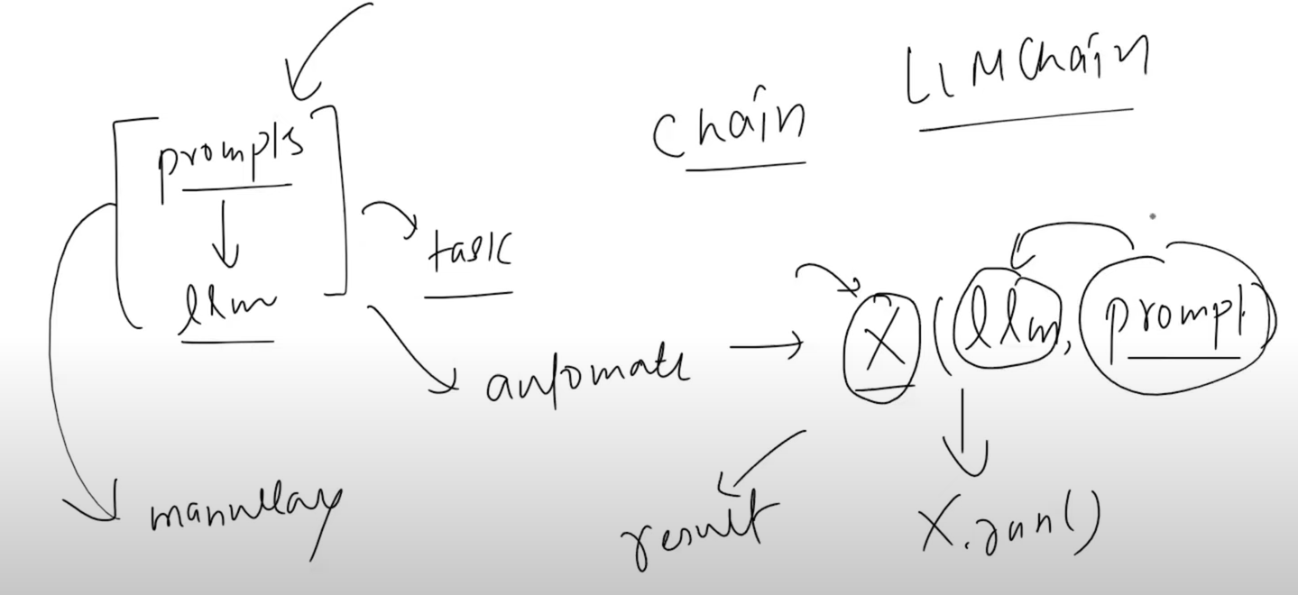

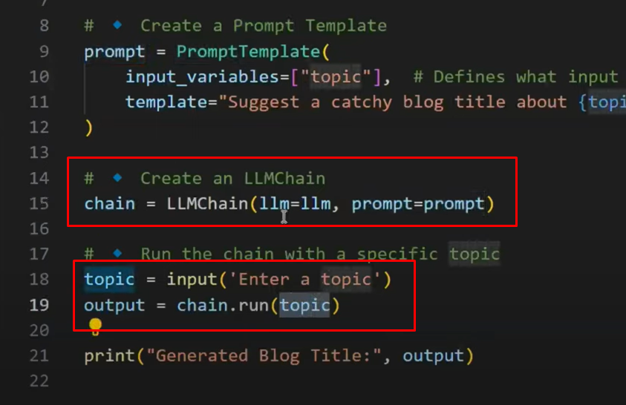

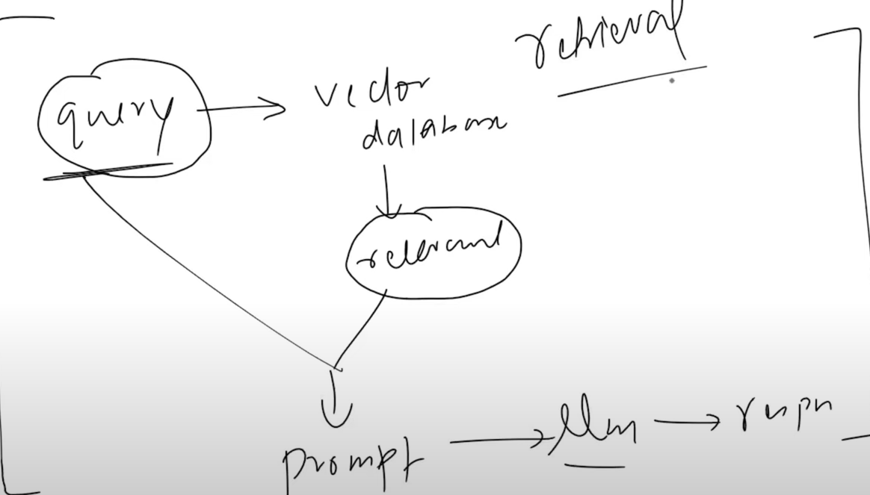

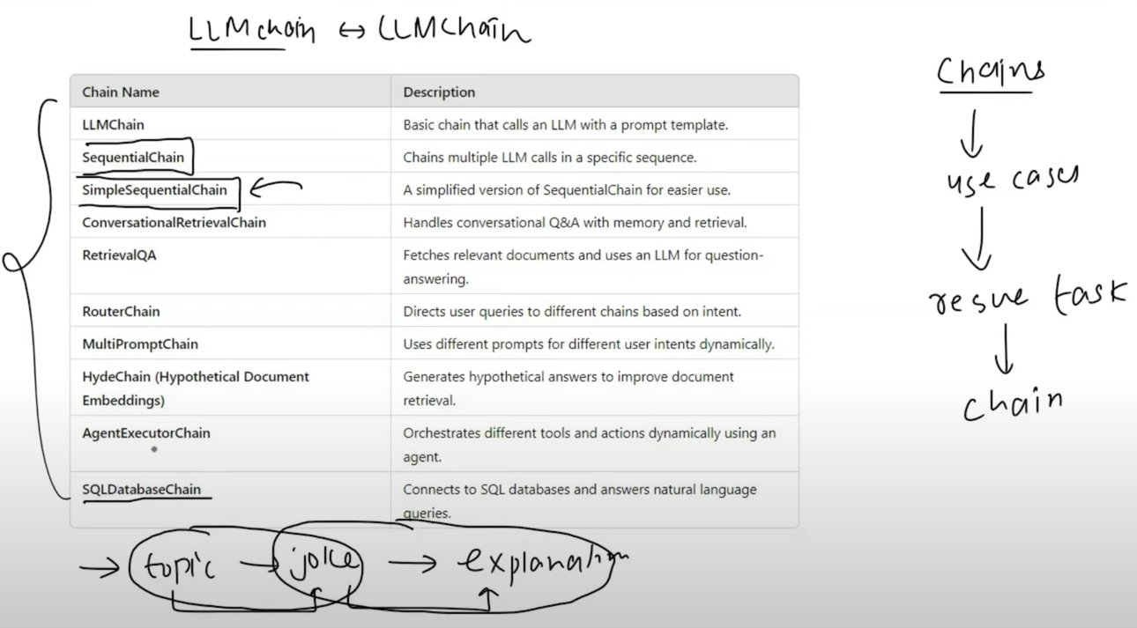

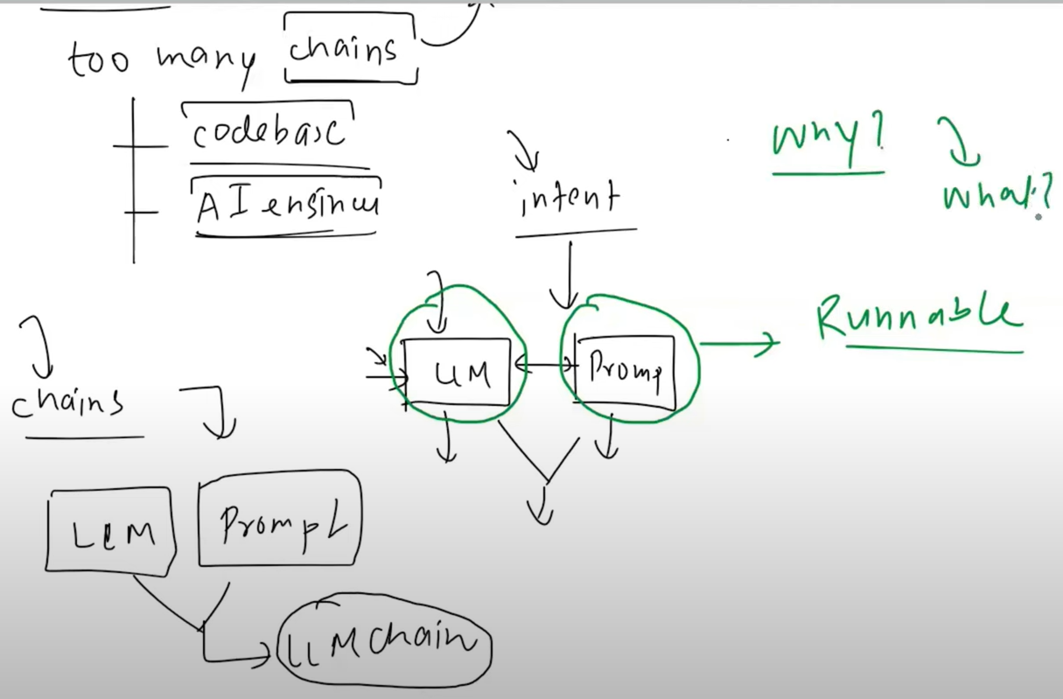

So why runnable is complete:

Now we will talk about what

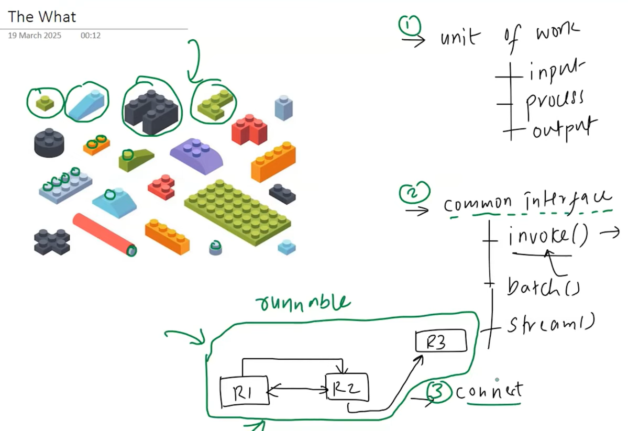

From what to How: <https://colab.research.google.com/drive/1gv3e-OfHCi6IuVBVR7xWmrcVl6gHsydv?usp=sharing> a colab file demonstration of how chain are working behind the sense

**Video #9**

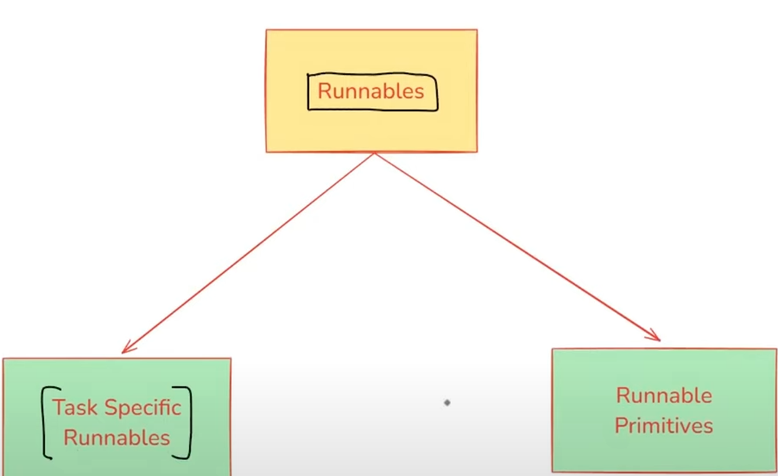

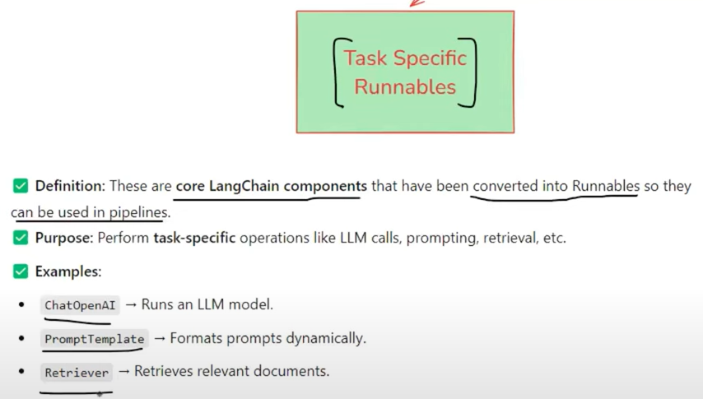

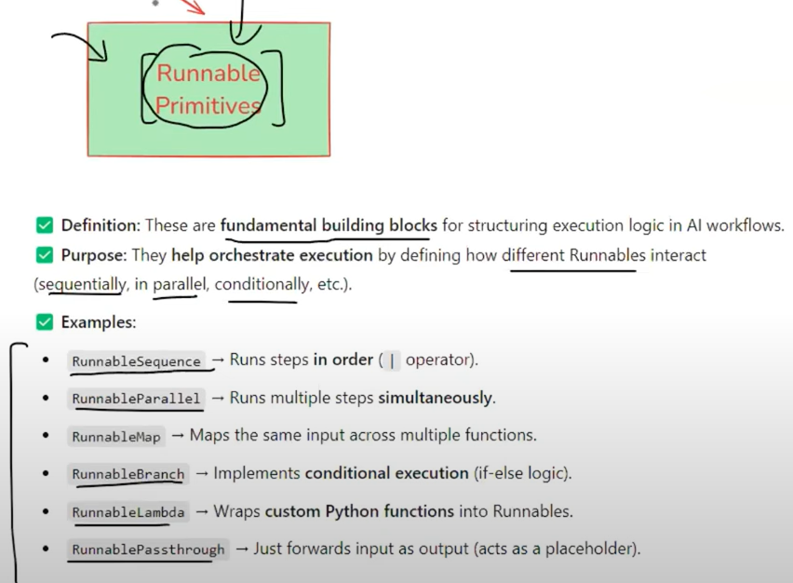

RunnableSequence:

* RunnableSequence is a sequential chain of runnables in LangChain that executes each step one after another, passing the output of one step as the input to the next.
* It is useful when you need to compose multiple runnables together in a structured workflow.

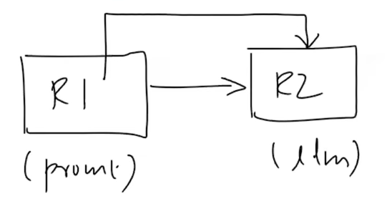

RunnableParallel:

* RunnableParallel is a runnable primitive that allows multiple runnables to execute in parallel.
* Each runnable receives the same input and processes it independently, producing a dictionary of outputs.

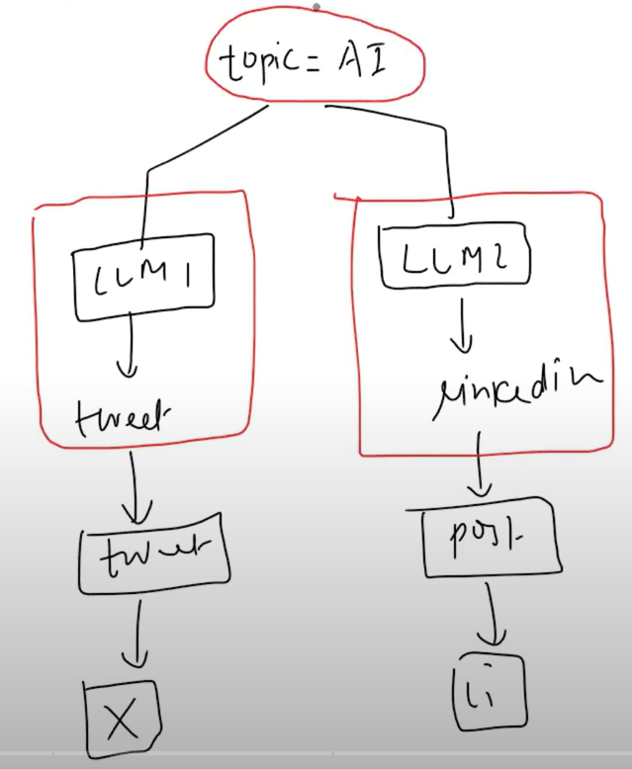

RunnablePassThrough:

* RunnablePassthrough is a special Runnable primitive that simply returns the input as output without modifying it.

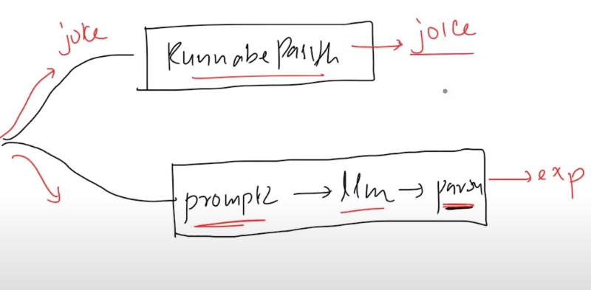

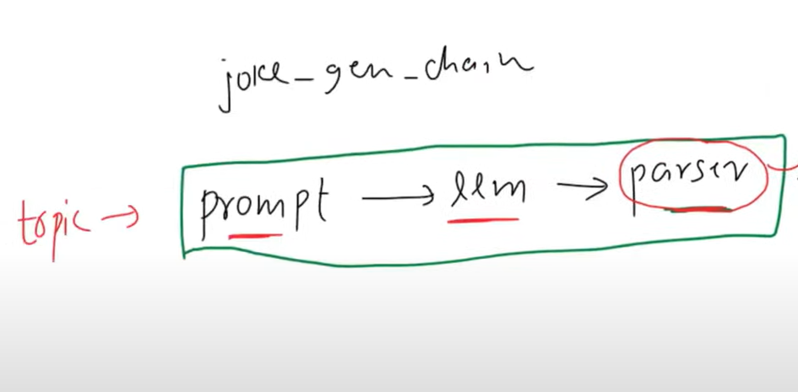

RunnableLambda:

* RunnableLambda is a runnable primitive that allows you to apply custom Python functions within an Al pipeline.
* It acts as a middleware between different Al components, enabling preprocessing, transformation, API calls, filtering, and post-processing in a LangChain workflow.

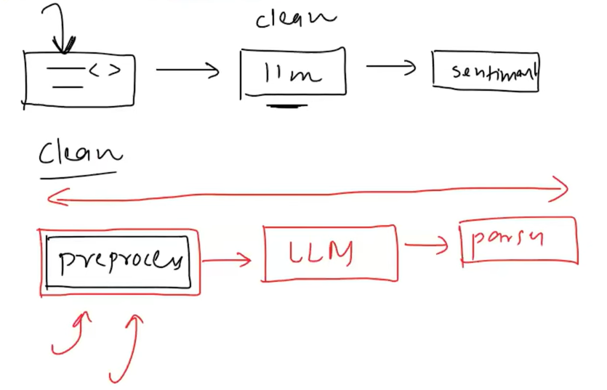

RunnableBranch:

* RunnableBranch is a control flow component in LangChain that allows you to conditionally route input data to different chains or runnables based on custom logic.
* It functions like an if/elif/else block for chains - where you define a set of condition functions, each associated with a runnable (e.g., LLM call, prompt chain, or tool). The first matching condition is executed. If no condition matches, a default runnable is used (if provided).

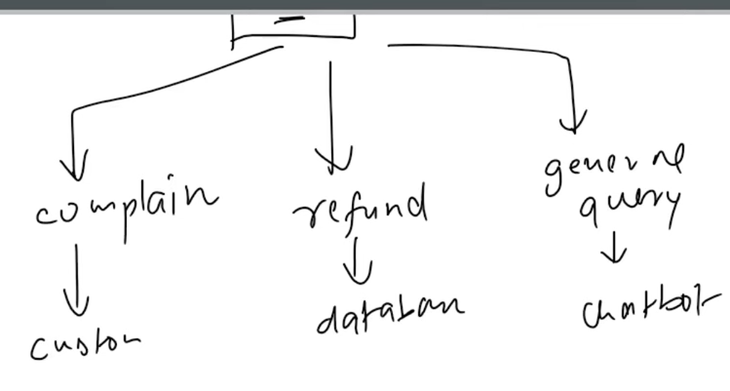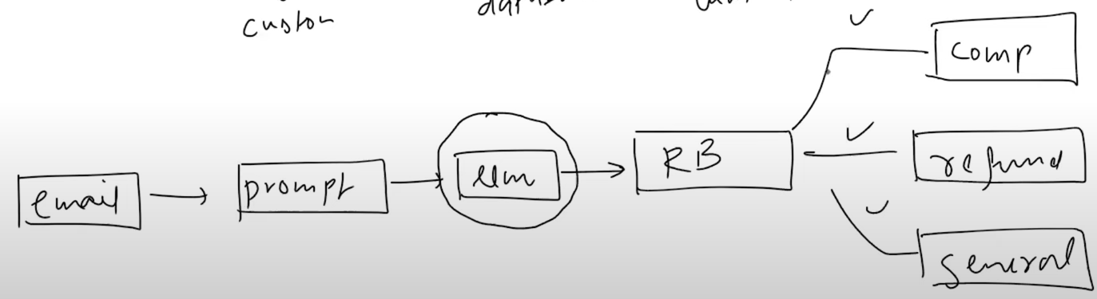

Example:

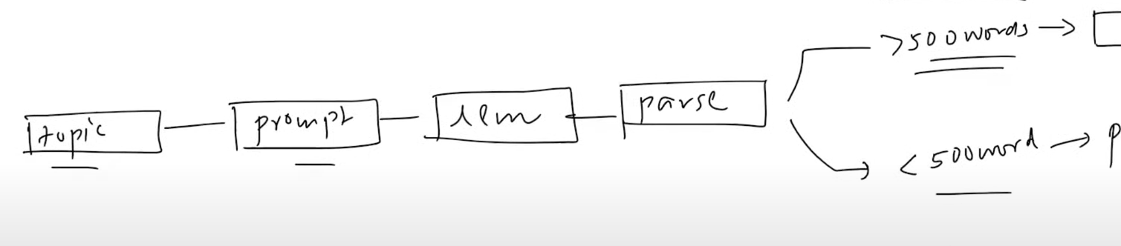

LCEL: langchain expiration language

* Morden and easy way to use Runnable Sequence by | symboll

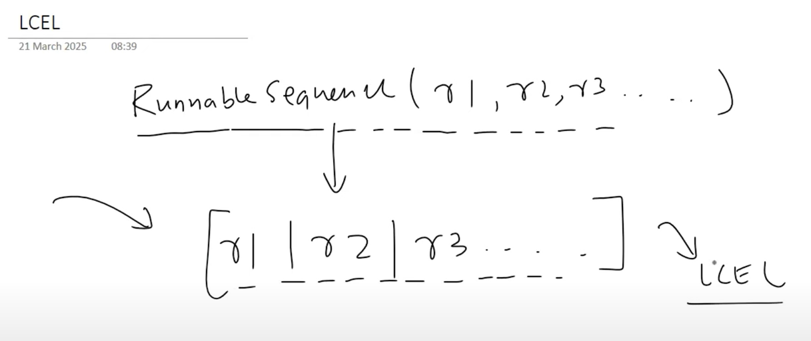

**Video #10**

**Document loader**

RAG is a technique that combines information retrieval with language generation,

where a model retrieves relevant documents from a knowledge base and then uses

them as context to generate accurate and grounded responses.

Benefits of using RAG:

* Use of up-to-date information
* Better privacy
* No limit of document size

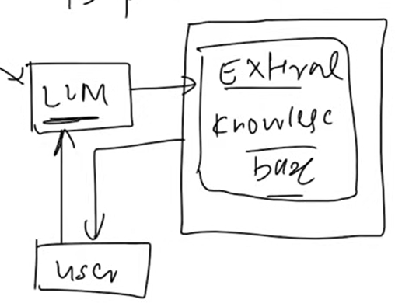

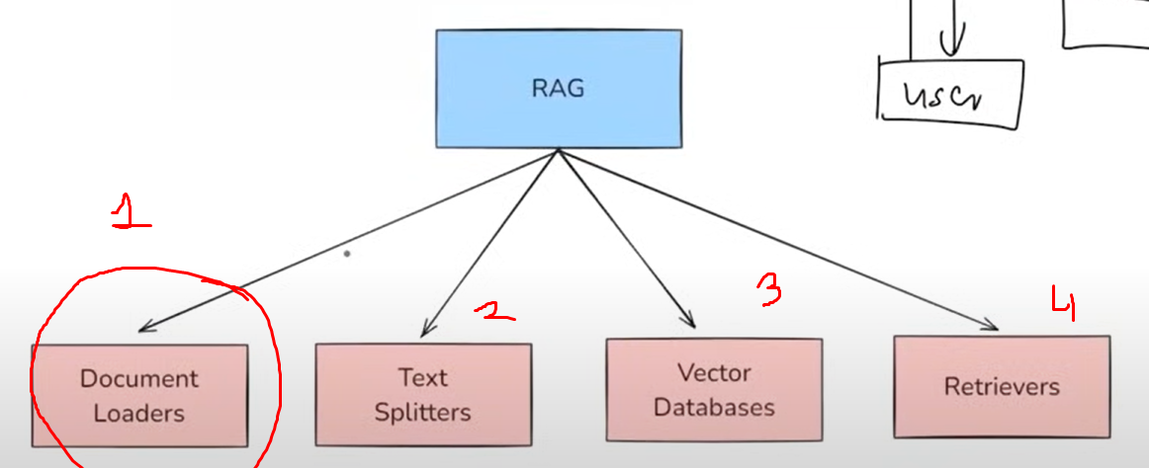

Main concept + command four document loader

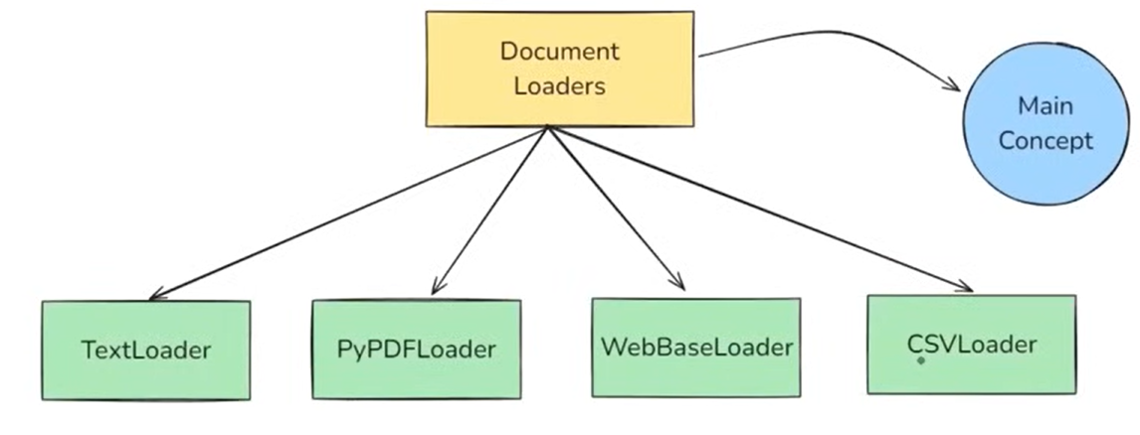

What is document loader in LangChain:

Document loaders are components in LangChain used to load data from various sources into a

standardized format (usually as Document objects), which can then be used for chunking,

embedding, retrieval, and generation.

From every format to single format:

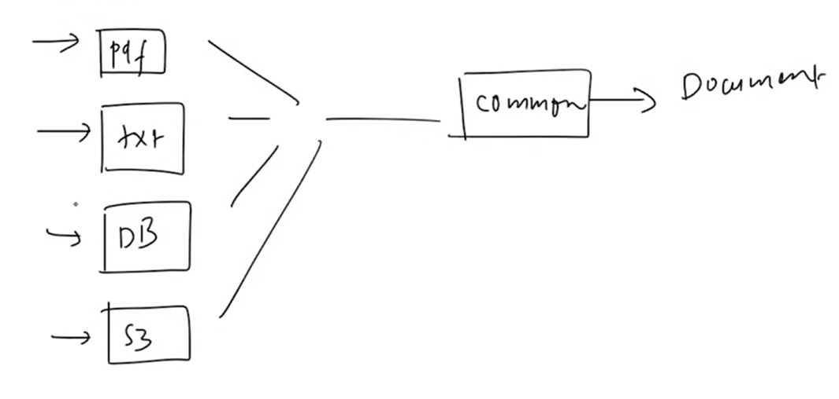

To convert into standardize format by document object:

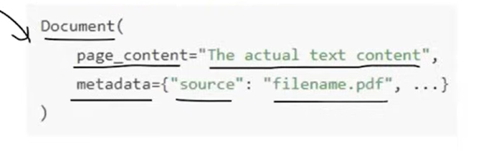

From the four types of loaders first is **TextLoader**:

TextLoader is a simple and commonly used document loader in LangChain that reads plain text

(.txt) files and converts them into LangChain Document objects.

Use Case

* Ideal for loading chat logs, scraped text, transcripts, code snippets, or any plain text data into a LangChain pipeline.

Limitation

* Works only with .txt files



Code part:

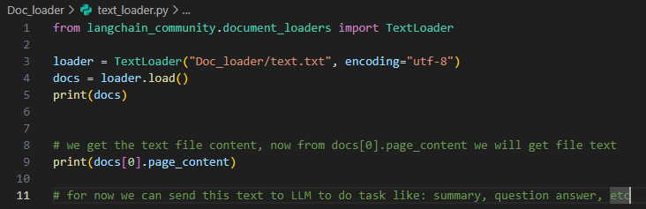

PyPDFLoader:

PyPDFLoader is a document loader in LangChain used to load content from PDF files and

convert each page into a Document object.

Limitations:

* It uses the PyPDF library under the hood - not great with scanned PDFs or complex layouts.

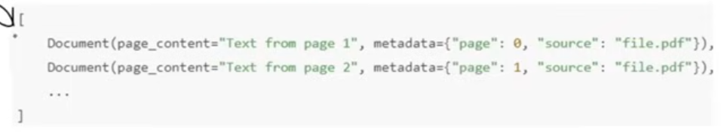

Like this ->

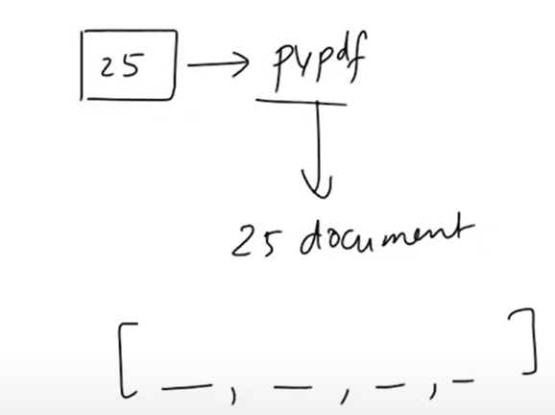

Make sure you have run this in terminal -> pip install PyPDFLoader

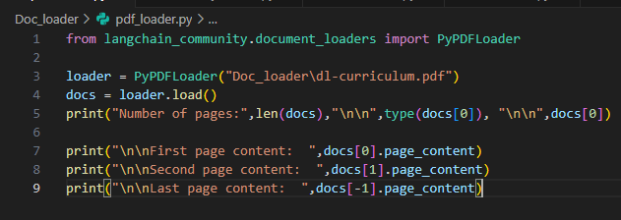

Different pdf loader for different type of pdfs:

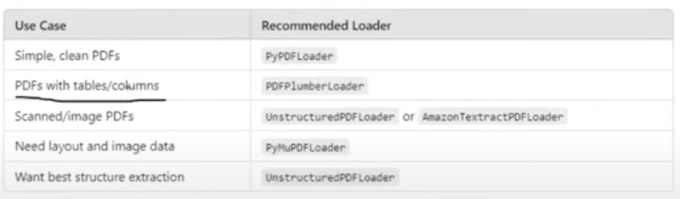

DirectoryLoader:

DirectoryLoader is a document loader that lets you load multiple documents from a directory

(folder) of files.

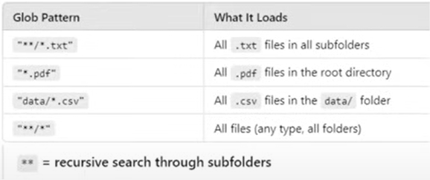

This loader loads each file into ram, in case of 100 or 500 plus files then the ram will be full and nothing will work on your system.

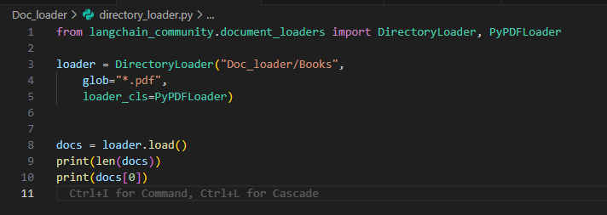

To over come this LazyLoader come

More referral books, not path this document:

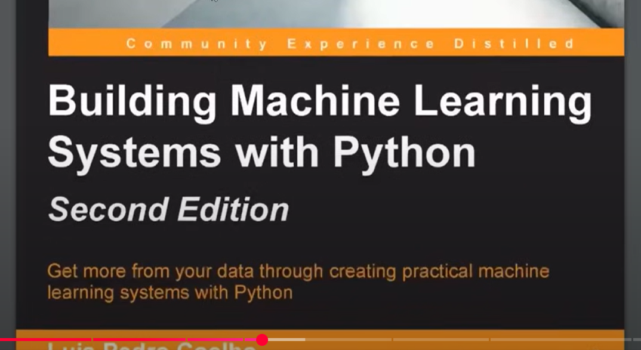  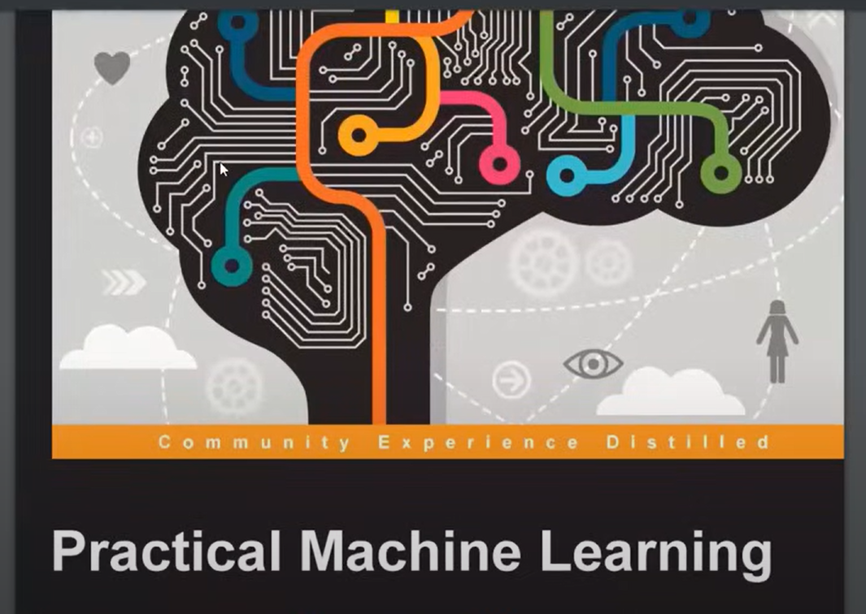

LazyLoader:

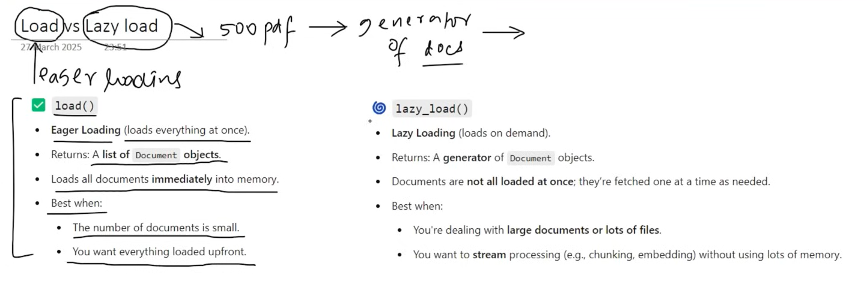

The only change is **list of Object** and **generator**

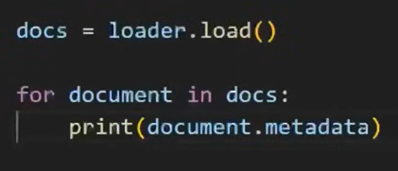 🡪 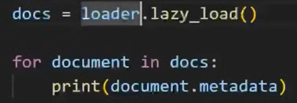

WebBaseLoader:

* WebBaseLoader is a document loader in LangChain used to load and extract text content from web pages (URLs).
* It uses BeautifulSoup under the hood to parse HTML and extract visible text.

When to Use:

* For blogs, news articles, or public websites where the content is primarily text-based and static.

Limitations:

* Doesn't handle JavaScript-heavy pages well (use SeleniumURLLoader for that).
* Loads only static content (what's in the HTML, not what loads after the page renders).

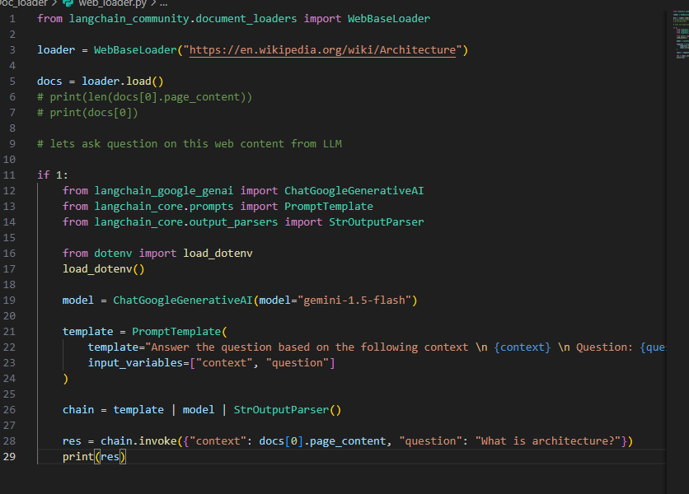

CSVLoader:

* CSVLoader is a document loader used to load CSV files into LangChain Document objects one per row, by default.

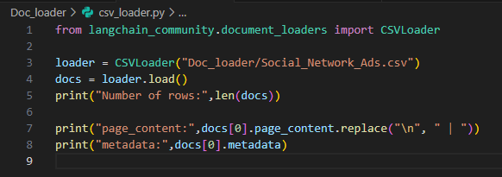



More on Document Loader from Langcahin : <https://python.langchain.com/docs/concepts/document_loaders/>

**Video #11**

Text Splitting:

* Text Splitting is the process of breaking large chunks of text (like articles, PDFs, HTML pages, or books) into smaller, manageable pieces (chunks) that an LLM can handle effectively.

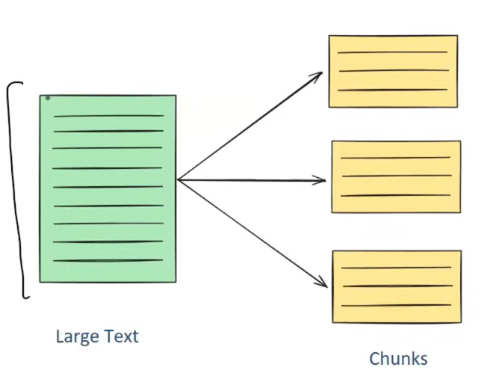

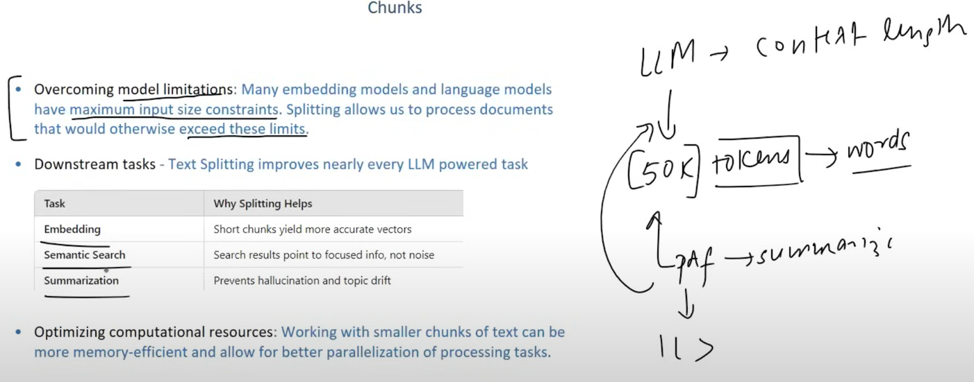

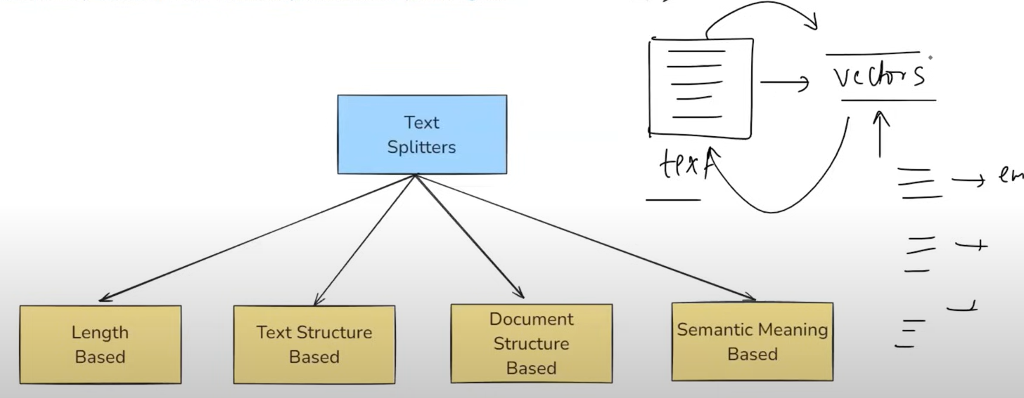

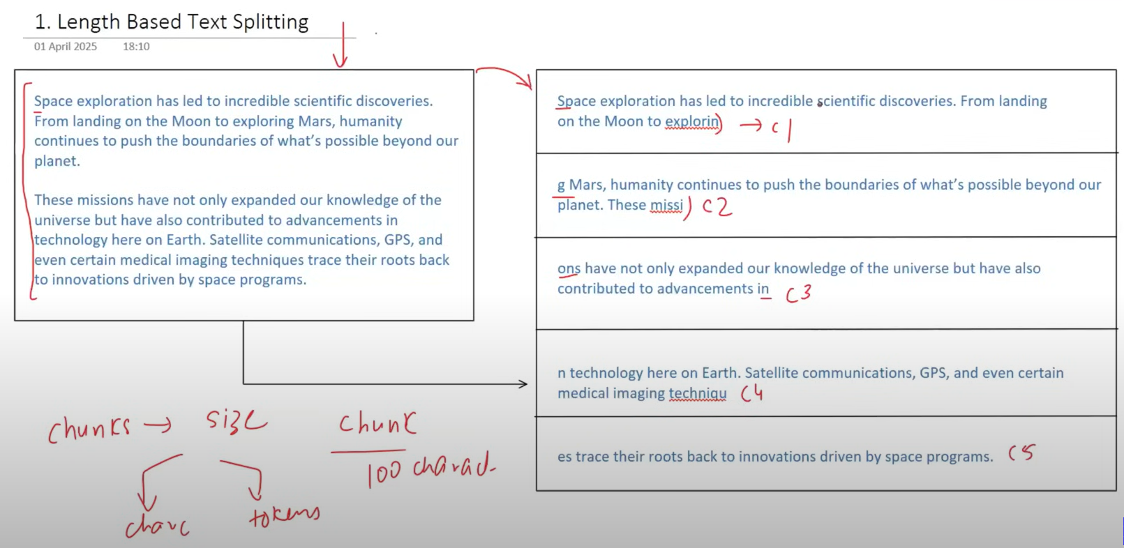

Also check this out online [character splitter](https://chunkviz.up.railway.app/)

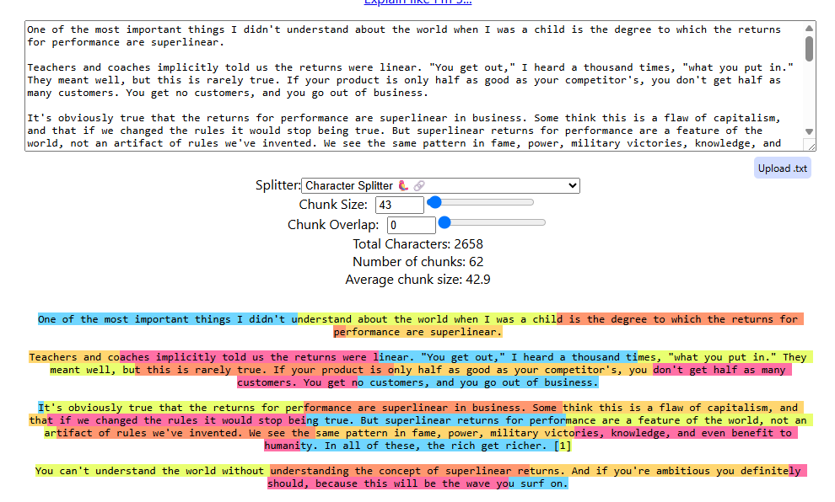

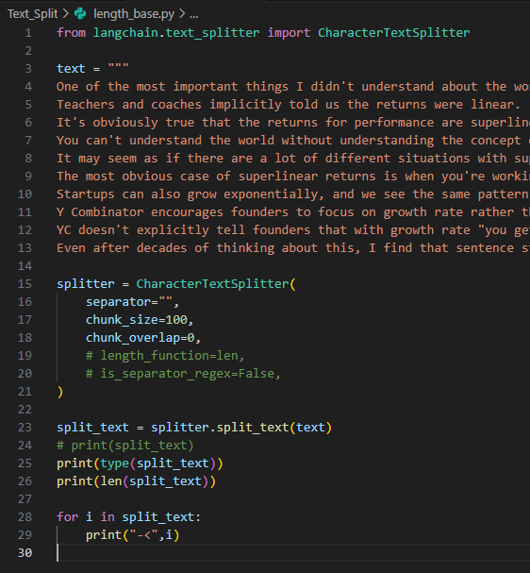

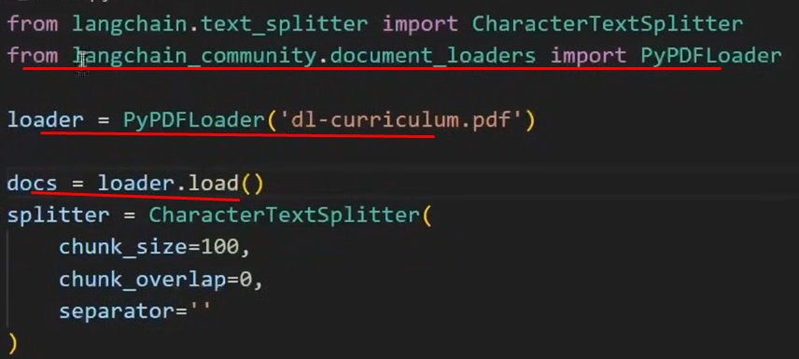

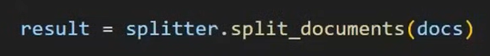

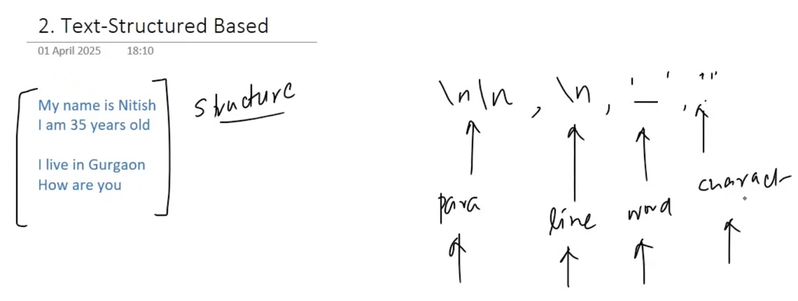

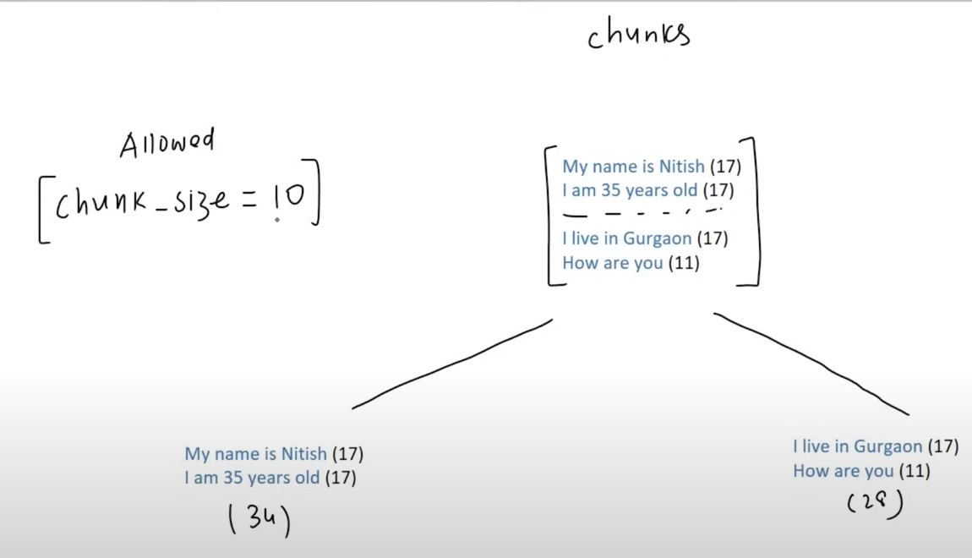

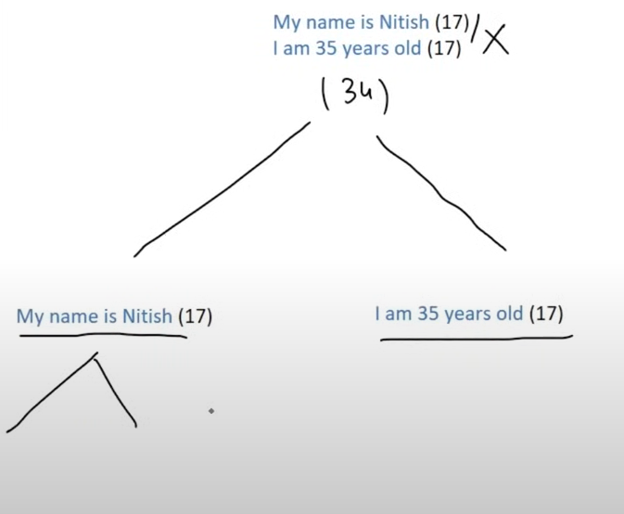

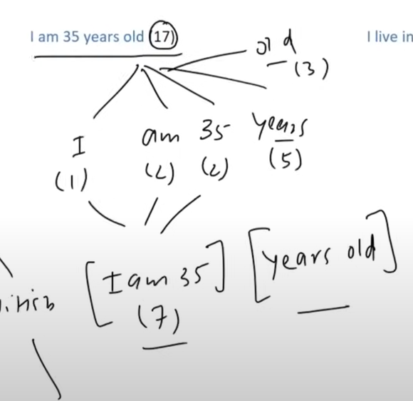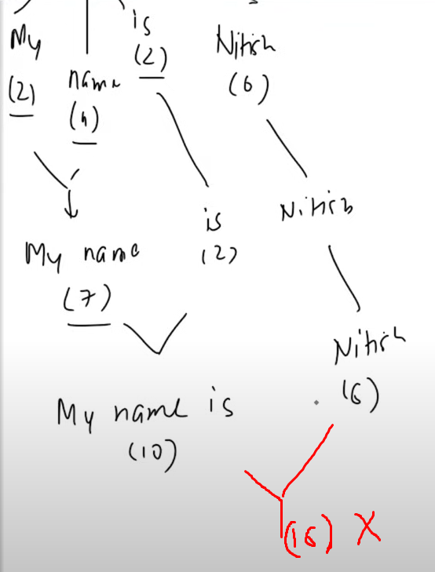

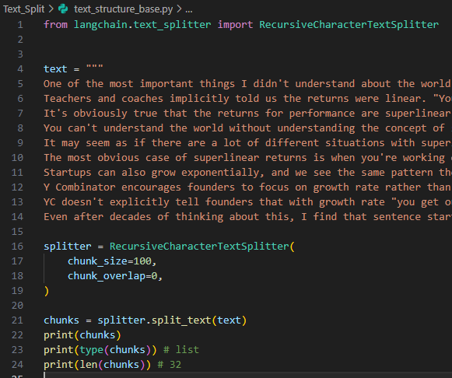

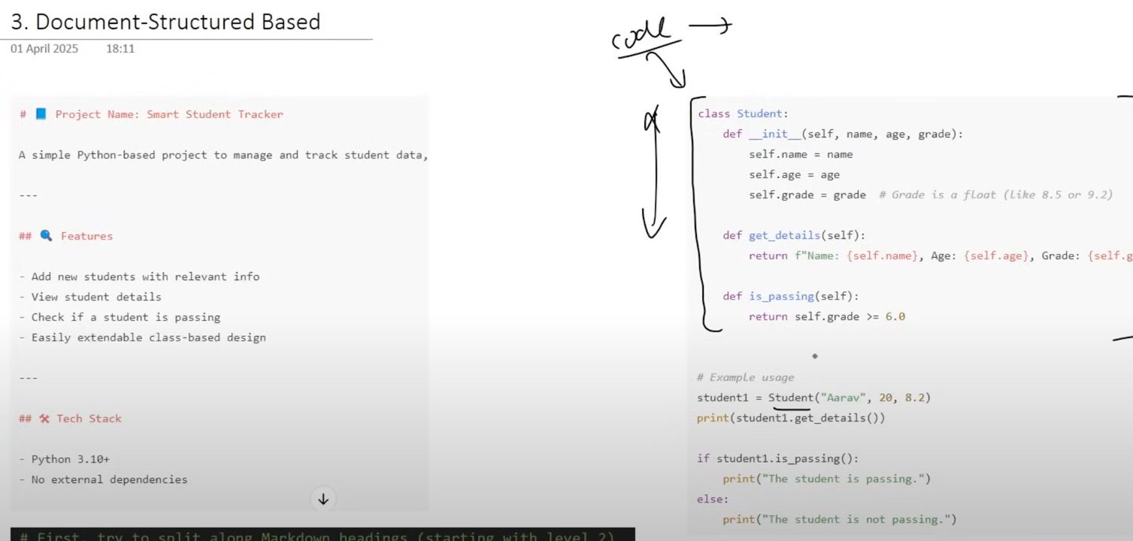

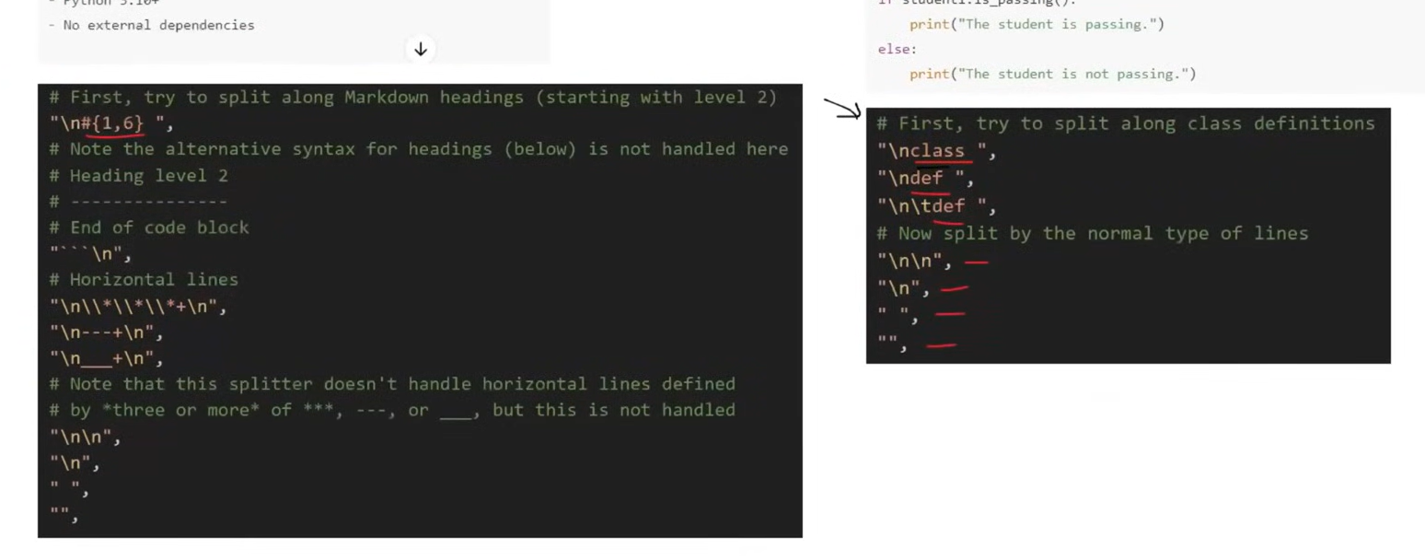

Semantic Meaning base:

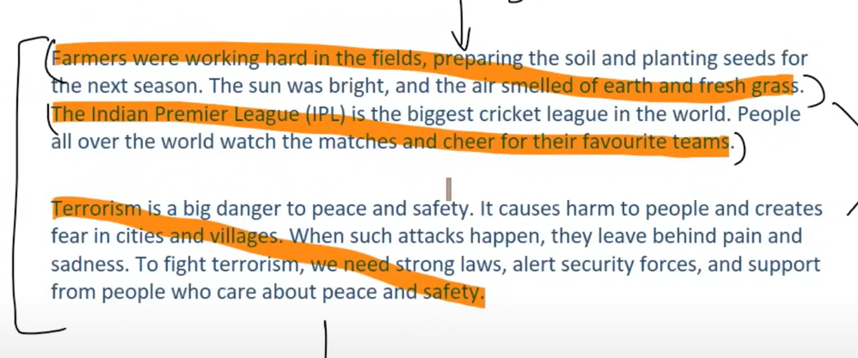

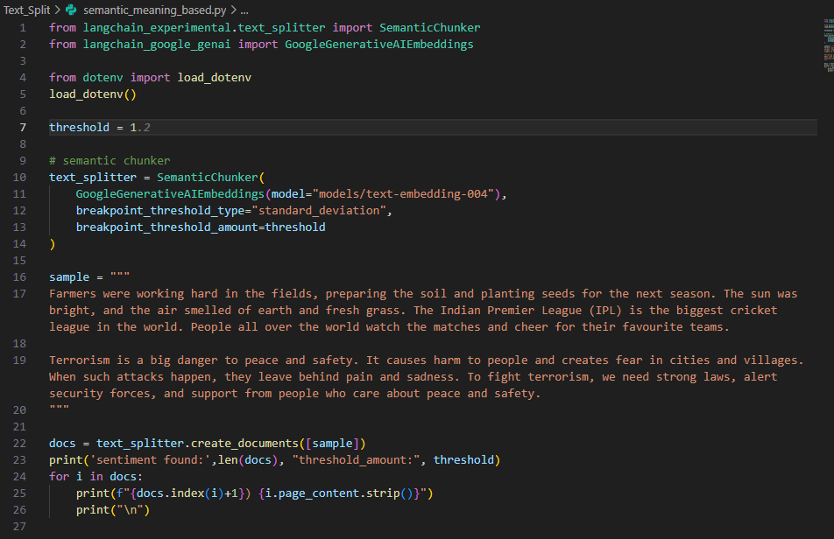

**Video #12**

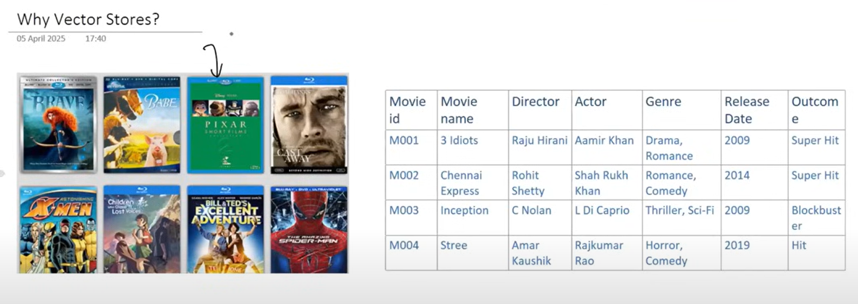

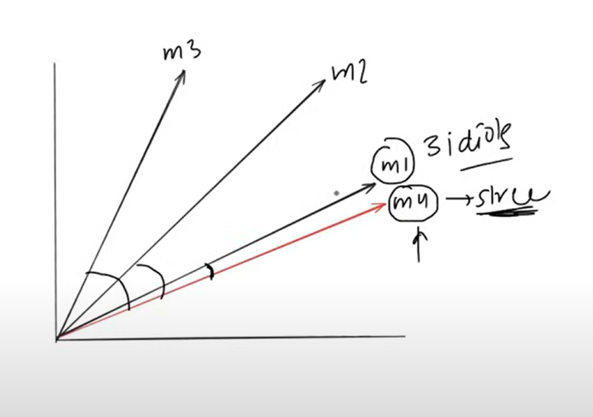

Challenges:

1. Generating embedding vectors
2. Storage for multi-use (need specific type of storage cannot store in any DB)
3. Semantic search (cosine similarity) (need intelligence cannot compare lakhs of vectors)
4. Solution -> Vector Store

What is Vector Store:

* A vector store is a system designed to store and retrieve data represented as numerical vectors.

Key Features

1. Storage - Ensures that vectors and their associated metadata are retained, whether in memory for quick lookups or on-disk for durability and large-scale use.
2. Similarity Search - Helps retrieve the vectors most similar to a query vector.
3. Indexing - Provide a data structure or method that enables fast similarity searches on high-dimensional vectors (e.g., approximate nearest neighbor lookups).
4. CRUD Operations - Manage the lifecycle of data-adding new vectors, reading them, updating existing entries, removing outdated vectors.

Use-cases

1. Semantic Search
2. RAG
3. Recommender Systems
4. Image / multi-media search

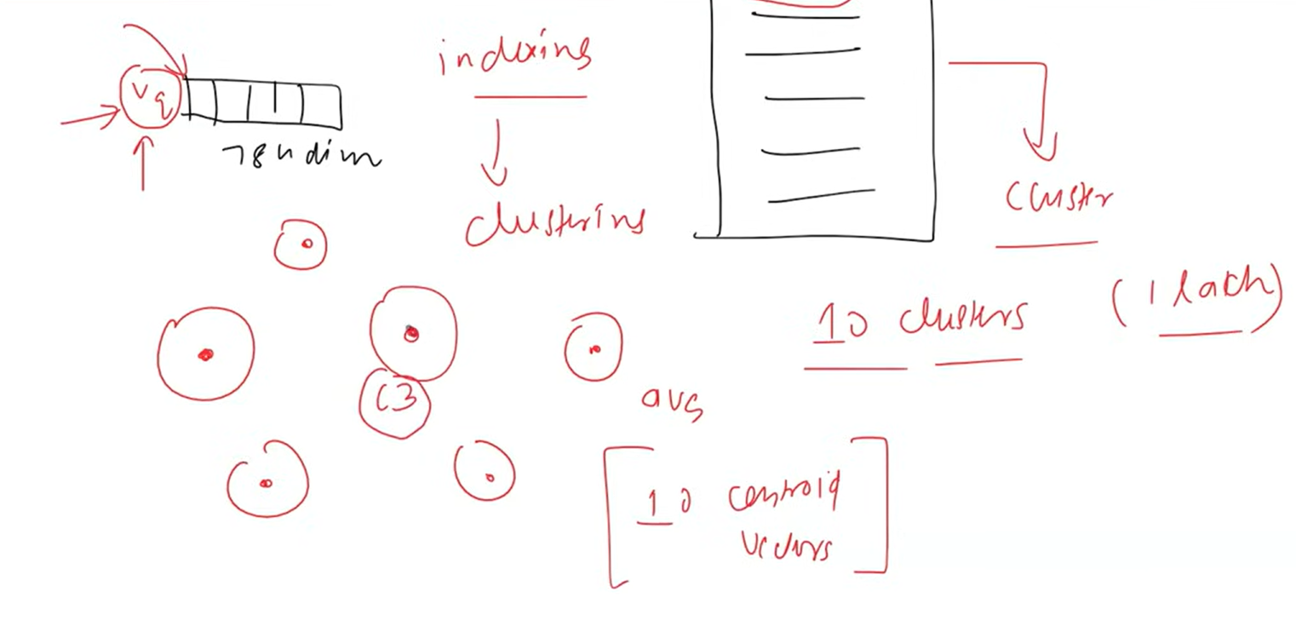

Vector Store Vs Vector Database:

Vector Store

* Typically refers to a lightweight library or service that focuses on storing vectors (embeddings) and performing similarity search.
* May not include many traditional database features like transactions, rich query languages, or role-based access control.
* Ideal for prototyping, smaller-scale applications
* Examples: FAISS (where you store vectors and can query them by similarity, but you handle persistence and scaling separately).

Vector Database

* A full-fledged database system designed to store and query vectors.
* Offers additional "database-like" features:
  + Distributed architecture for horizontal scaling
  + Durability and persistence (replication, backup/restore)
  + Metadata handling (schemas, filters)
  + Potential for ACID or near-ACID guarantees
  + Authentication/authorization and more advanced security
* Geared for production environments with significant scaling, large datasets
* Examples: Milvus, Qdrant, Weaviate, Pine Cone

A vector database is effectively a vector store with extra database features (e.g., clustering, scaling, security, metadata filtering, and durability)

Vector Stores in LangChain

* Supported Stores: LangChain integrates with multiple vector stores (FAISS, Pinecone, Chroma, Qdrant, Weaviate, etc.), giving you flexibility in scale, features, and deployment.
* Common Interface: A uniform Vector Store API lets you swap out one backend (e.g., FAISS) for another (e.g., Pinecone) with minimal code changes.
* Metadata Handling: Most vector stores in LangChain allow you to attach metadata (e.g., timestamps, authors) to each document, enabling filter-based retrieval.

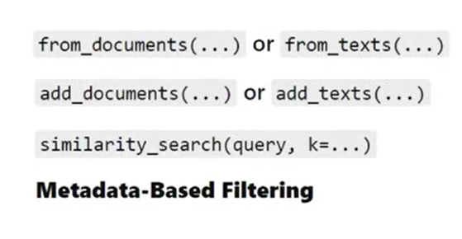

Chroma Vector Store:

* Chroma is a lightweight, open-source vector database that is especially friendly for local development and small- to medium-scale production needs.

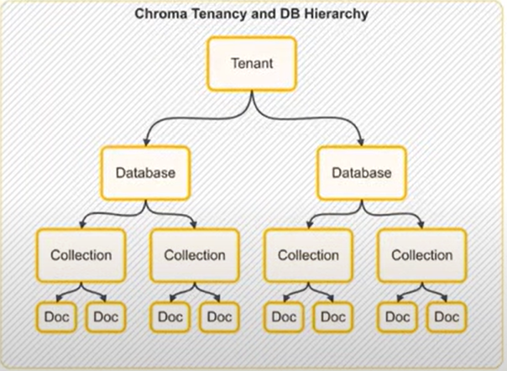

**Video #13**

What are retrievers:

* A retriever is a component in LangChain that fetches relevant documents from a data source in response to a user's query.
* There are multiple types of retrievers
* All retrievers in LangChain are runnables

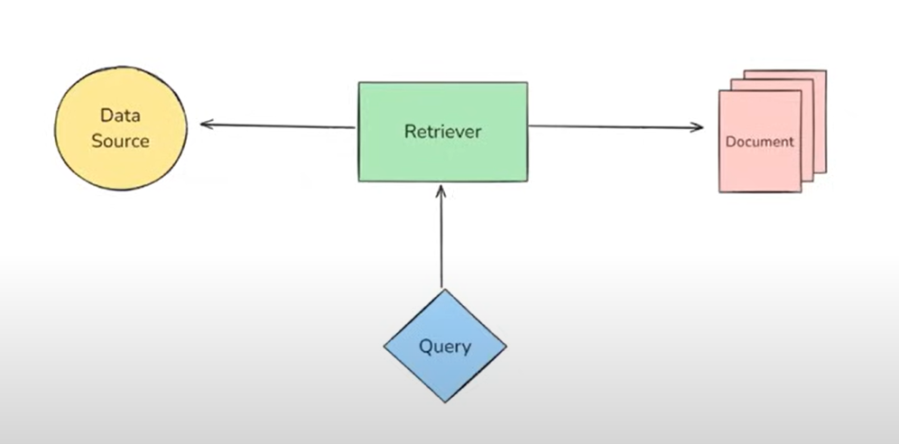

Types of retrievers:

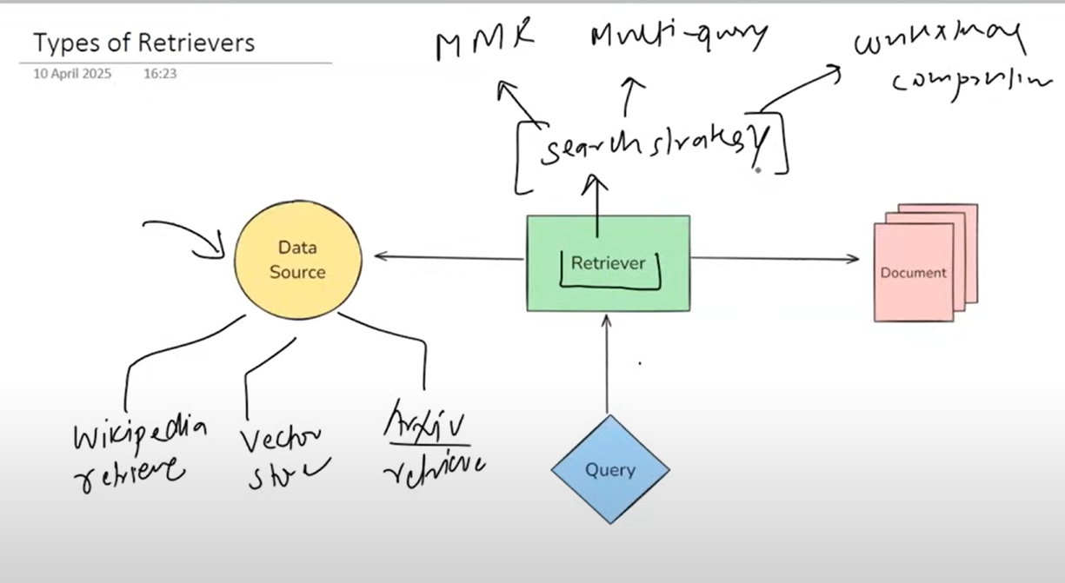

Wikipedia Retriever:

* A Wikipedia Retriever is a retriever that queries the Wikipedia API to fetch relevant content for a given query.
* How It Works:
* You give it a query (e.g., "Albert Einstein")
* It sends the query to Wikipedia's API
* It retrieves the most relevant articles
* It returns them as LangChain Document objects

Vector Store Retriever:

* A Vector Store Retriever in LangChain is the most common type of retriever that lets you search and fetch documents from a vector store based on semantic similarity using vector embeddings.
* How It Works
  + You store your documents in a vector store (like FAISS, Chroma, Weaviate)
  + Each document is converted into a dense vector using an embedding model
  + When the user enters a query:
    - It's also turned into a vector
    - The retriever compares the query vector with the stored vectors
    - It retrieves the top-k most similar ones

Maximal Marginal Relevance (MMR):

"How can we pick results that are not only relevant to the query but also different from each other?"

* MMR is an information retrieval algorithm designed to reduce redundancy in the retrieved results while maintaining high relevance to the query.

Why MMR Retriever?

In regular similarity search, you may get documents that are:

* All very similar to each other
* Repeating the same info
* Lacking diverse perspectives

MMR Retriever avoids that by:

* Picking the most relevant document first
* Then picking the next most relevant and least similar to already selected docs
* And so on ...

This helps especially in RAG pipelines where:

* You want your context window to contain diverse but still relevant information

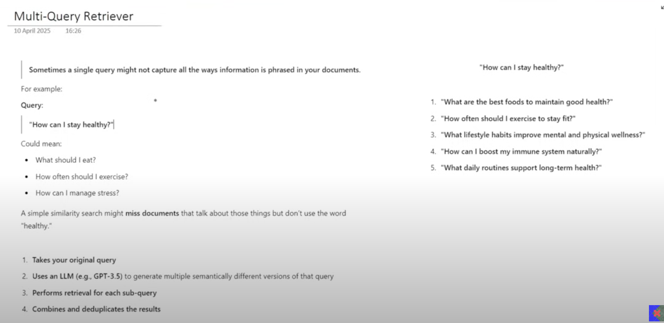

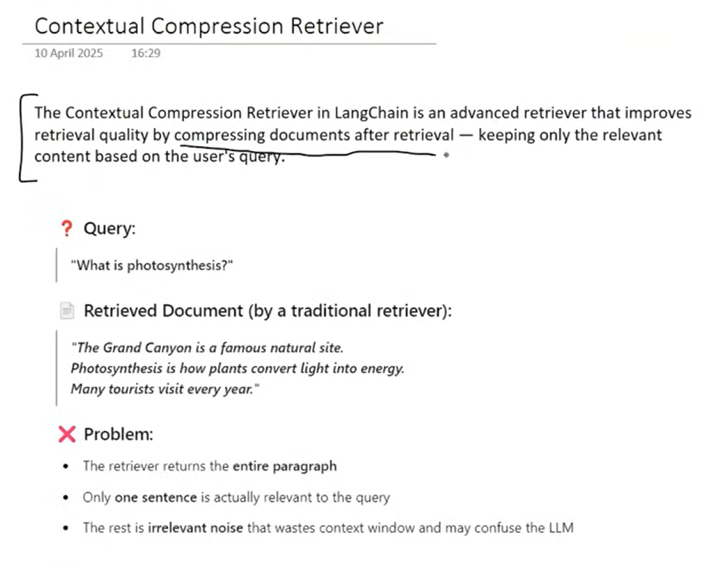

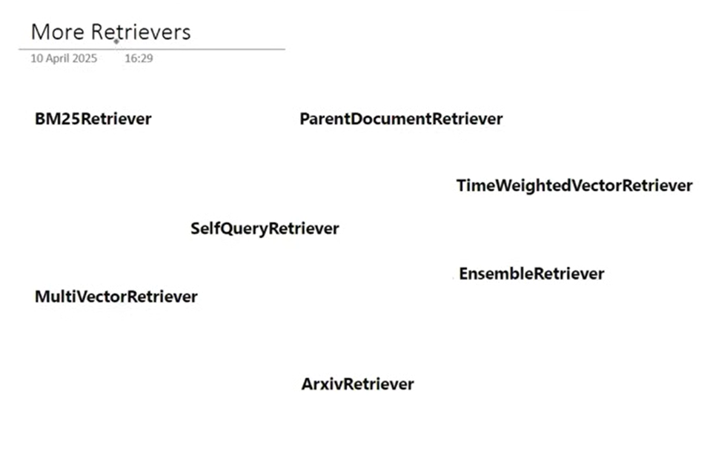

<https://python.langchain.com/docs/integrations/retrievers/>

**Video**

**#What is RAG**

The why part:

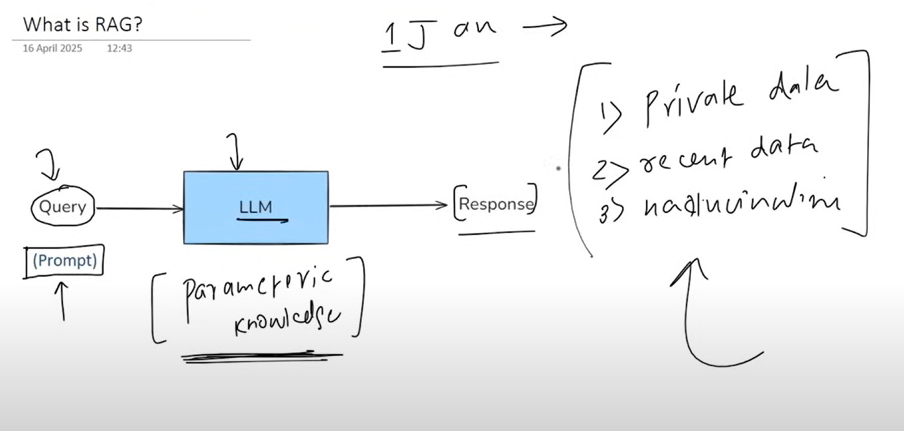

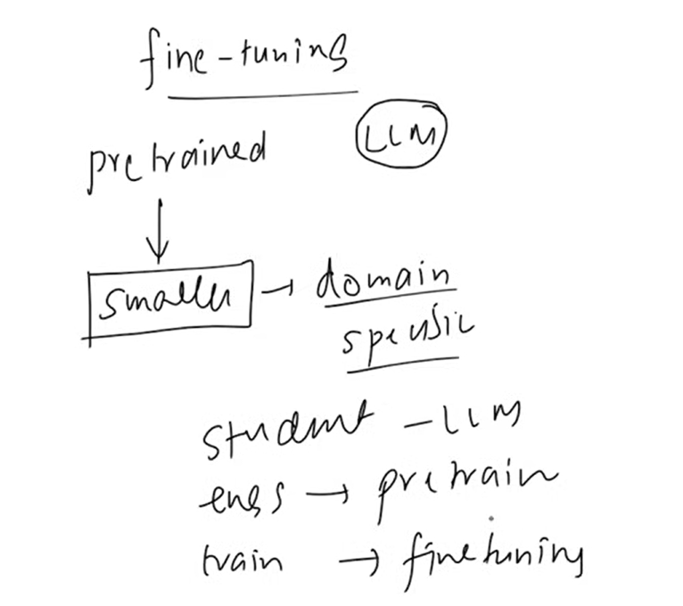

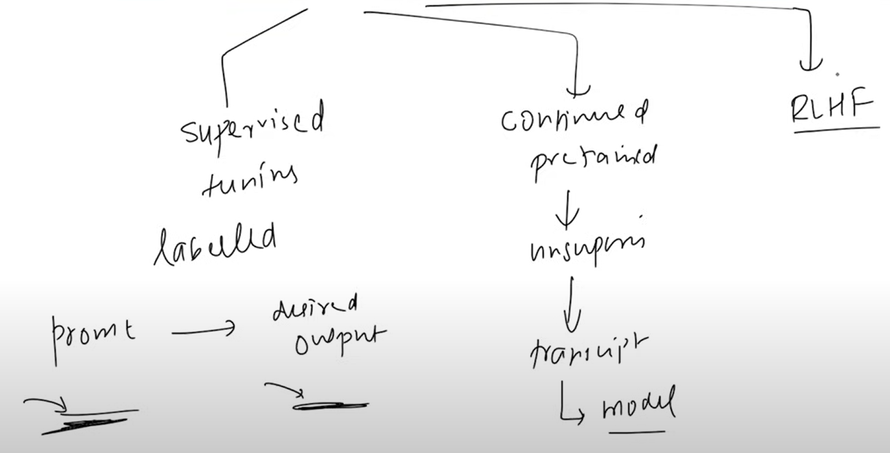

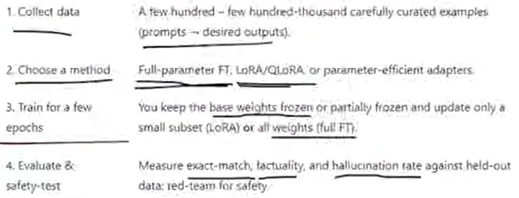

In context learning:

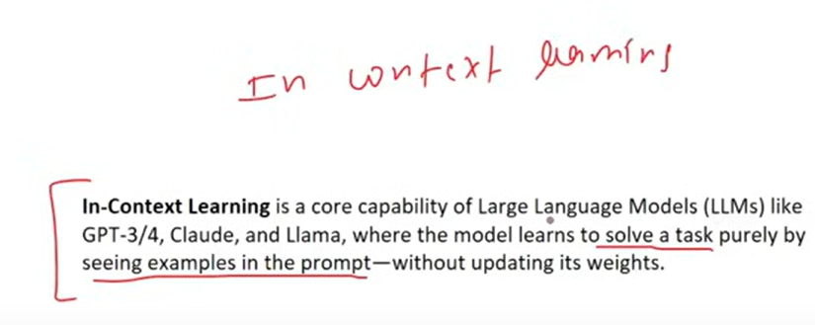

Example:

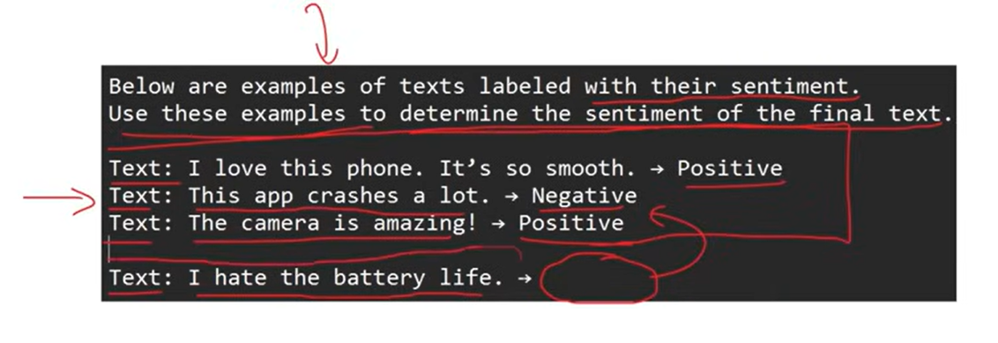

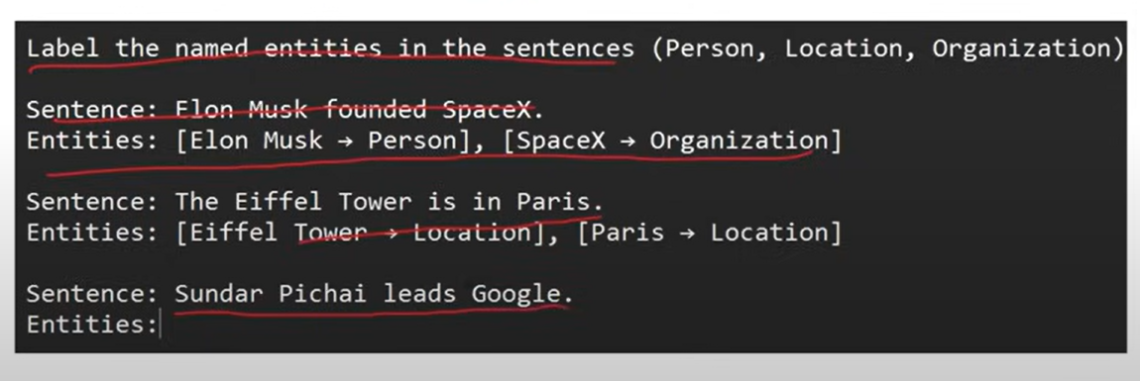

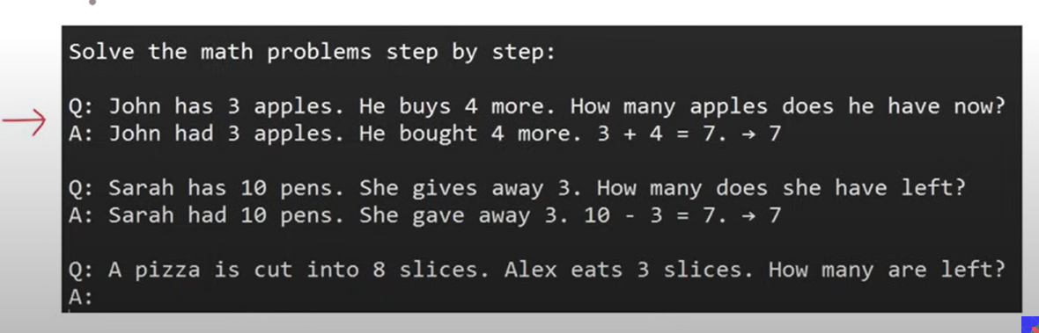

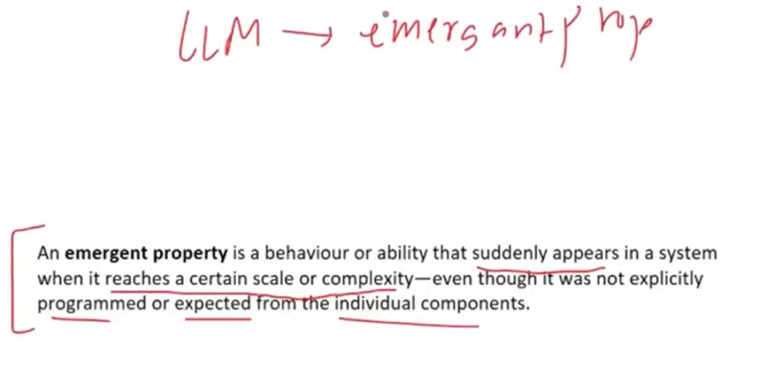

One paper shows this: ( few short learning)

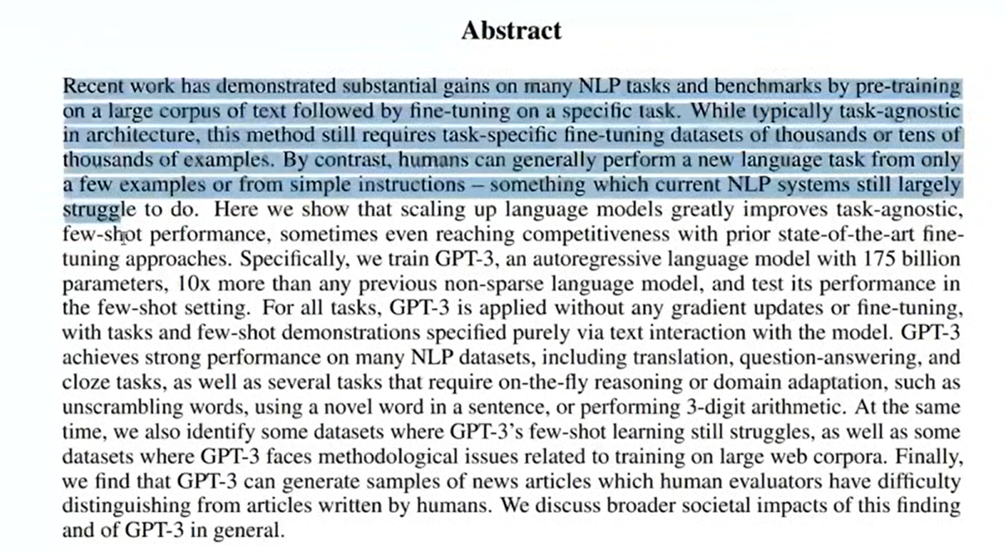

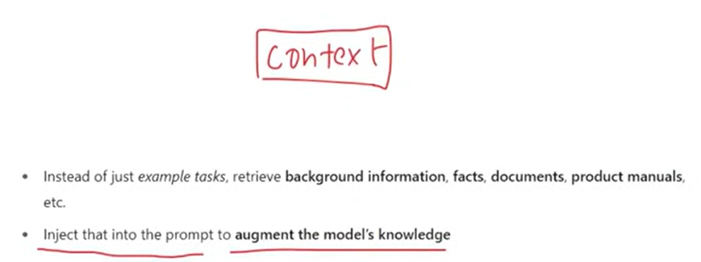

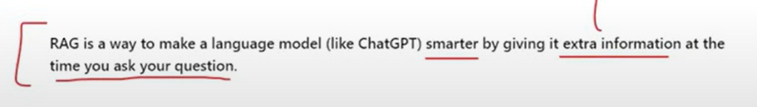

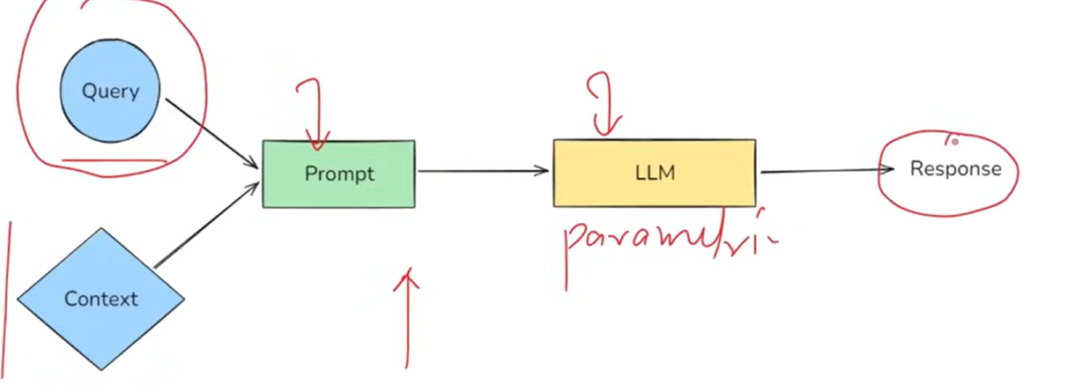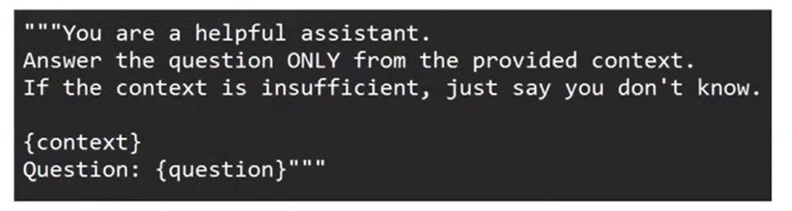

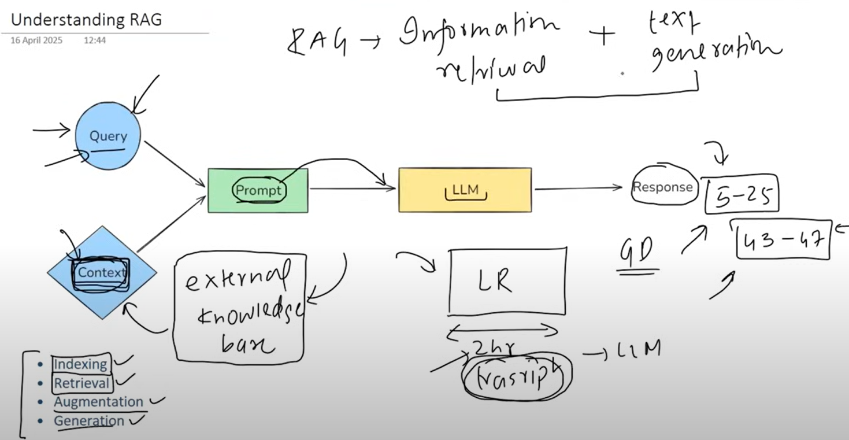

RAG flow:

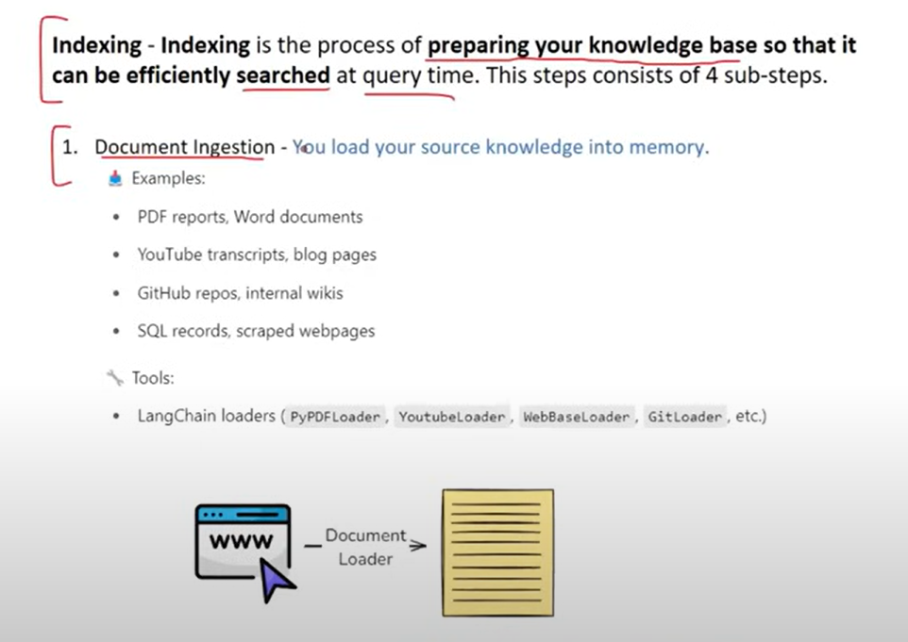

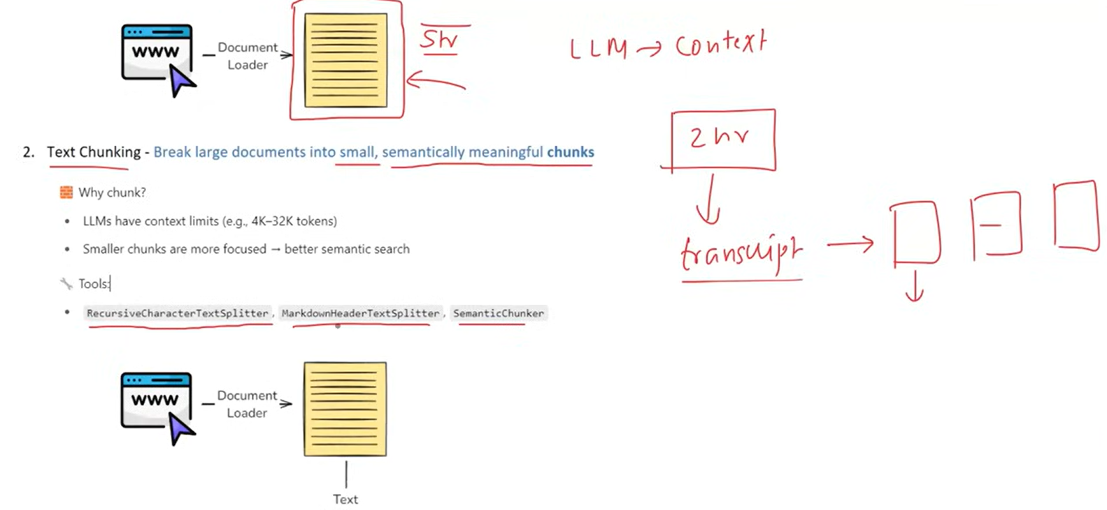

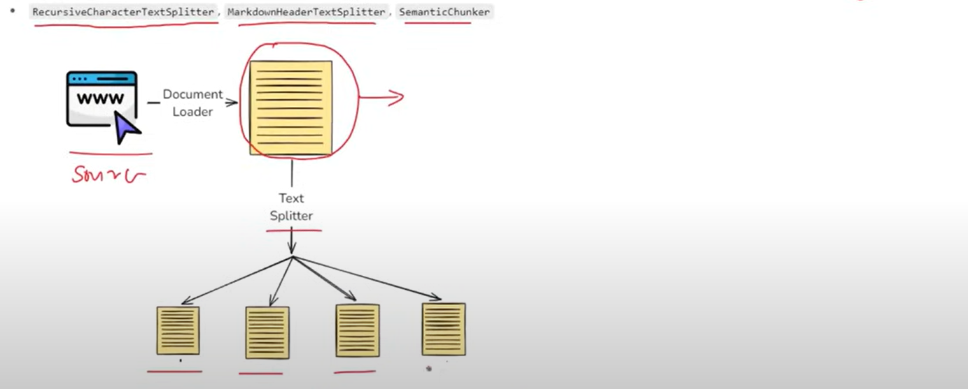

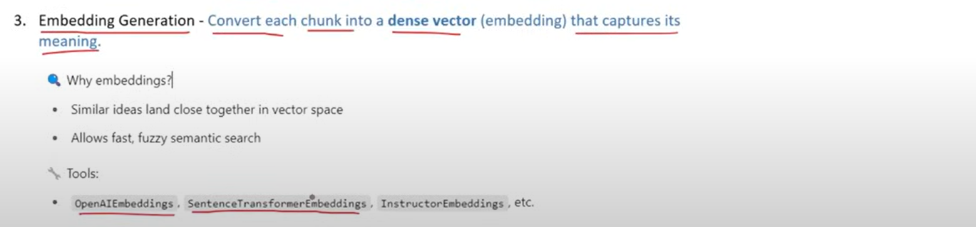

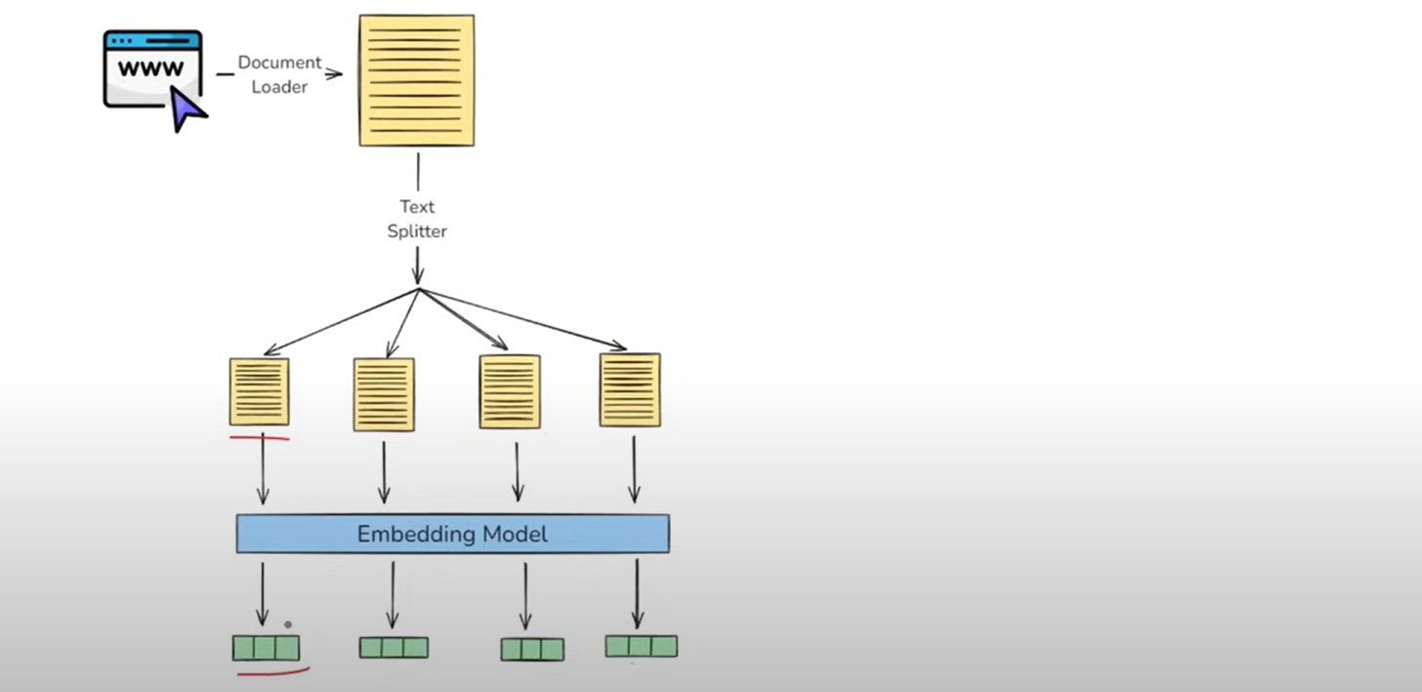

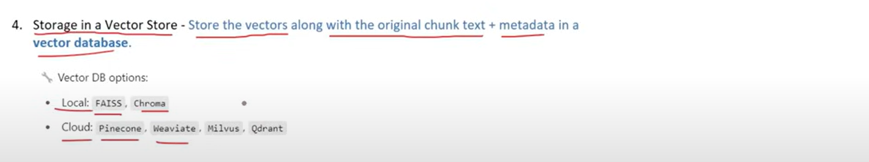

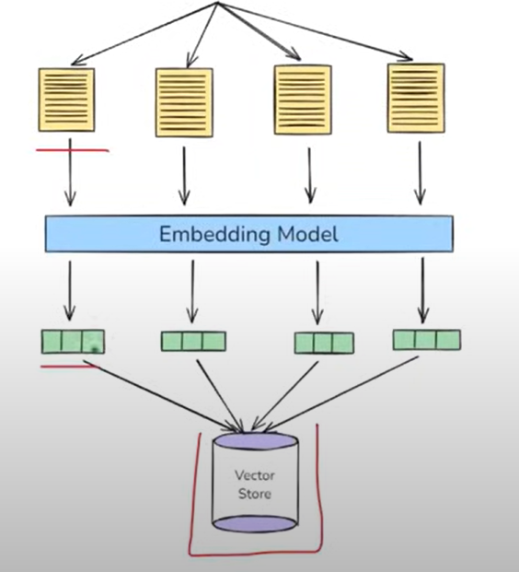

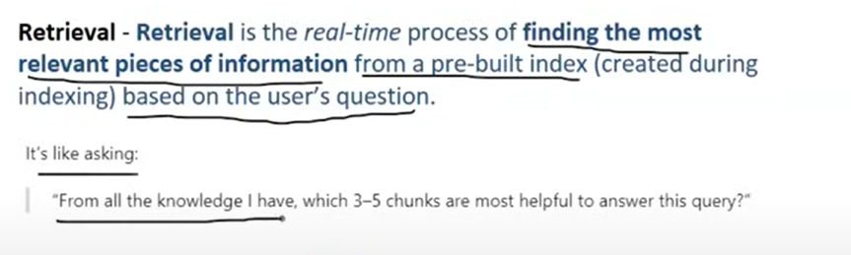

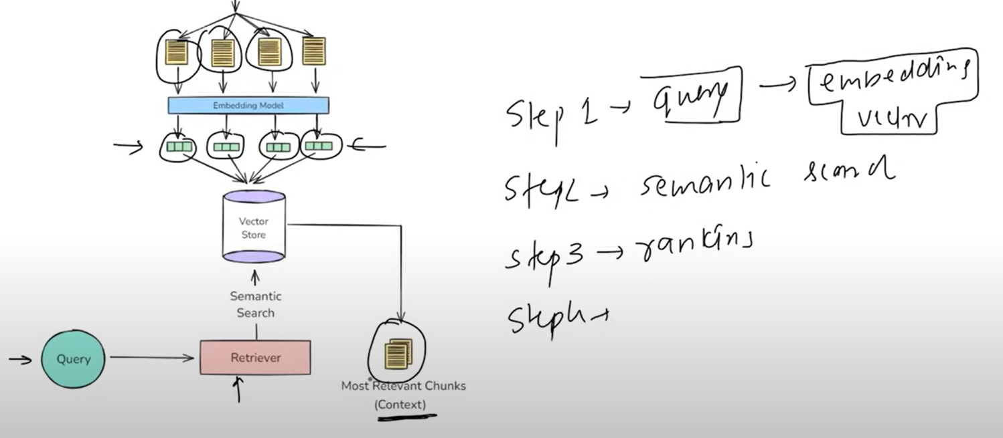

Augment:

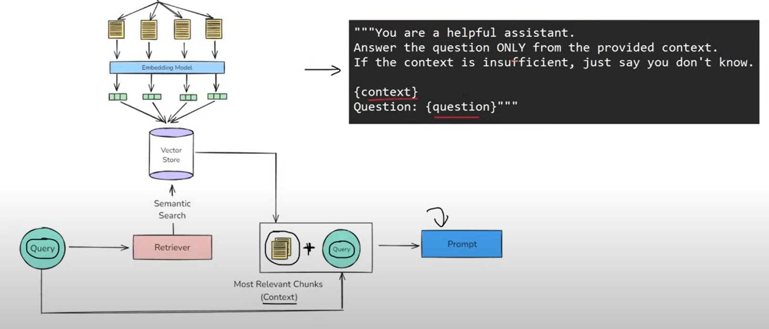

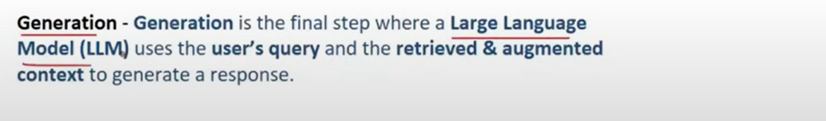

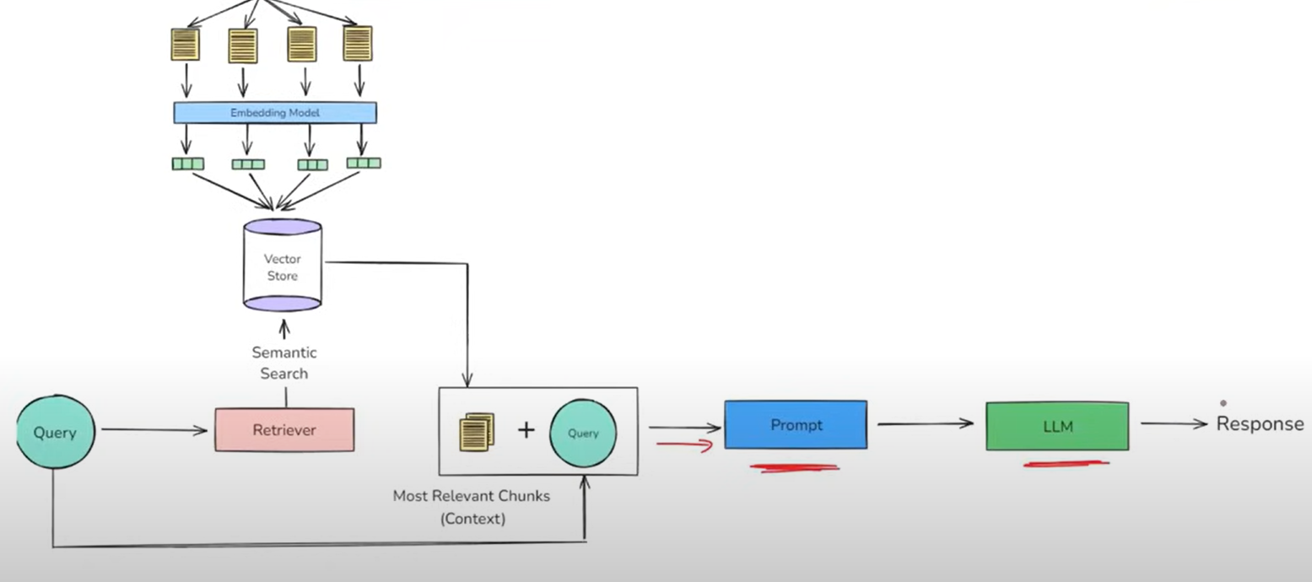

**Video**

**#RAG with Langchain**

In this part will we make a YouTube video summarizer with help of RAG

{Image of youtube summarizer app}

**Points of improvement:**

1. UI base enhancements
2. Evalution:
   1. Ragas:
      1. 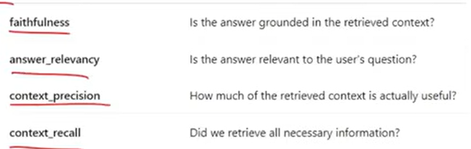
   2. LangSmith:
      1. **LangSmith** is a powerful **evaluation and debugging platform** for LLM-powered applications. It lets developers move beyond ad hoc testing to **systematic, repeatable, and measurable evaluation**, which is essential for building reliable, high-quality LLM systems.
3. Indexing
   1. Document loader
      1. Grammar error
      2. Multi language
   2. Text splitting
      1. May get wrong splitting
   3. Vector store
      1. Chroma and FAISS are local
      2. Pinecone is cloud
4. Retrieval:
   1. Pre retrieval:
      1. Query rewrite using LLM
      2. Multi query generation
      3. Domian aware routing
   2. During retrieval:
      1. MMR
      2. Hybrid retrieval
      3. Reranking
   3. Post retrieval:
      1. Contextual compression
5. Augmentation:
   1. Prompt template
   2. Answer grounding
   3. Context window optimization
6. Generation:
   1. Answer with citation:
      1. Reason for type answer
   2. Guard railing:
      1. Prevent LLM from non-sense answer
7. System design:
   1. Multimodel
   2. Agentic
   3. Memory based

**Video #16**

**Tools in LangChain**

Work flow of AI agent

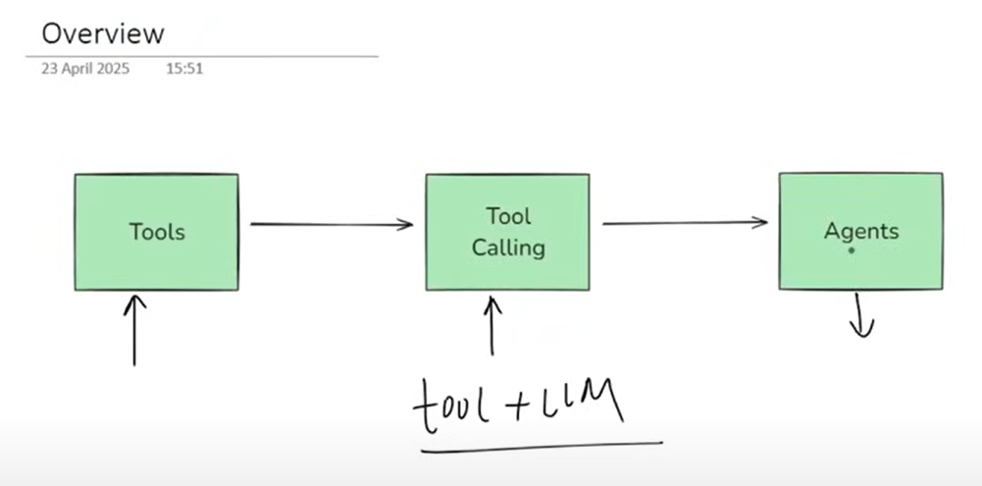

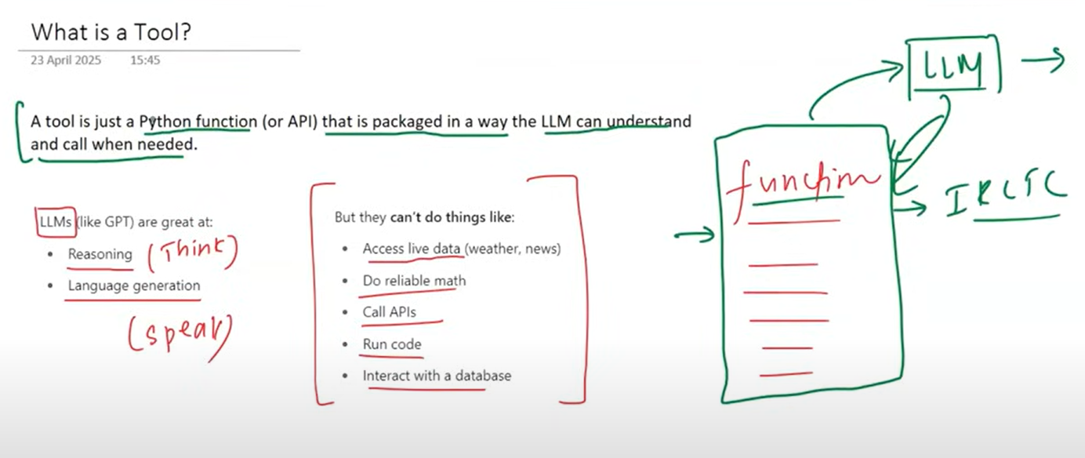

Tools is just a way to provide hands and legs to LLM so it can walk and run

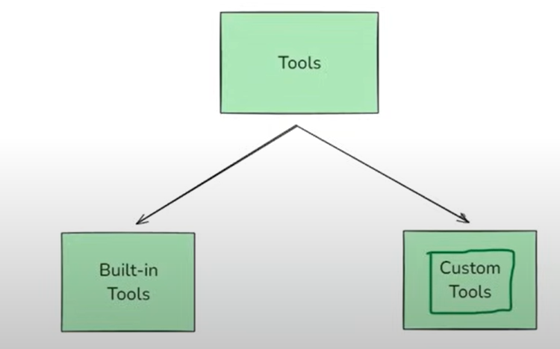

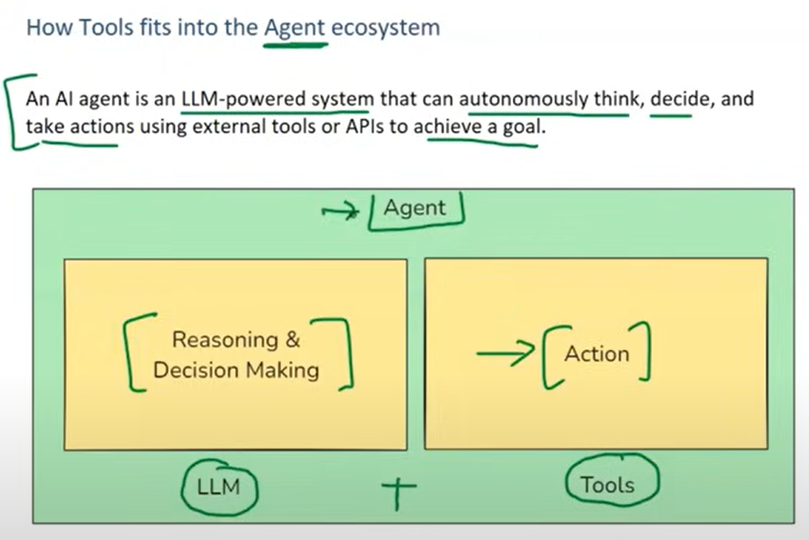

Built in langchain tools

* A built-in tool is a tool that LangChain already provides for you -it's pre-built, production-ready, and requires minimal or no setup.
* You don't have to write the function logic yourself - you just import and use it.

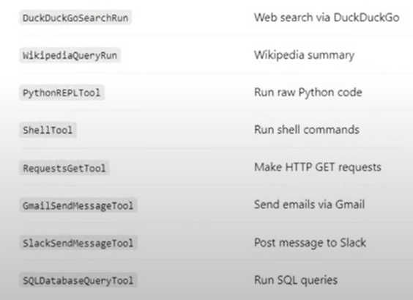

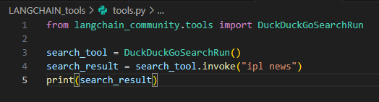

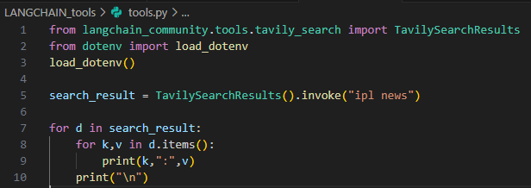

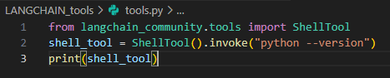

Custom tools:

* Tools that you define yourself

When to use custom tools:

* Call your own API
* Encapsulate business logic
* LLM interact with your Database, product, and app

Let us create own tool by using decorator.

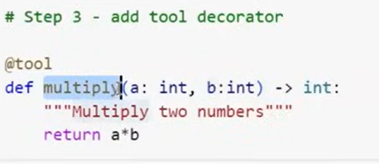

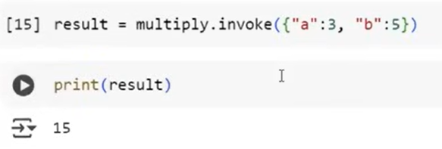

This is the basic tool but that is how any tool works.

Metadata of tool:

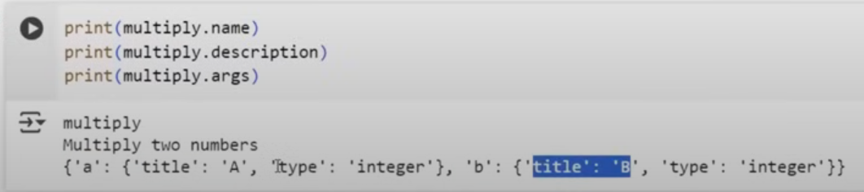

Here LLM see tools as json schema

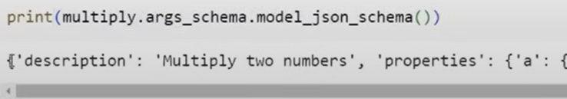

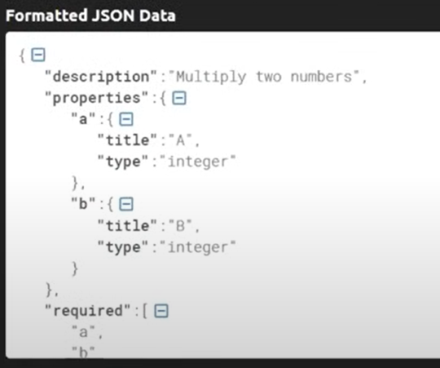

More way to create custom tools:

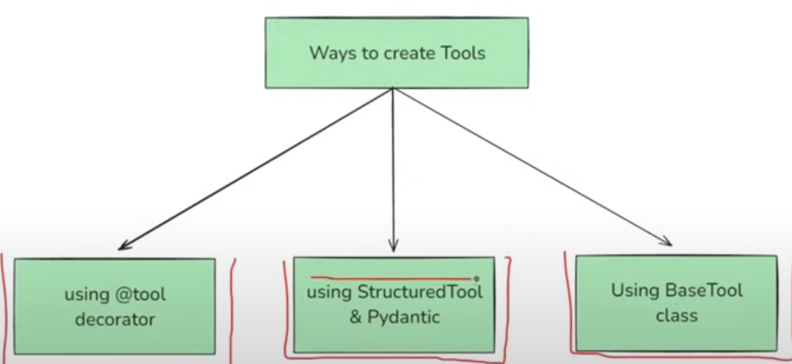

Using StructuredTool and Pydantic:

A Structured Tool in LangChain is a special type of tool where the input

to the tool follows a structured schema, typically defined using a

Pydantic model.

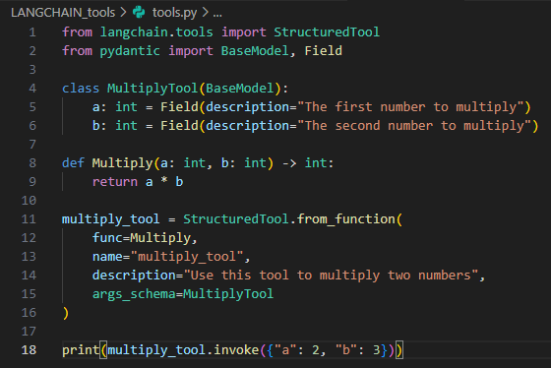

Using BaseTool:

* BaseTool is the abstract base class for all tools in LangChain. It defines the core structure and interface that any tool must follow, whether it's a simple one-liner or a fully customized function.
* All other tool types like @tool, StructuredTool are built on top of BaseTool

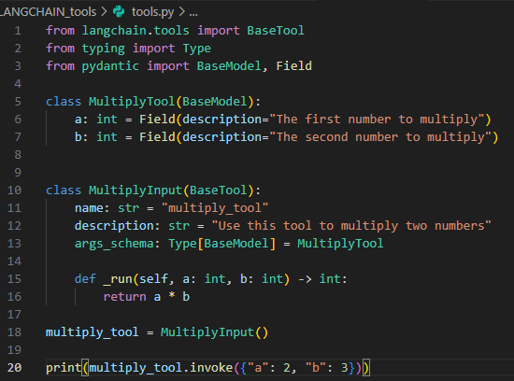

Conclusion:

* In most case the tool decorator is used but if you creativity use pydantic.

ToolKits:

* A toolkit is just a collection (bundle) of related tools that serve a common purpose - packaged together for convenience and reusability.
  + A toolkit might be: GoogleDriveToolKit
  + And it can contain the following tools
* 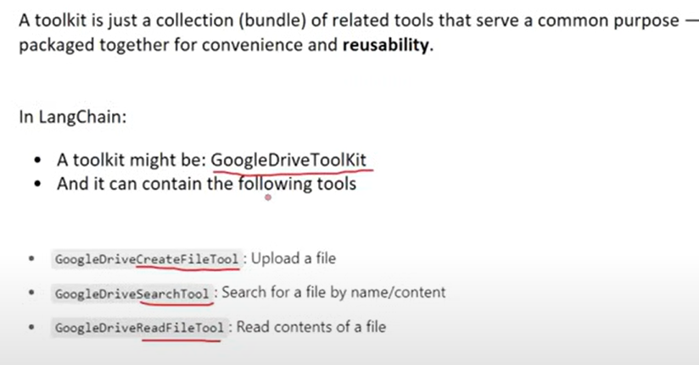

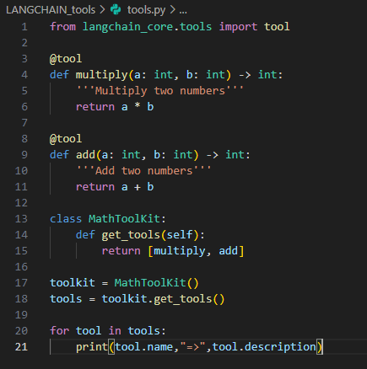

**Video #19**

**Tool calling**

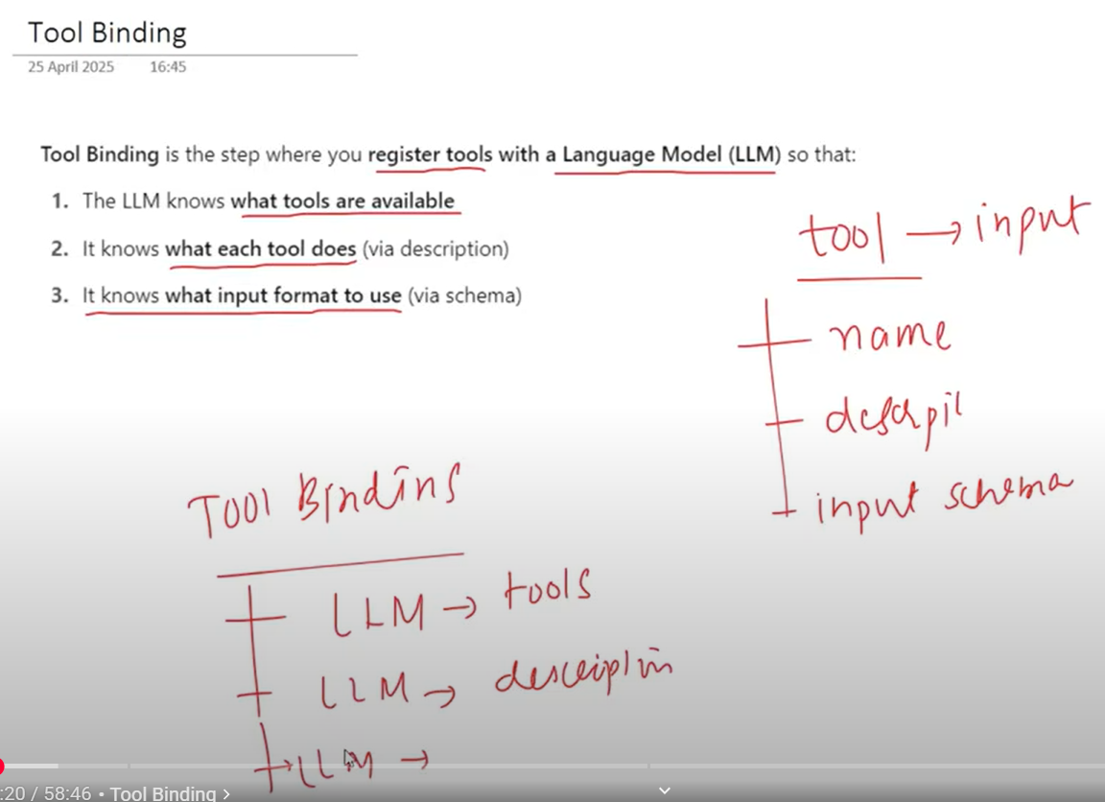

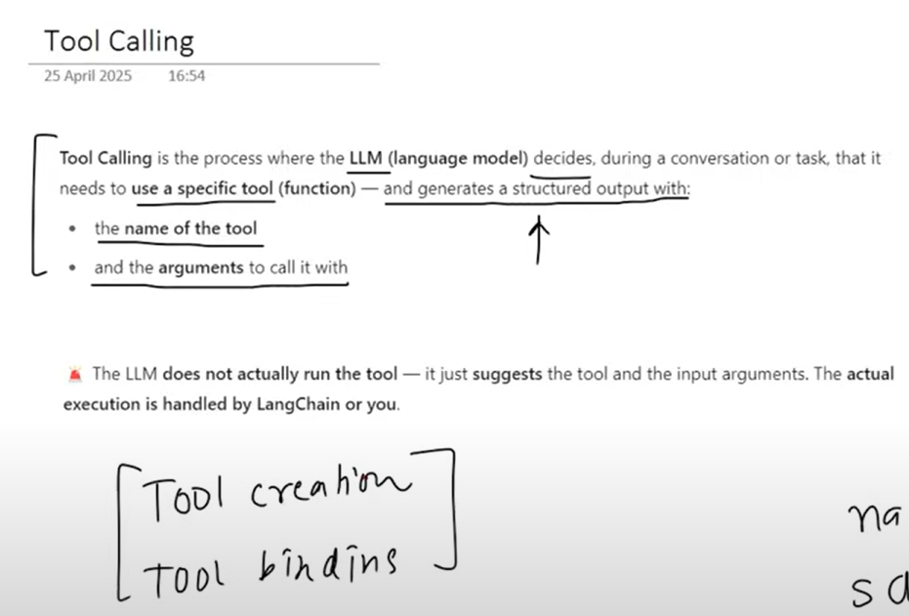

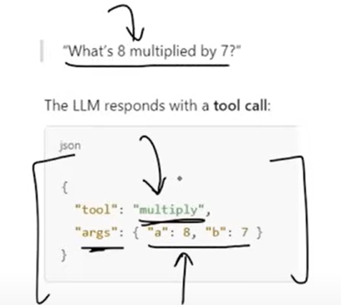

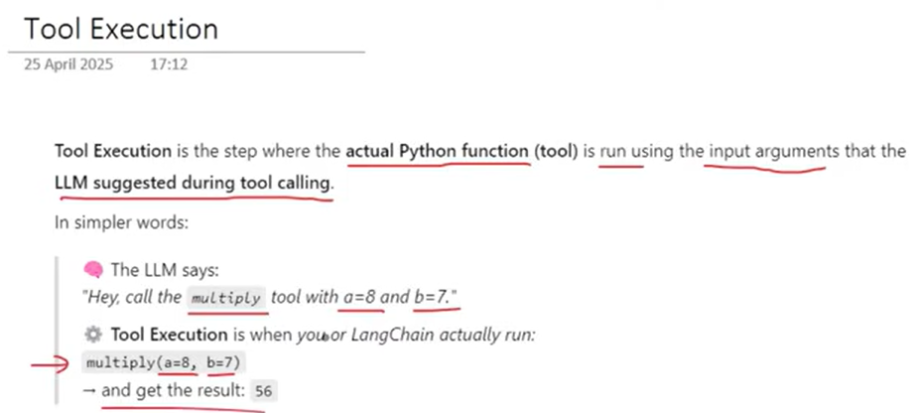

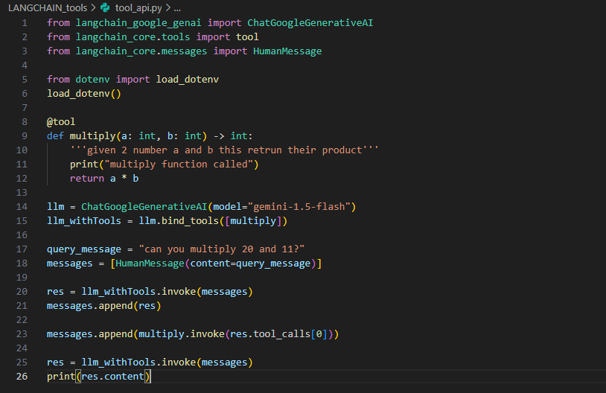

How the answer looks:

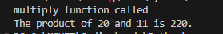

Currency conversion program:

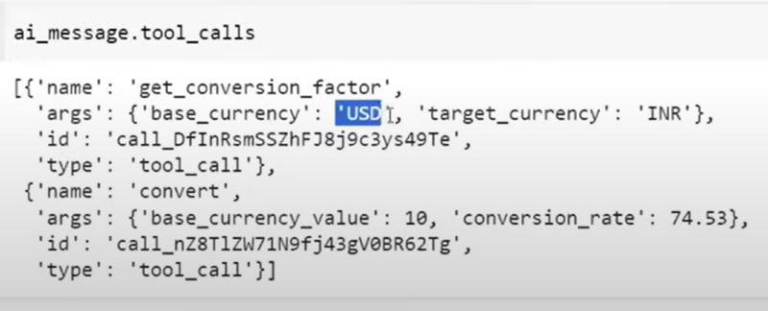

There is a value conversion rate: 74.53, which is not correct value for (date:4-JUL-2025)

Because we try to find conversion rate and ask to convert $10 to INR in same query, the LLM finds both the tools as helpful but non of the tool was called but LLM have to provide value for conversion rate parameter of convert tool.

To overcome this issues we used:

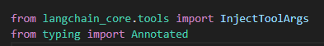

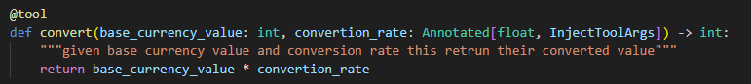

❎ LLM, do not try to fill this argument.

✅ I (the developer/runtime) will inject this value after running earlier tools.